|  |
| --- |
| **D-CUBE** |
| **Manual** |
|  |
| **Created person: Cube System Viet Nam** |
| **Created date: 2020 - 05 -20** |

LIST

**A.** **HOME** 4

1. Setting my profile(Including: Change email, phone, theme, Full name, password) 4

Click on profite→Change mail,phone, theme, full name, password **Error! Bookmark not defined.**

2. Switch language 8

3. Edit message 9

4. Collapse/Expand menu 10

**B.** **OFFICE** 12

**1.** **Search** 12

a. Search file 12

b. Edit file (Only authorized users) 13

**C.** **OFFICE ADMIN** 15

**1.** **Folders** 15

a. Search folder 15

b. Add folder 116

c. Edit folder 17

d. Delete folder 19

**2.** **Files** 22

a. Search file 22

b. Add file 23

c. Edit file 24

d. Delete file 226

**3.** **Messages** 29

a. Create new message for Office 29

**D.** **QC** 31

**1.** **Scan** 31

a. Barcode Reader 31

**E.** **QC Admin** 32

**1.** **Drawings** 32

a. Search drawings in **Files Explorer** 32

b. Add drawings filein **File Explorer** 33

c. Add drawings folder in **File Explorer** 34

d. Search drawings in **Drawings List** 35

e. Add drawings in **Drawings List** 336

f. Edit drawings in **Drawings List** 39

g. Delete drawings in **Drawings List** 40

h. Activate drawings in **Drawings List** 41

i. Show history of drawing 43

j. Update drawings in **Update drawing by CSV** 45

k. Search drawings in **Update drawing by CSV** 46

l. Edit drawingsin **Update drawing by CSV** 47

m. Delete drawings in **Update drawing by CSV** 49

**2.** **Messages** 50

a. Create new message for QC 50

**F.** **Admin** 52

**1.** **User** 52

a. Search user 52

b. Add user 54

c. Edit user 55

d. Delete user 56

e. Activating/deactivating 58

**2.** **Dropdowns** 59

a. Add Dropdown 59

b. Search dropdrown 61

c. Edit dropdown 62

d. Deactive dropdown 64

**3.** **Setting** 66

a. Create a new message 66

b. Path settings 67

c. Logo Settings 68

* **NOTE:** Depend on differently permission code, you can use list following table below.

|  |  |  |  |  |  |
| --- | --- | --- | --- | --- | --- |
| Module | Admin Permission | Office Admin  Permission | OfficeUser  Permission | QCAdmin  Permission | QCUser  Permission |
| 1. HOME | | | | | |
| Setting my profile | **✔** | **✔** | **✔** | **✔** | **✔** |
| Switch language | **✔** | **✔** | **✔** | **✔** | **✔** |
| Edit message | **✔** | **✔** | **✔** | **✔** | **✔** |
| Collapse/Expand menu | **✔** | **✔** | **✔** | **✔** | **✔** |
| 1. OFFICE | | | | | |
| Search file | ✔ | **✔** | **✔** | **×** | **×** |
| Edit file (Only authorized users) | **×** | **✔**  **※** | **✔**  **※** | **×** | **×** |
| 1. OFFICE ADMIN | | | | | |
| Search folder | **✔** | **✔** | **×** | **×** | **×** |
| Add folder | **✔** | **✔** | **×** | **×** | **×** |
| Edit folder | **✔** | **✔** | **×** | **×** | **×** |
| Delete folder | **✔** | **✔** | **×** | **×** | **×** |
| Search file | **✔** | **✔** | **×** | **×** | **×** |
| Add file | **✔** | **✔** | **×** | **×** | **×** |
| Edit file | **✔** | **✔** | **×** | **×** | **×** |
| Delete file | **✔** | **✔** | **×** | **×** | **×** |
| Create new message for Office | **✔** | **✔** | **×** | **×** | **×** |
| 1. QC | | | | | |
| Barcode Reader | **✔** | **✔** | **✔** | **×** | **×** |
| 1. QC ADMIN | | | | | |
| Search drawings in Files explorer | **✔** | **×** | **×** | **✔** | **×** |
| Add drawings file in File explorer | **✔** | **×** | **×** | **✔** | **×** |
| Add drawings folder in File exporer | **✔** | **×** | **×** | **✔** | **×** |
| Search drawings in Drawings List | **✔** | **×** | **×** | **✔** | **×** |
| Add drawings in Drawings List | **✔** | **×** | **×** | **✔** | **×** |
| Edit drawings in Drawings List | **✔** | **×** | **×** | **✔** | **×** |
| Delete drawings in Drawings List | **✔** | **×** | **×** | **✔** | **×** |
| Update drawings in Update drawings by CSV | **✔** | **×** | **×** | **✔** | **×** |
| Search drawings in Update drawing by CSV | **✔** | **×** | **×** | **✔** | **×** |
| Edit drawings in Update drawing by CSV | **✔** | **×** | **×** | **✔** | **×** |
| Delete drawings in Update drawing by CSV | **✔** | **×** | **×** | **✔** | **×** |
| Create new message for QC | **✔** | **×** | **×** | **✔** | **×** |
| 1. ADMIN | | | | | |
| Mode show or hide Deactivated records | **✔** | **×** | **×** | **×** | **×** |
| Search user |  |  |  |  |  |
| Add user | **✔** | **×** | **×** | **×** | **×** |
| Edit user | **✔** | **×** | **×** | **×** | **×** |
| Delete user | **✔** | **×** | **×** | **×** | **×** |
| Activating/deactivating | **✔** | **×** | **×** | **×** | **×** |
| New message | **✔** | **×** | **×** | **×** | **×** |
| Path settings | **✔** | **×** | **×** | **×** | **×** |
| Logo Settings | **✔** | **×** | **×** | **×** | **×** |

* With **✔ :** Useable

**× :** Non useable

**※ :** Only authorized users

1. **HOME**
2. Setting my profile(Including: Change avatar, email, phone, theme, full name, password)

Click on profile→change the content→click **Save**

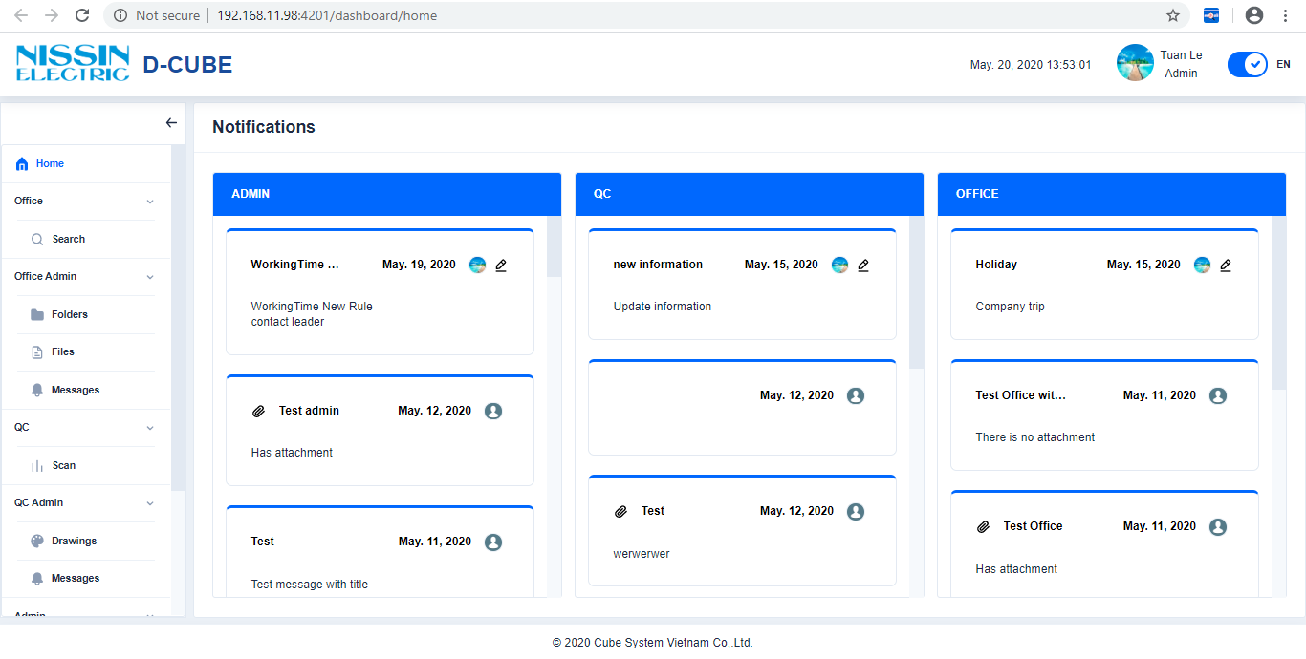 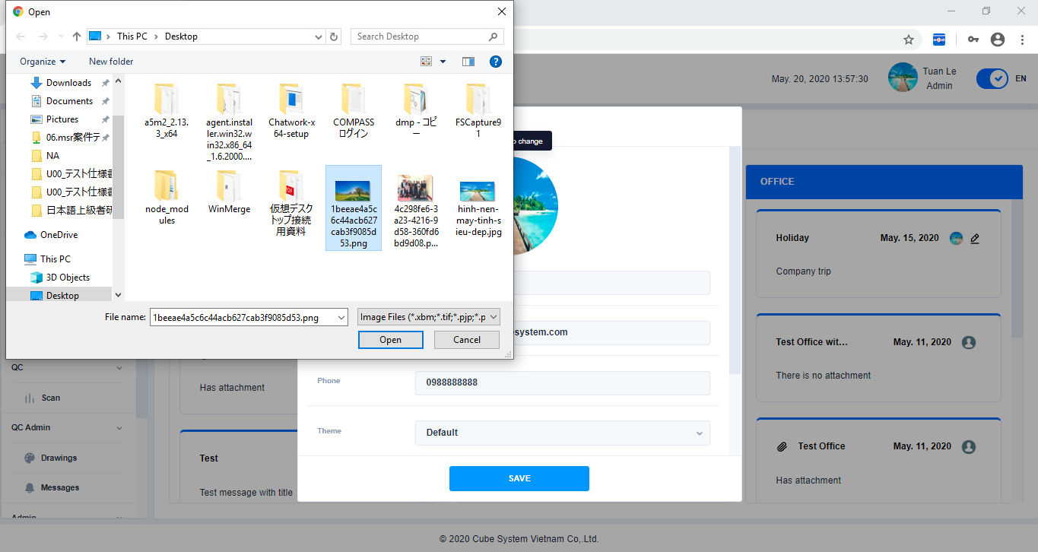 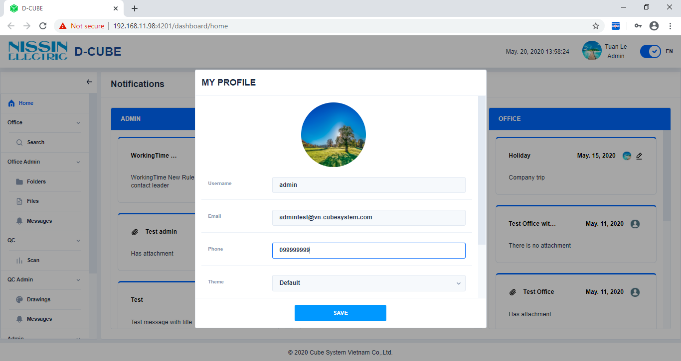

Change avatar, email, phone, thêm, fullname, password

Click on profile

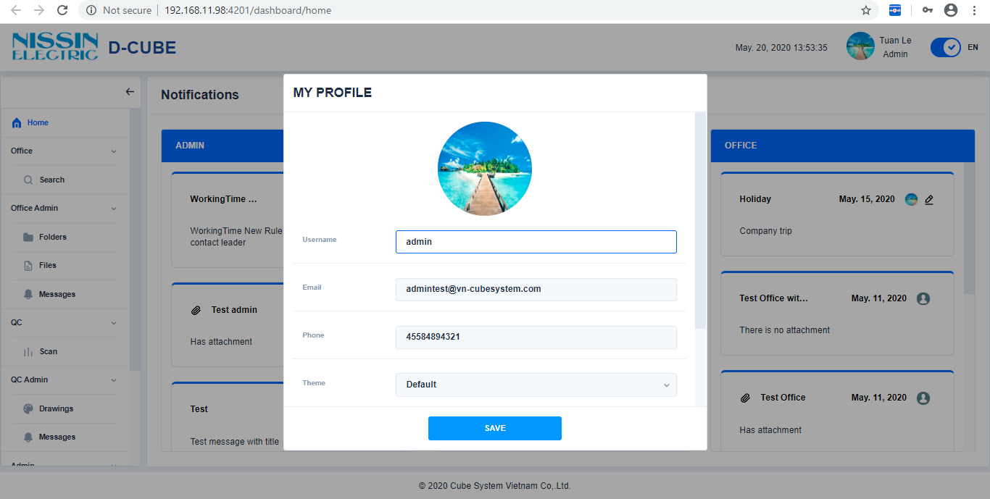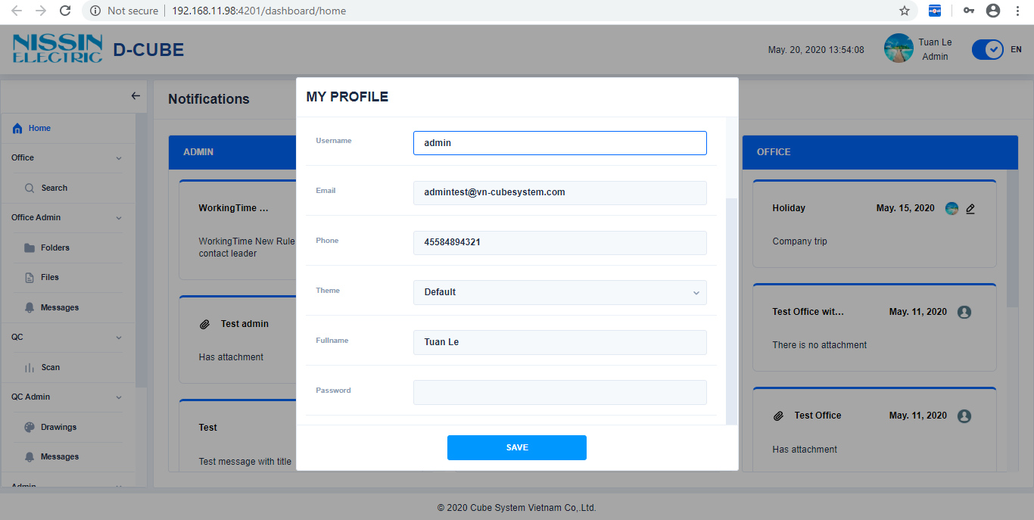

Click

Click here or double click on file to change avatar

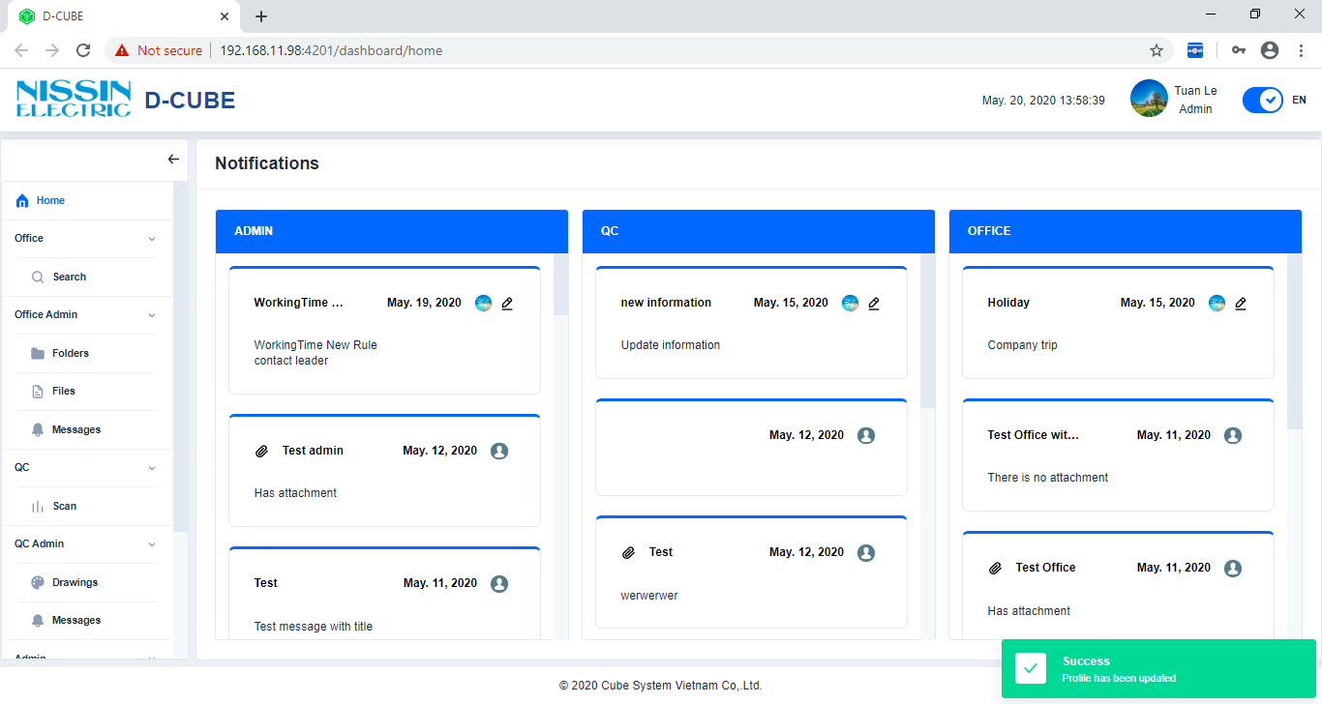

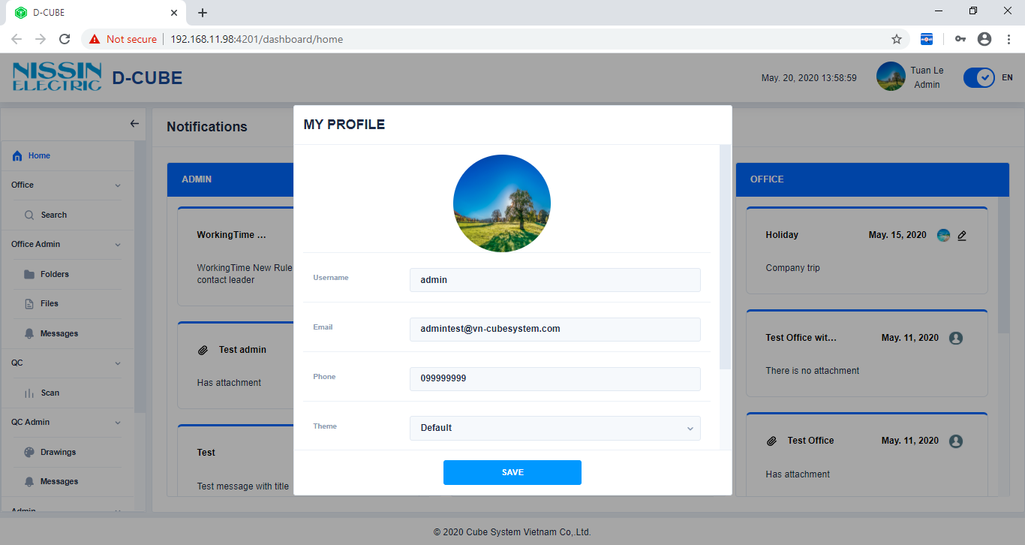

1. Switch language

Click to change language

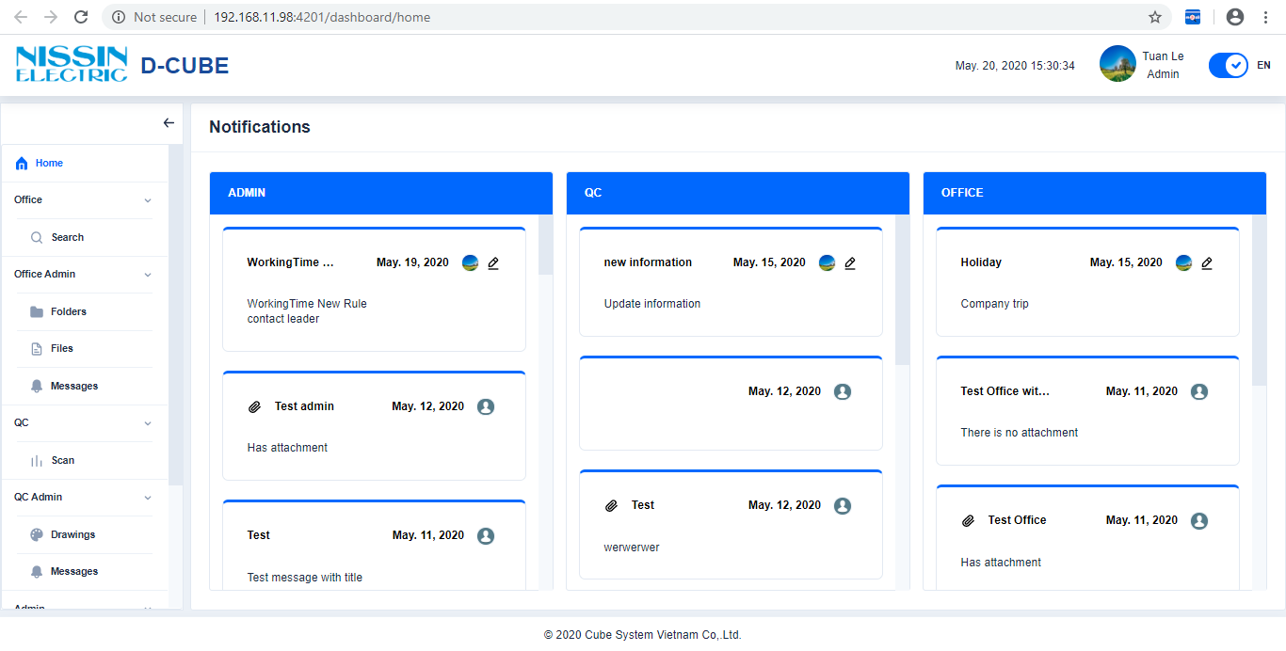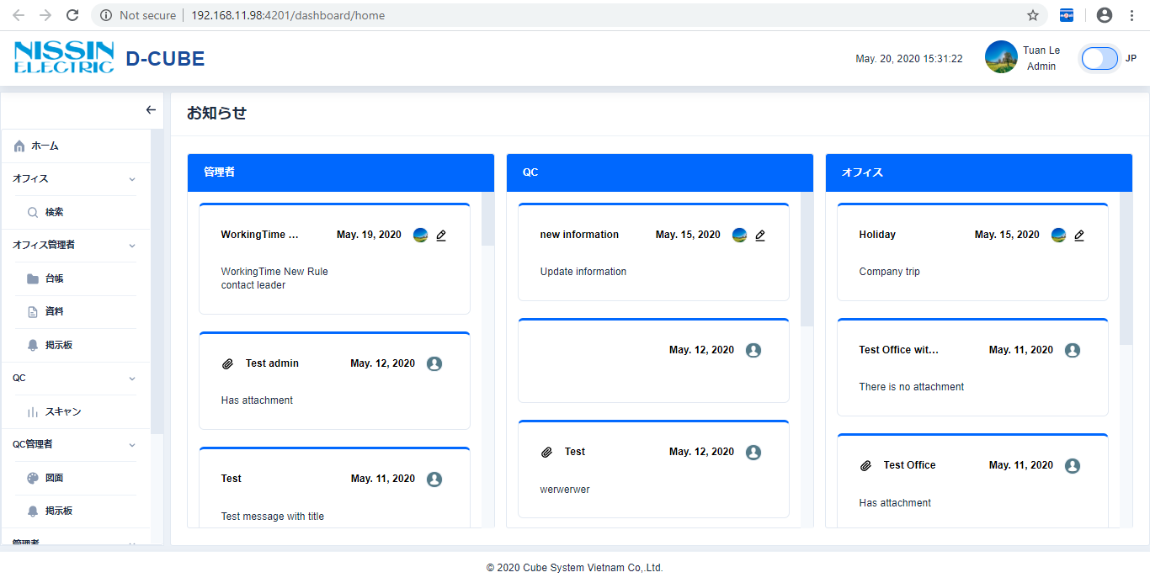

Click

Click

1. Edit message

Click on →Edit message→click **Save**

※Only for editing the latest message 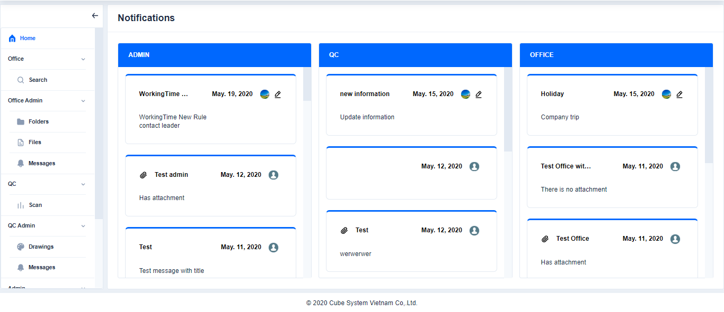

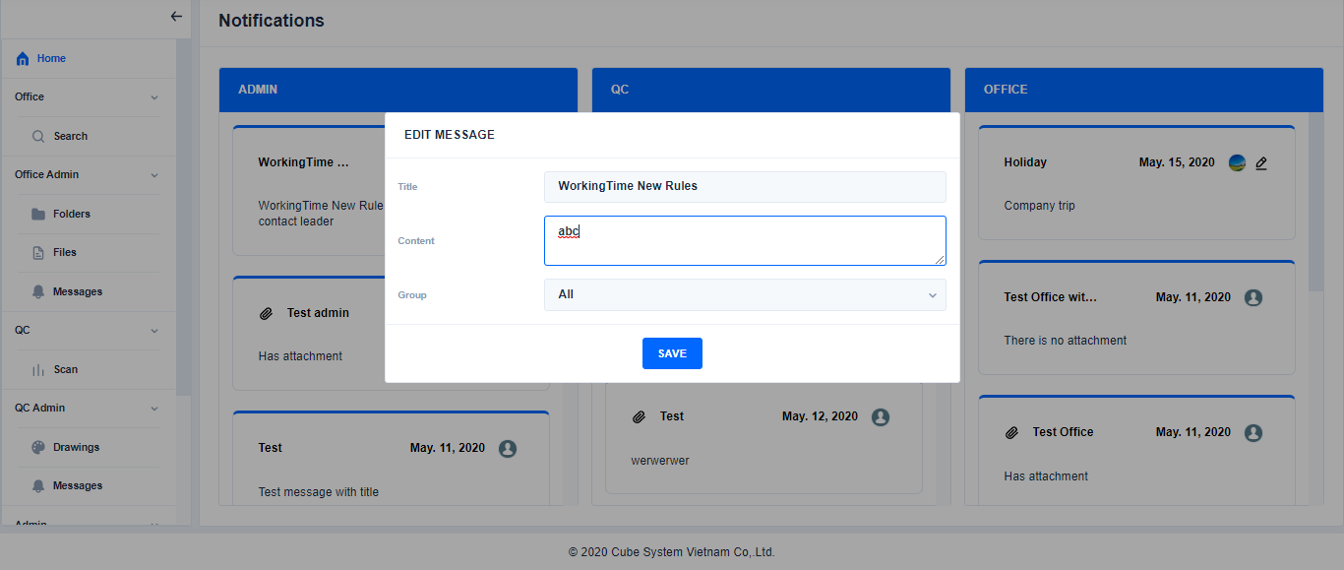 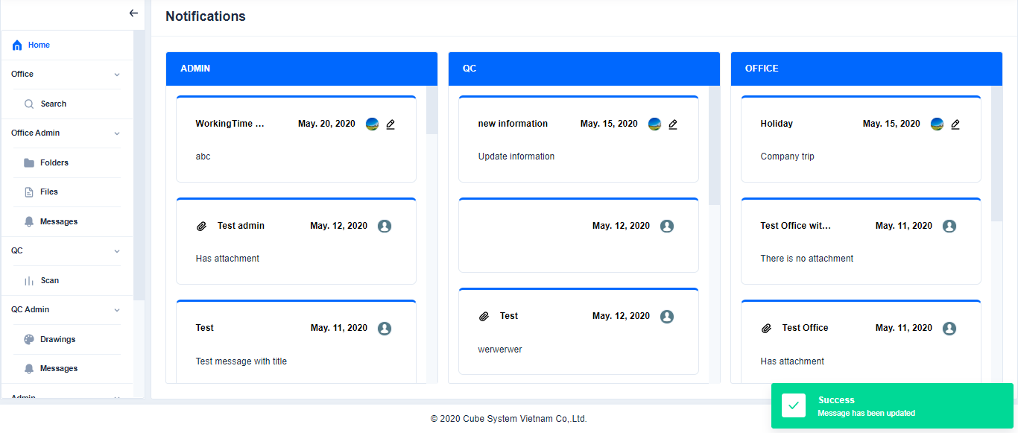

Click

Edit title, content, group

Click

1. Collapse/Expand the Menu or List

Click  /to collapse the Menu or List

Click / to expand the Menu or List 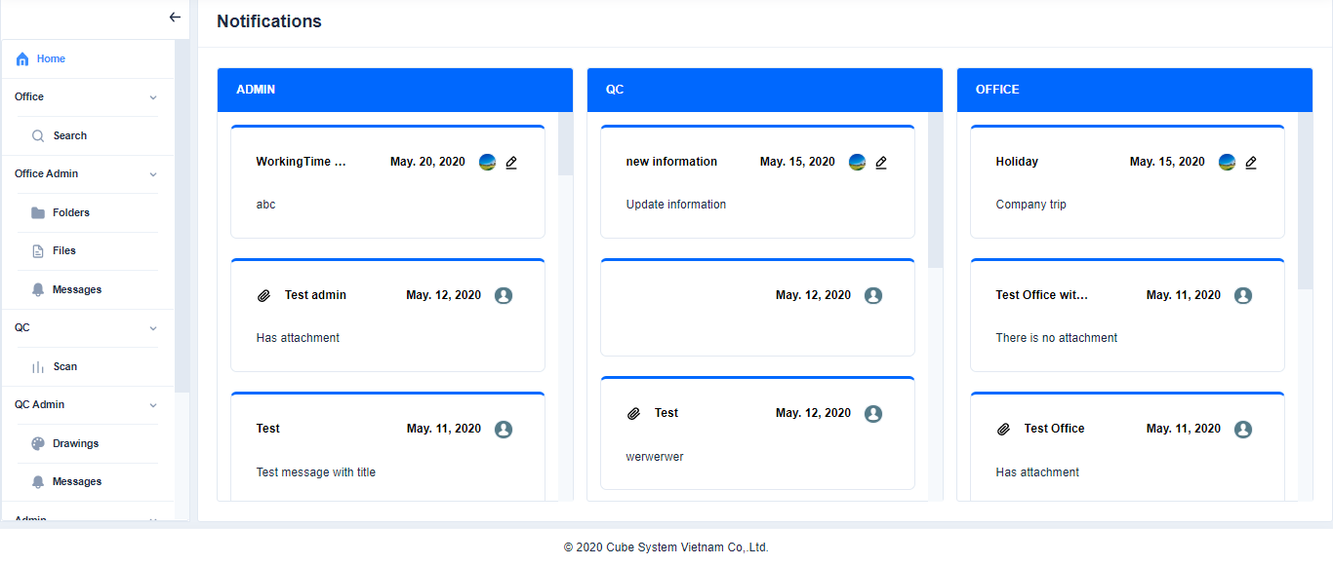

Click

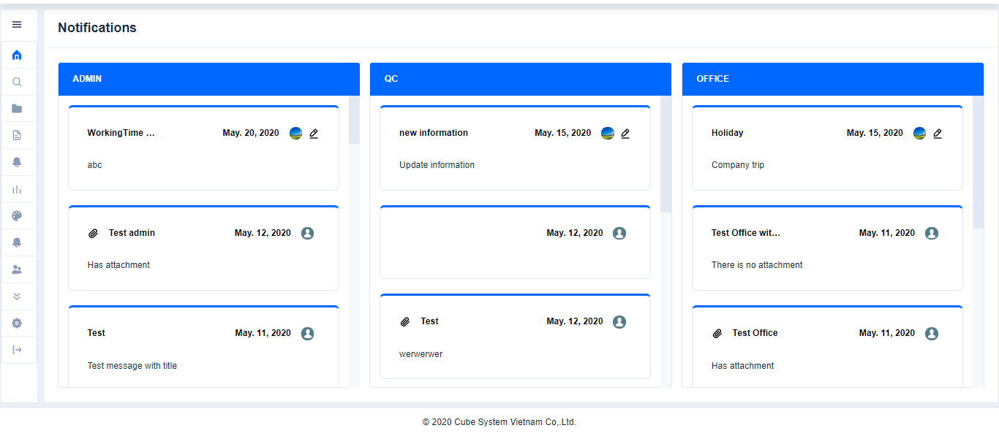

Click

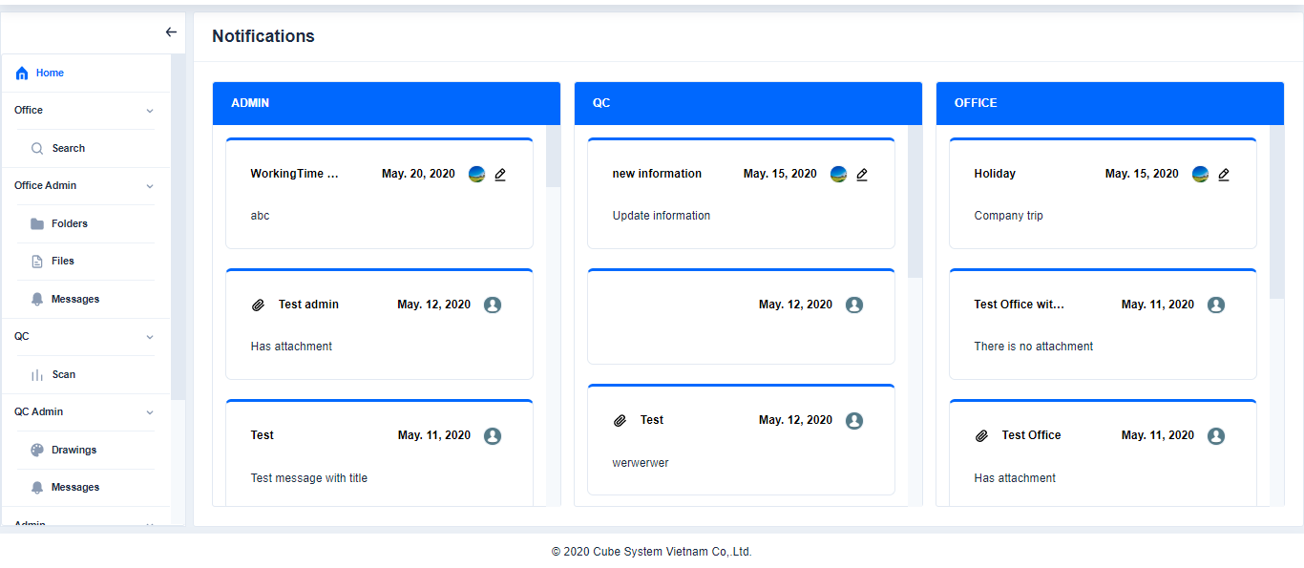

Click

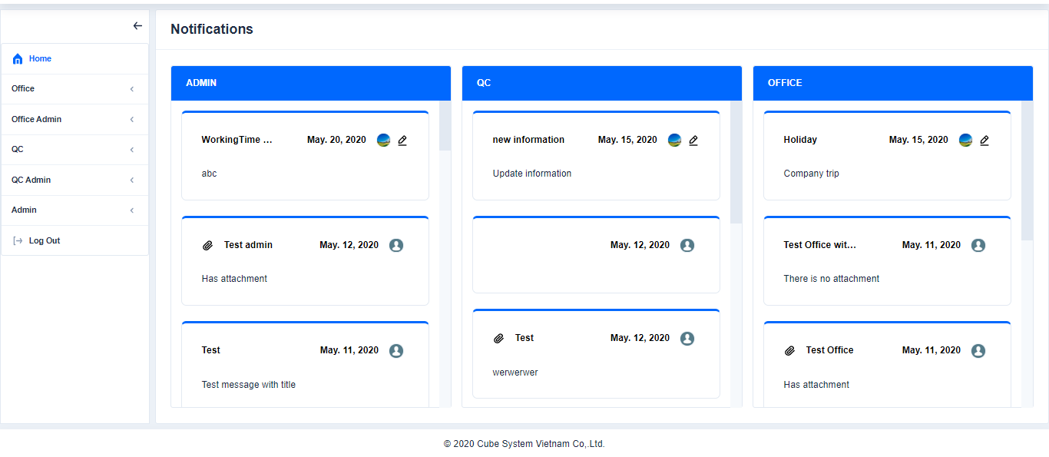

Click

1. **OFFICE**
2. **Search**
3. Search file

Click **Search**→Choose a folder→Search File

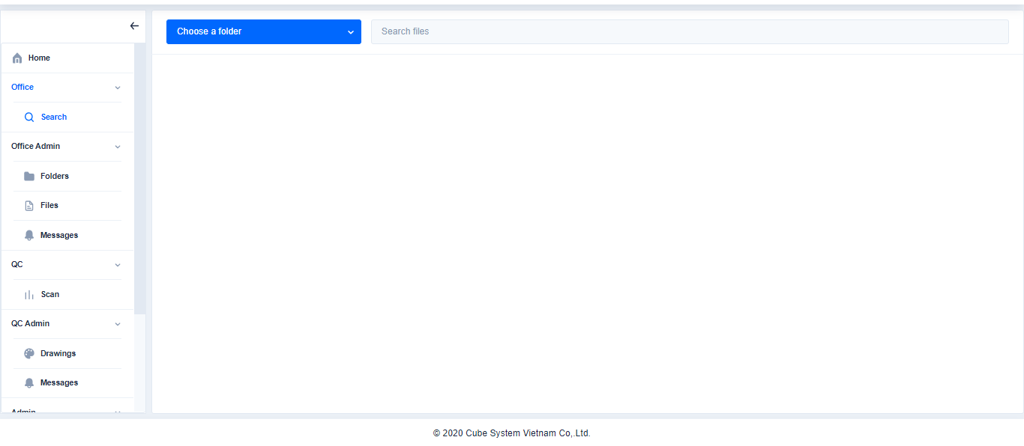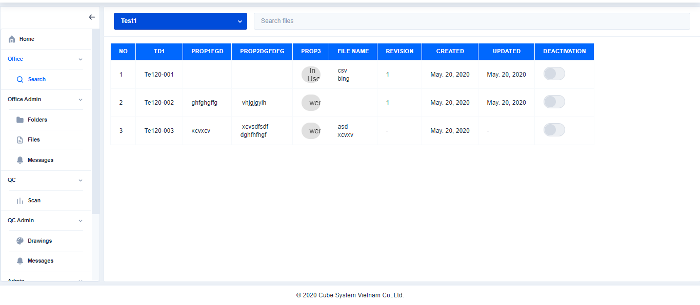

Click

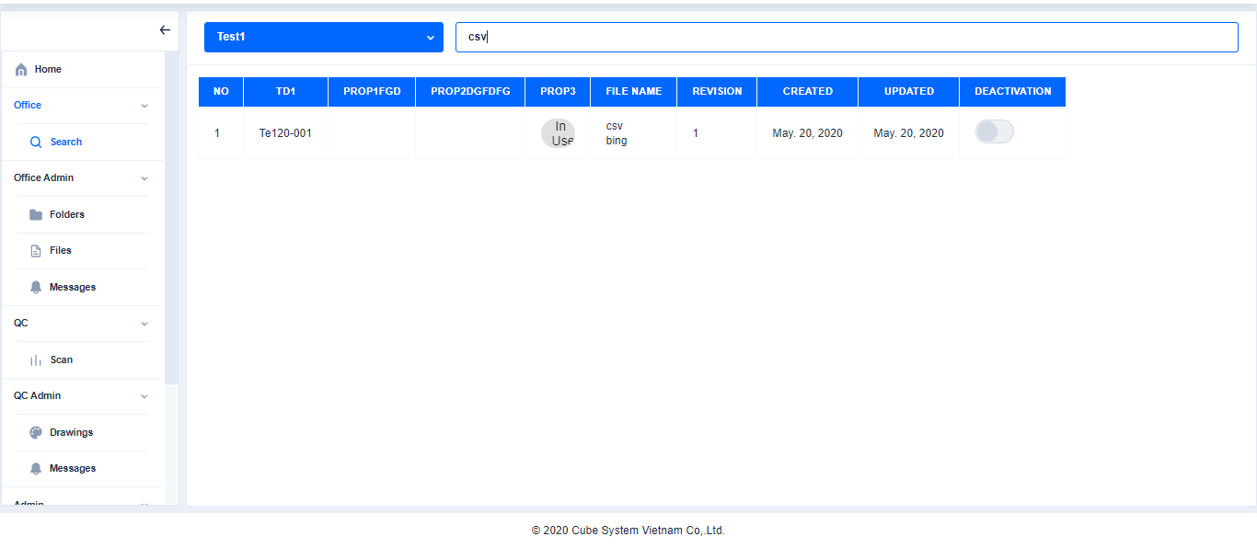

Search file

Choose a folder

1. Edit file (Only authorized users)

Login with authorized user→Click **search**→choose a folder and file→Click **Edit**

→Edit the content→Click **Save**

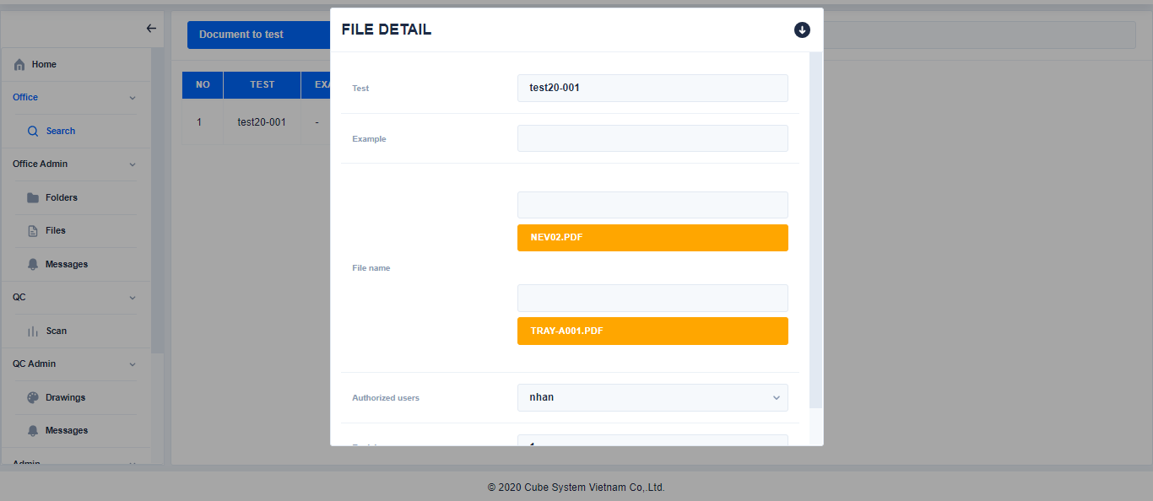 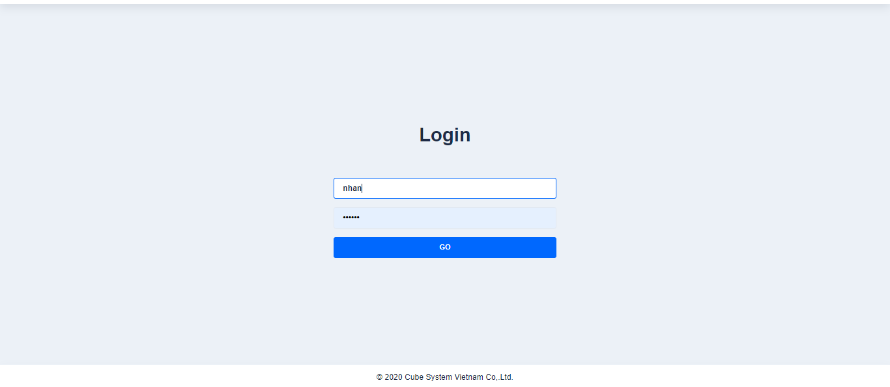

Login with user is nhan

Authorized user: nhan

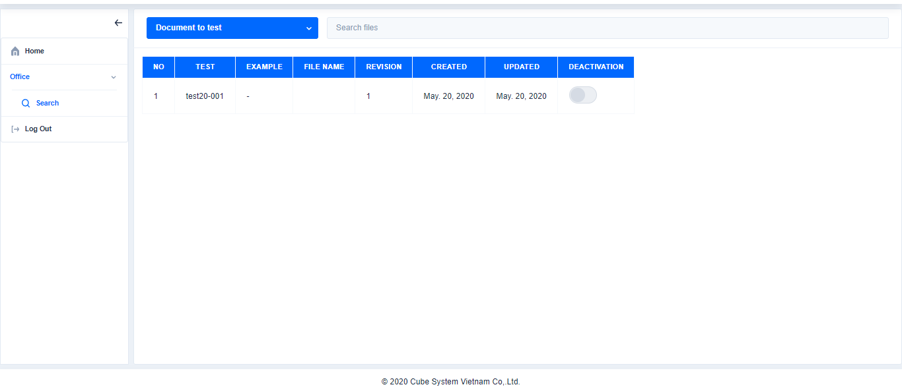 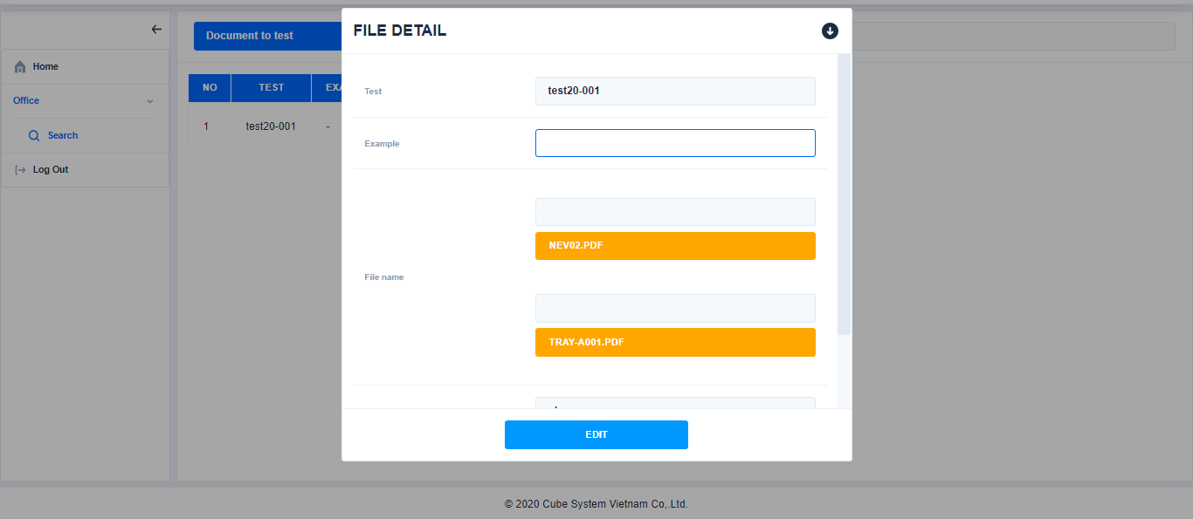 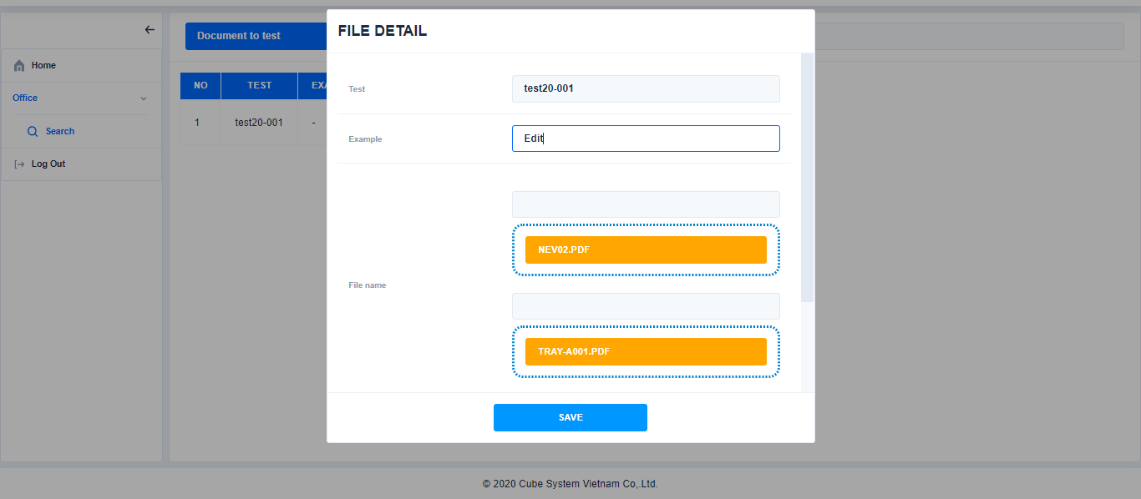 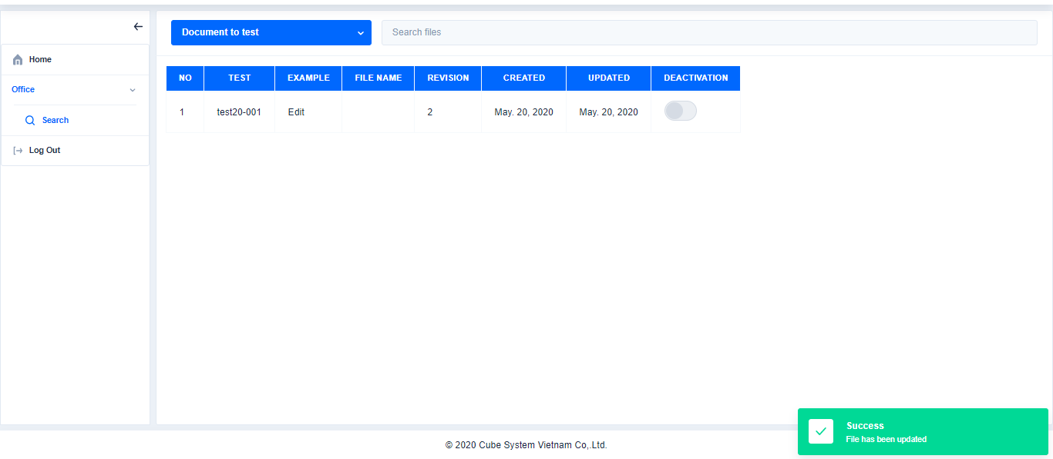

Choose a folder and file

Choose a folder and file

Click

1. **OFFICE ADMIN**

Click

Edit the content

Click

1. **Folders**
2. Search folder

Click Folders→Search file→

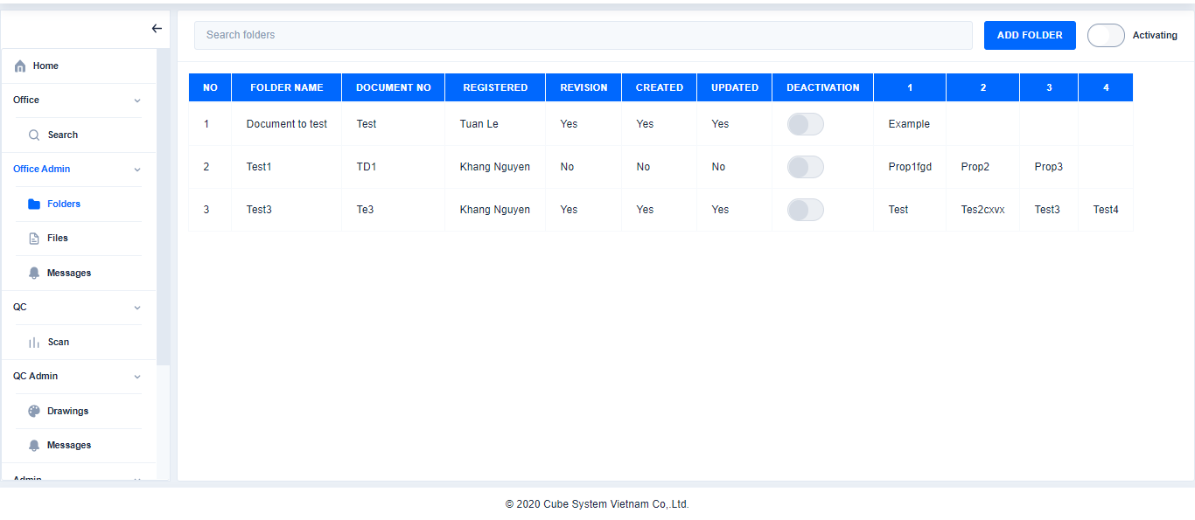

Click

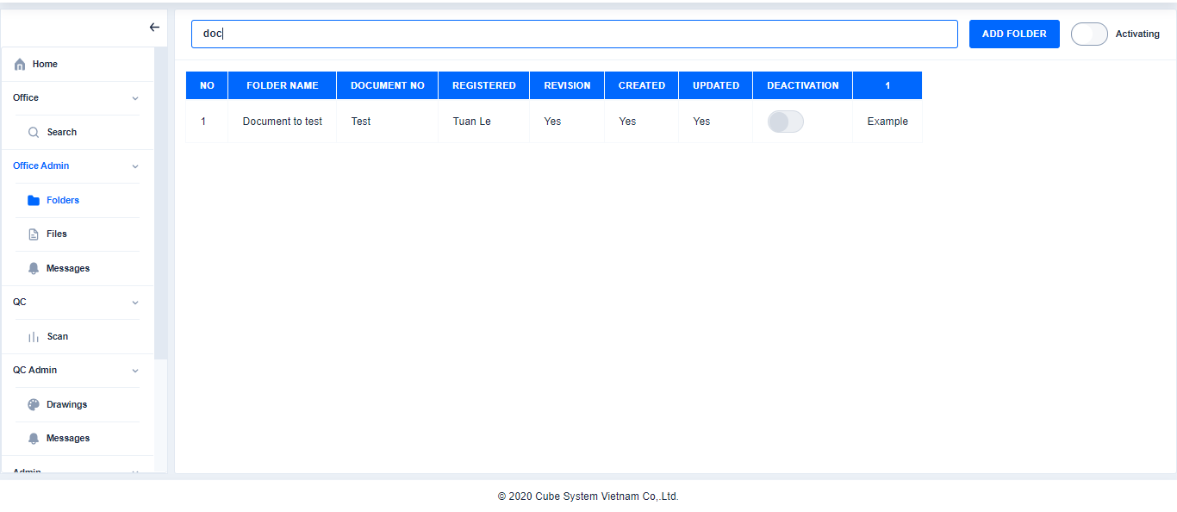

Search folder

1. Add folder

Click Folders→Click Add Folder→Enter or select content→Click Create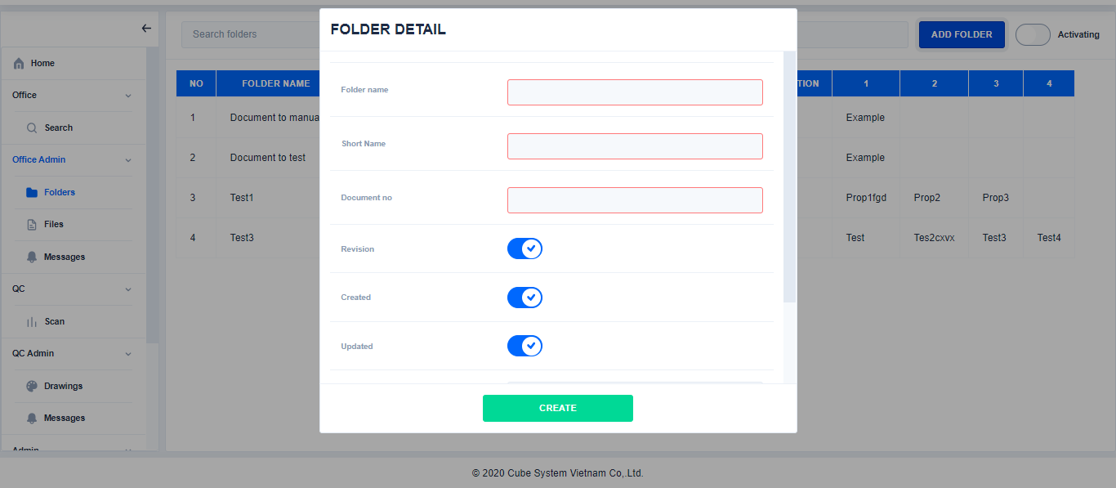 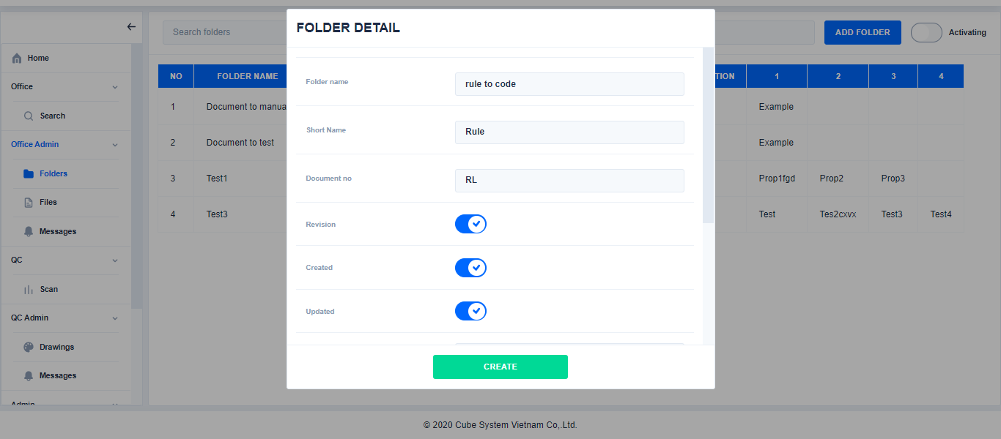 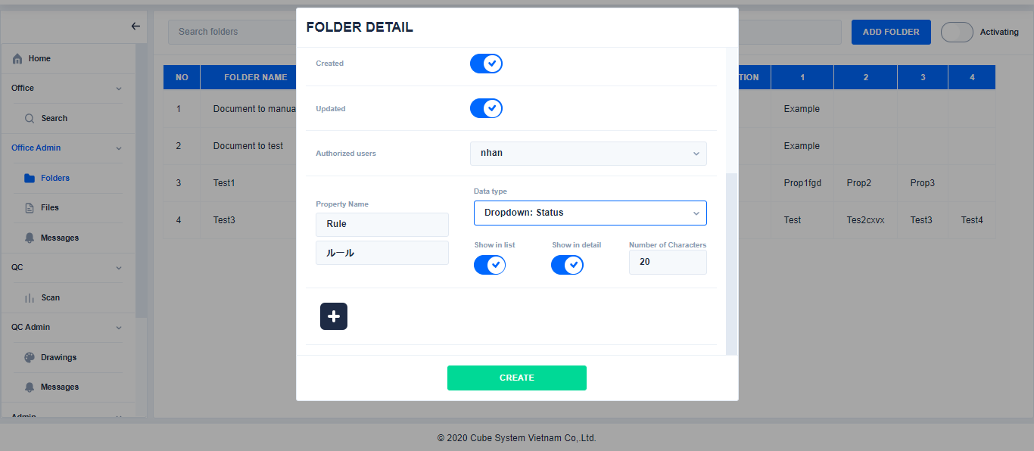 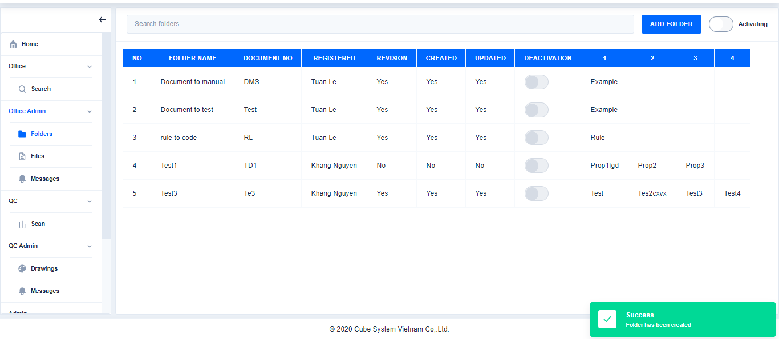

Click

Click

1. Edit folder

Click

Enter or select content

Enter or select content

Click Folder→Select a folder→Click Edit→Edit the content→Click Save→

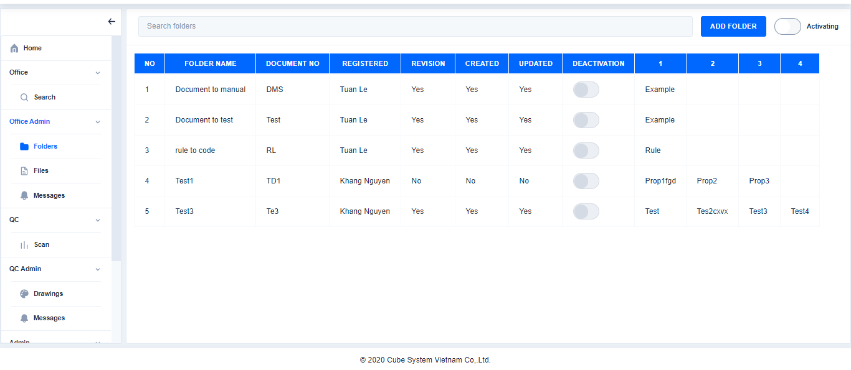 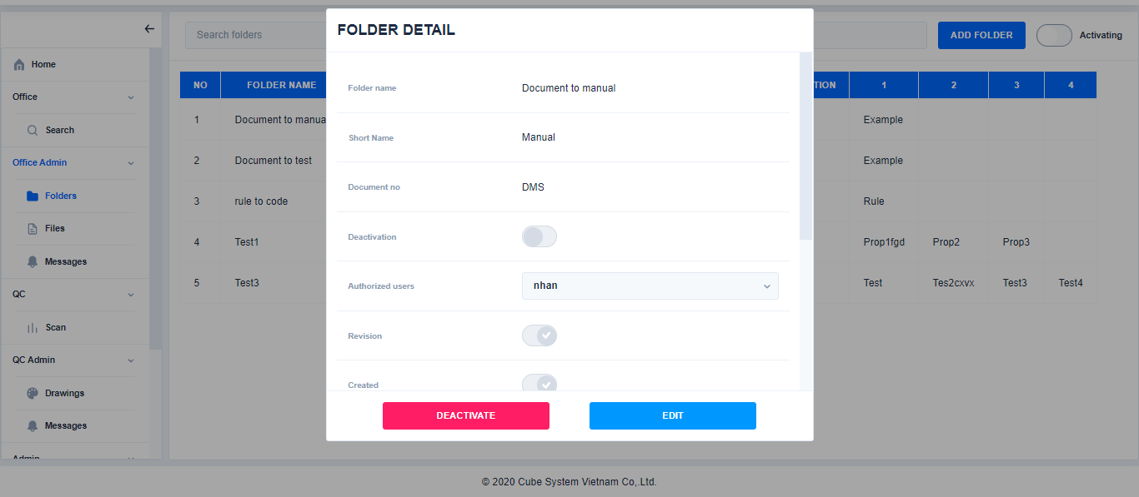 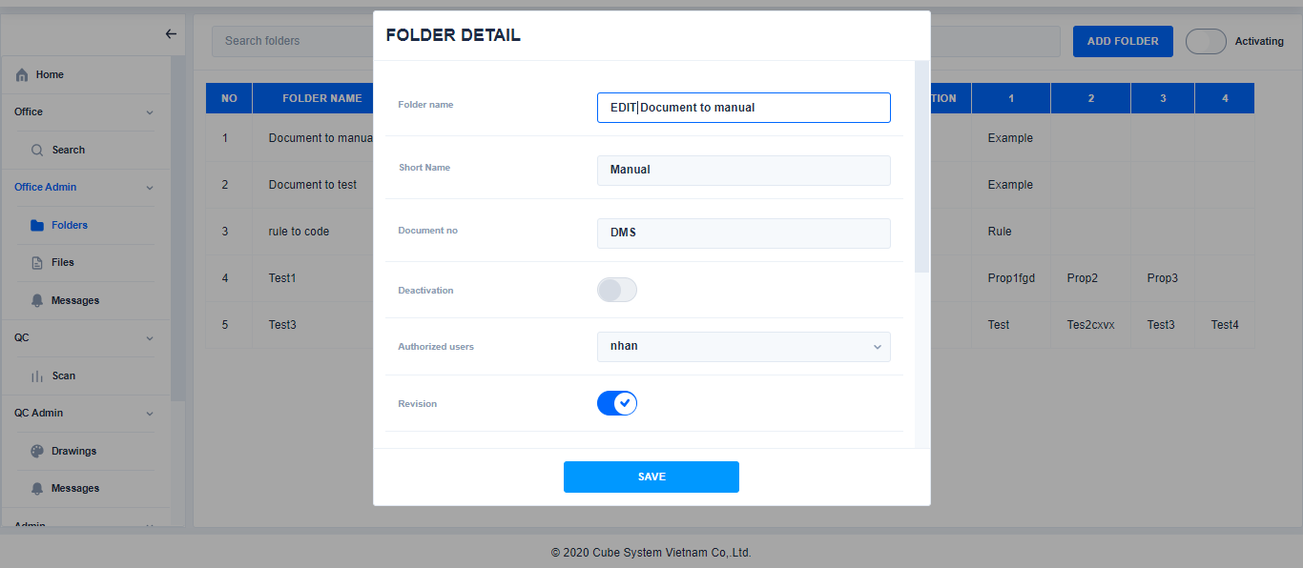 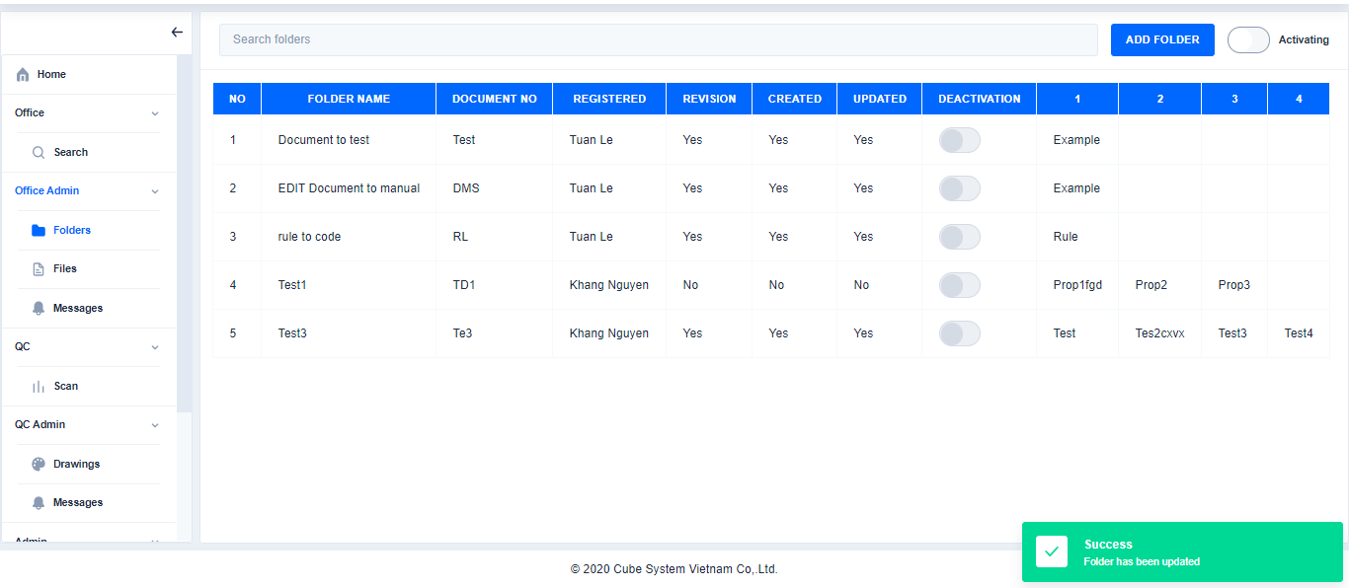

Click

Edit the content

Click

Select a folder

Click

1. Deactivate/active folder

※Deactivate folder

Click Folder→Choose folder→Click Deactivate→Click Yes→

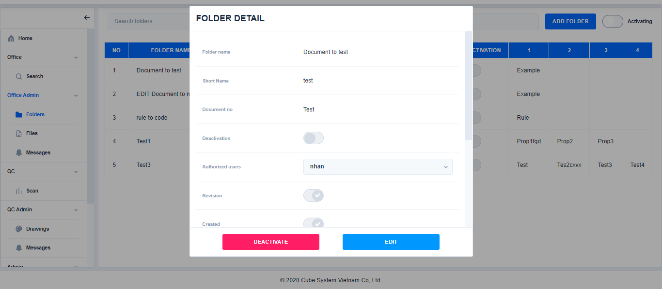

Click

Choose folder

Click

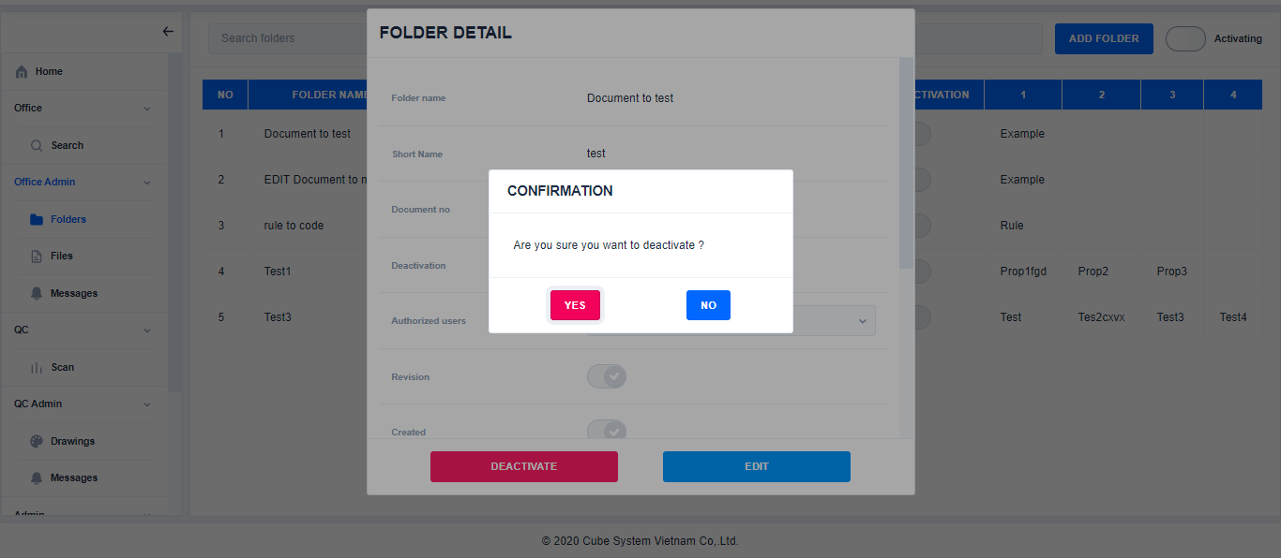

Click

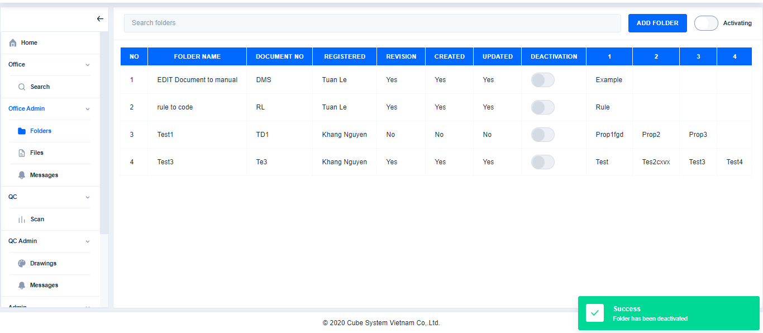

※Active folder

Click

Click Folders→Click Add→Choose folder→Click Activate→Click Yes

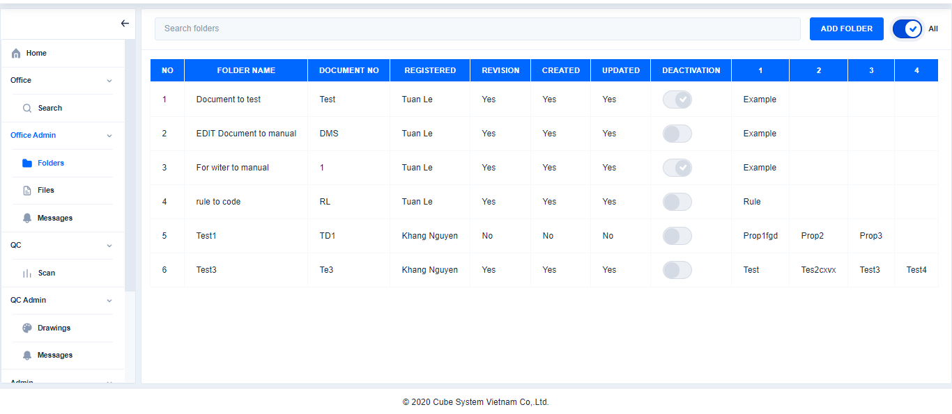 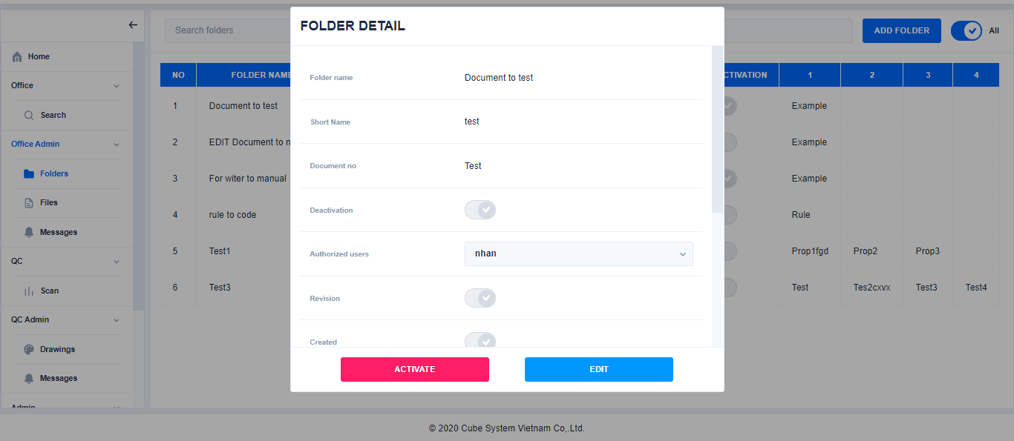 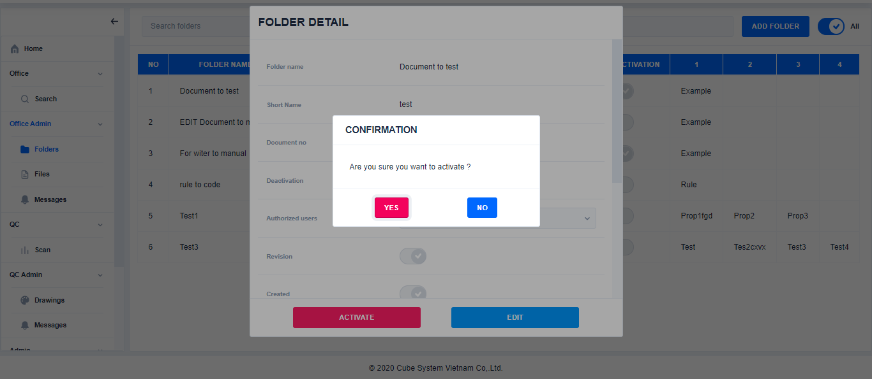 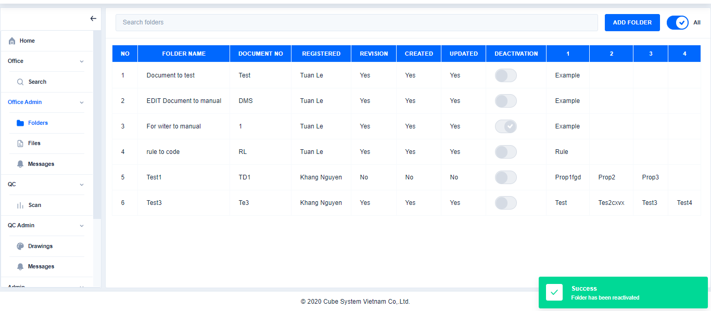

Click

Choose folder

Click

Click

**※Mode: Show or hide Deactivated records**

If status of this button is All: Display All the records

If status of this button is Activating: Only display the records that currently activating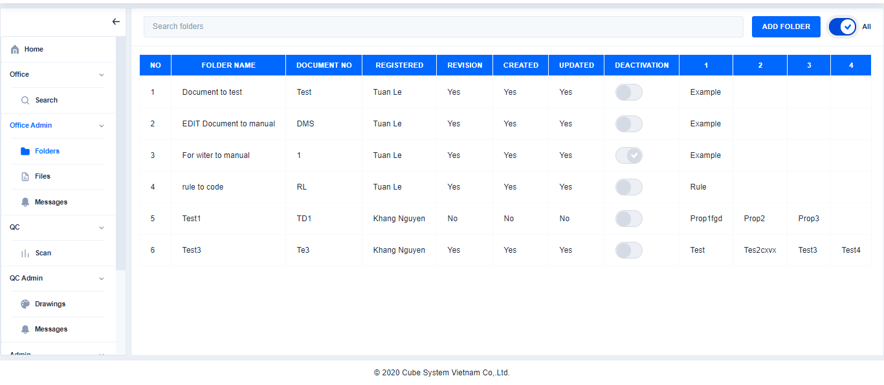 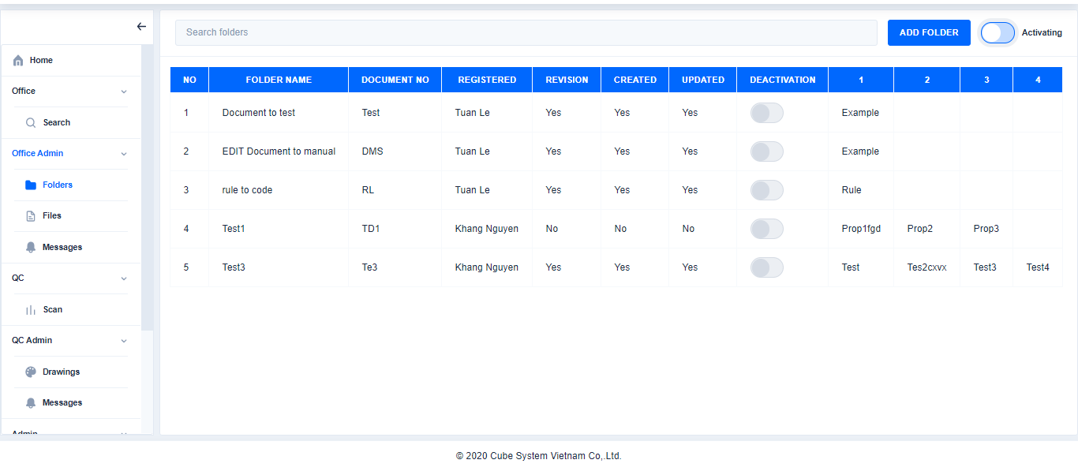

1. **Files**
2. Search file

Click Files→Choose a folder→Search file

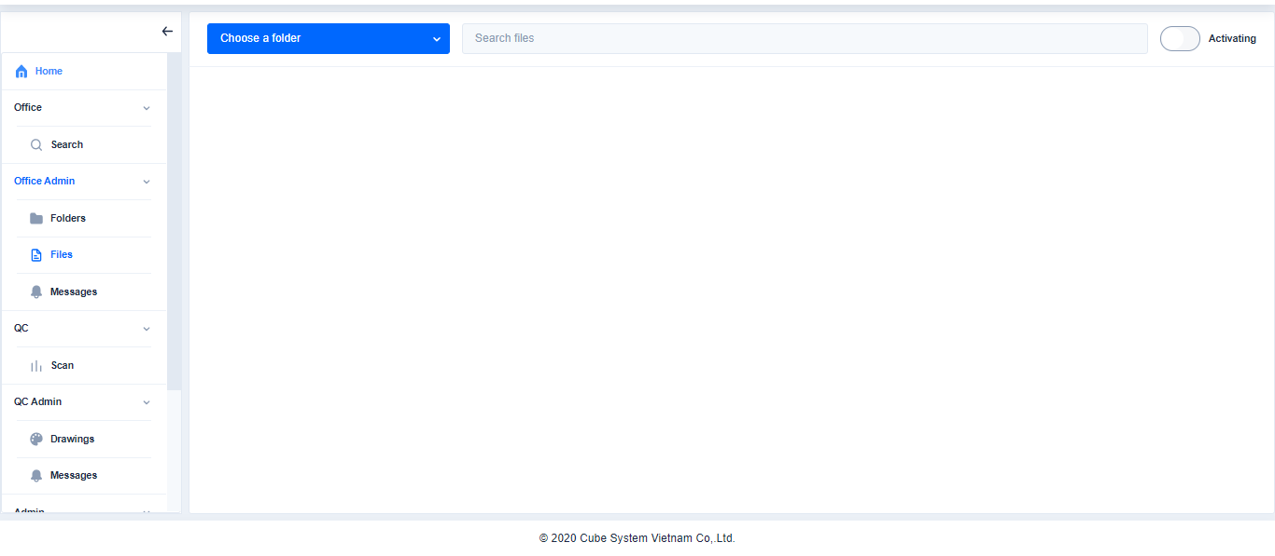 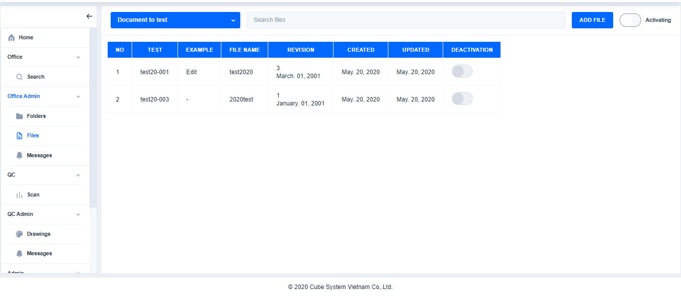 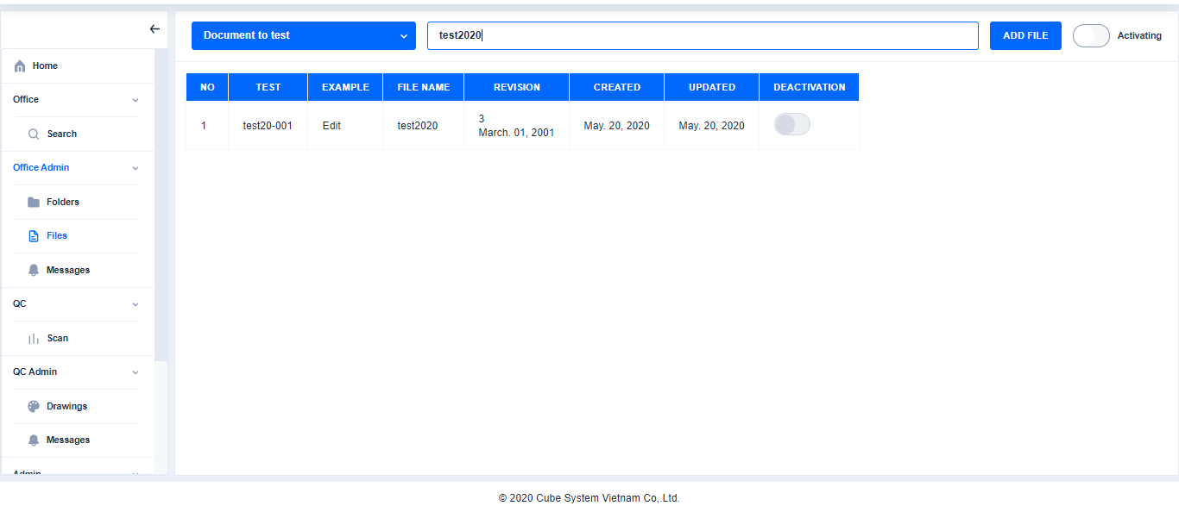

Choose a folder

Click

1. Add file

Search file

Click Files→Choose a folder→Click Add file→Enter the content and browse file

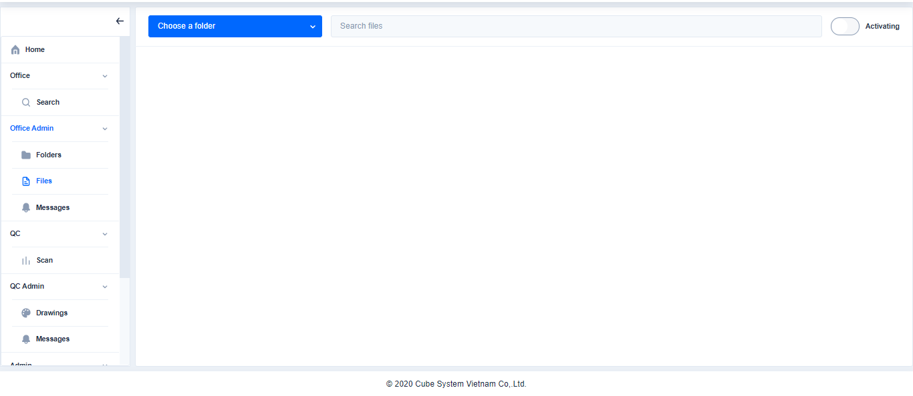 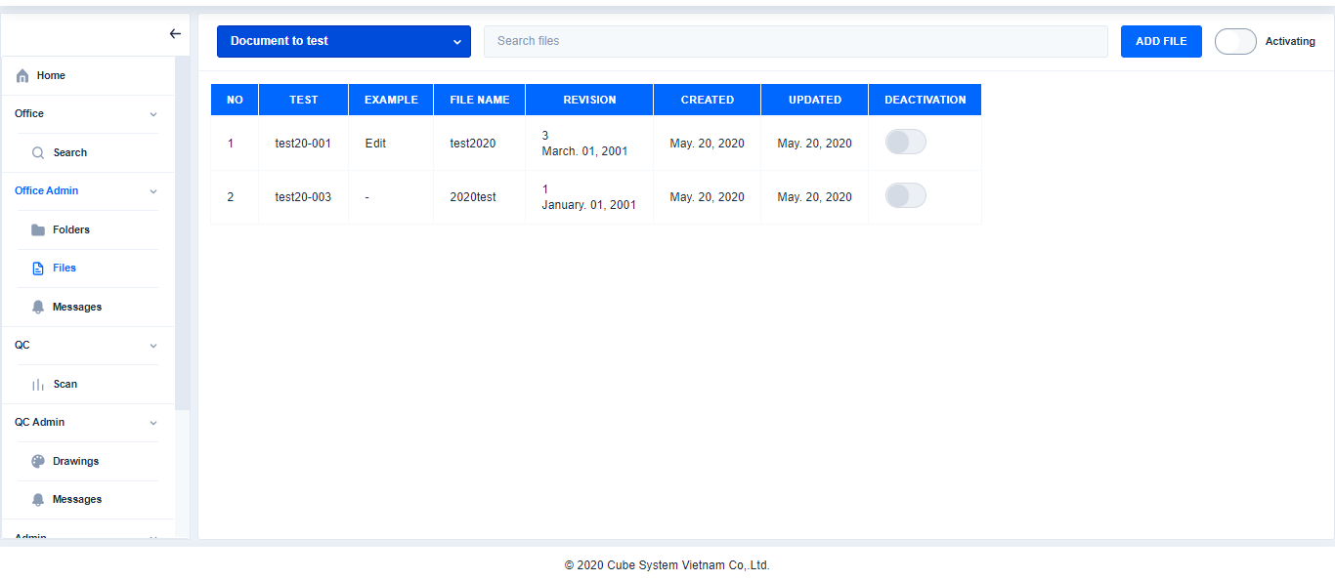 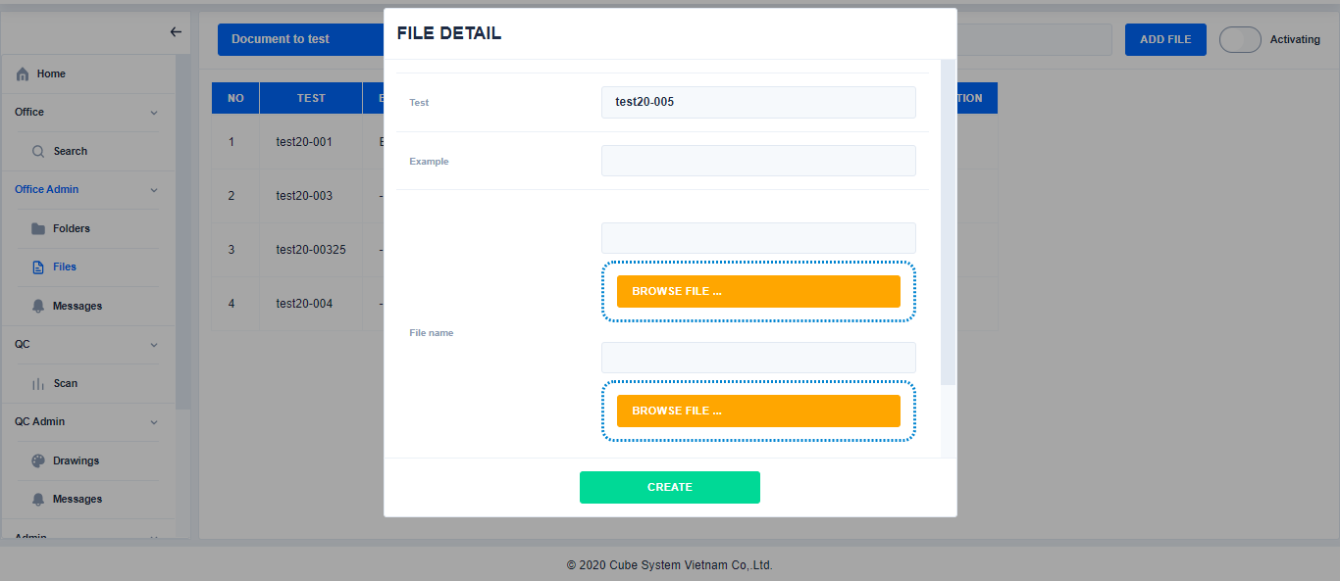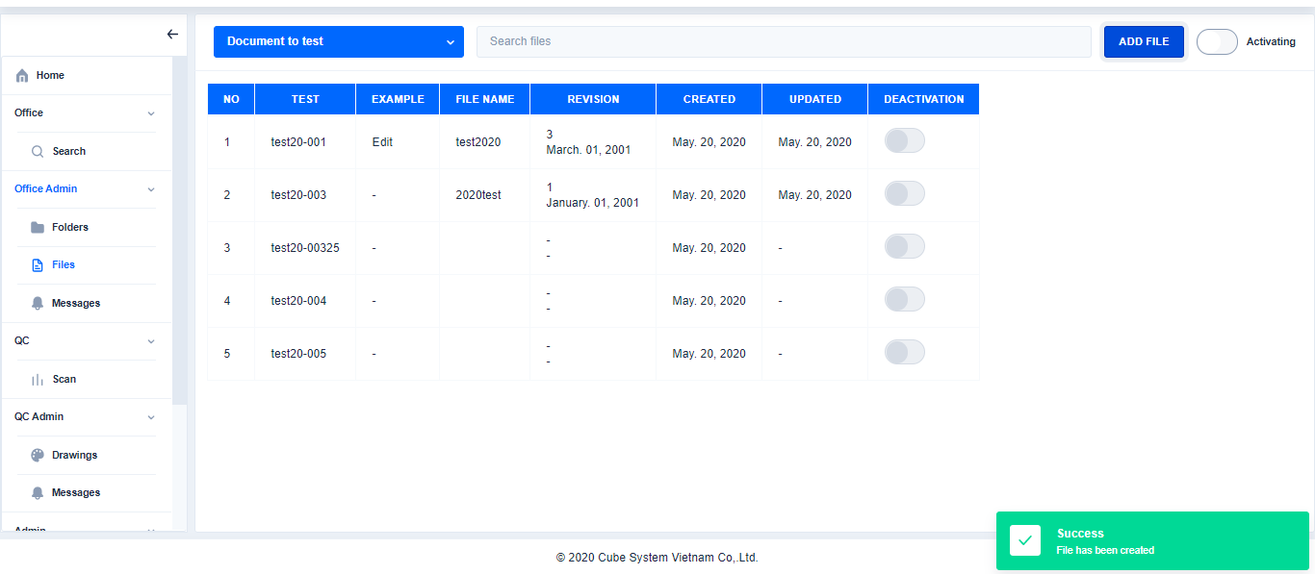

Choose a folder

Choose a folder

Click

Click

Enter the content and browse file

1. Edit file

Enter the content and browse file

Click

Click Files→Choose a folder and file→Click Edit→Edit content→Click Save

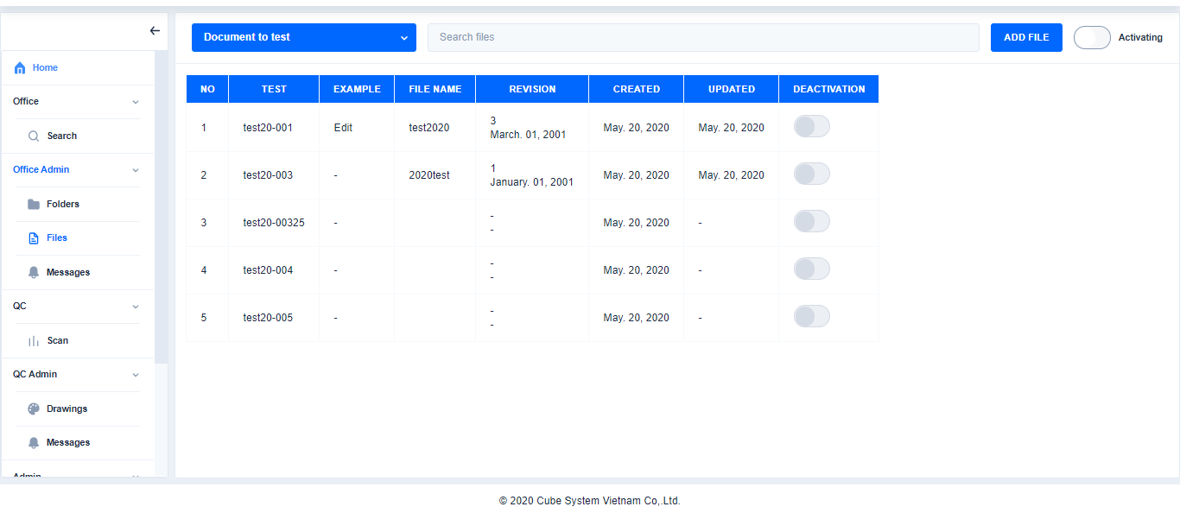 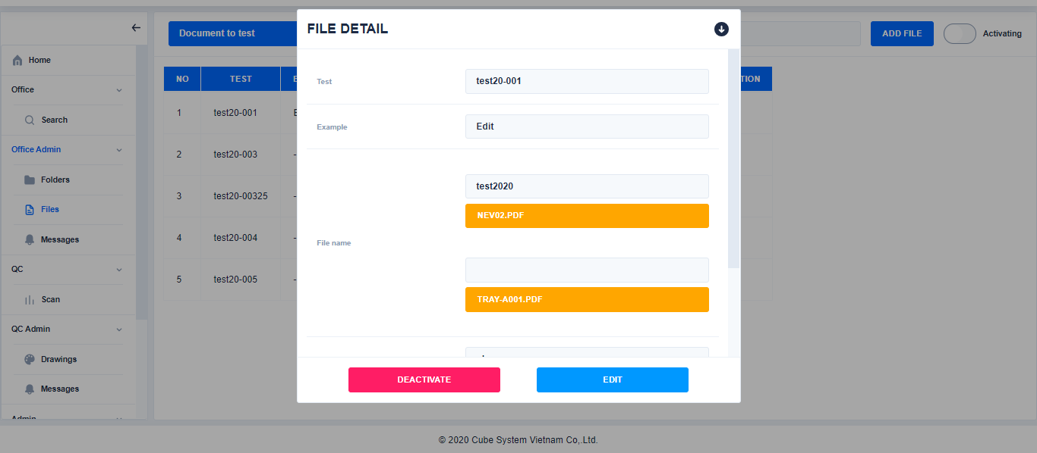

Click

Choose a folder and file

Choose a folder and file

Click

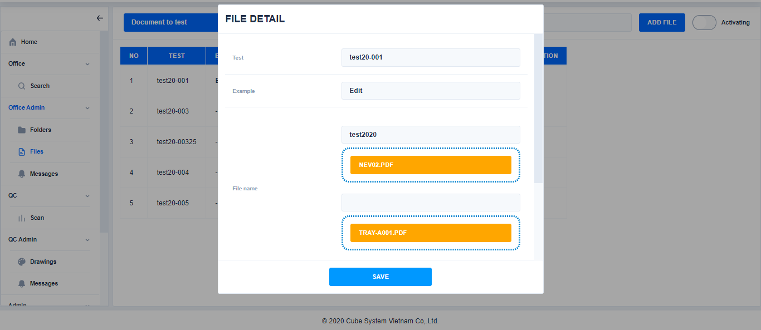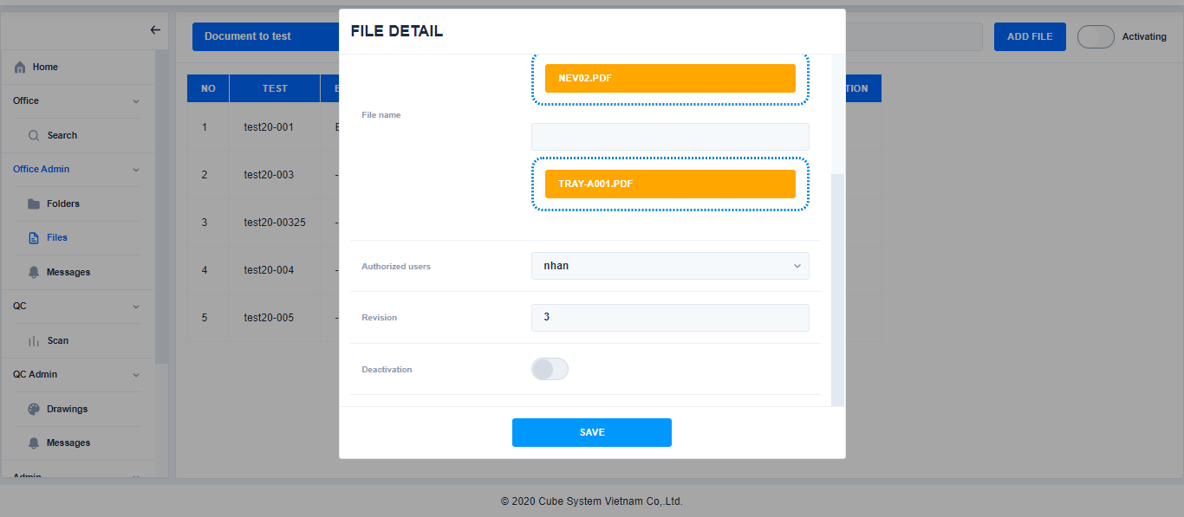

Edit content

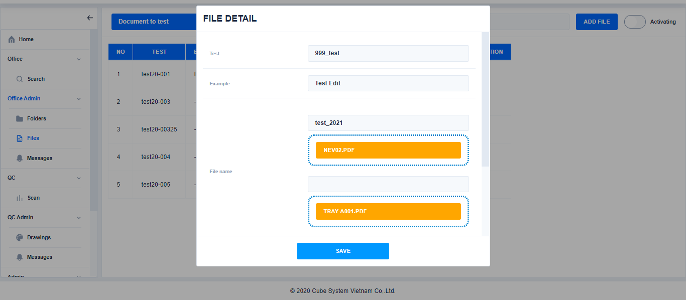 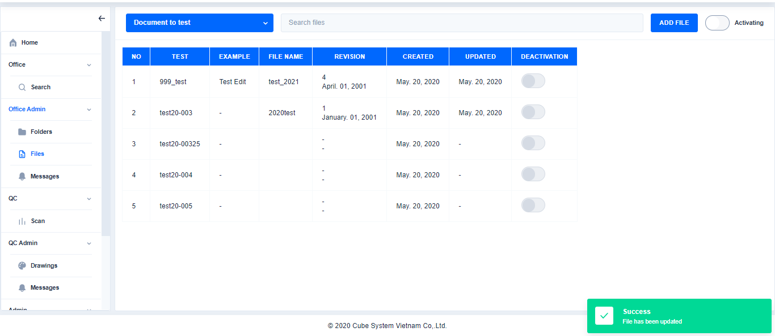

1. Deactive/Active File

Click

※Deactive file

Clieck Files→Choose file→Clieck Deactivate→Click Yes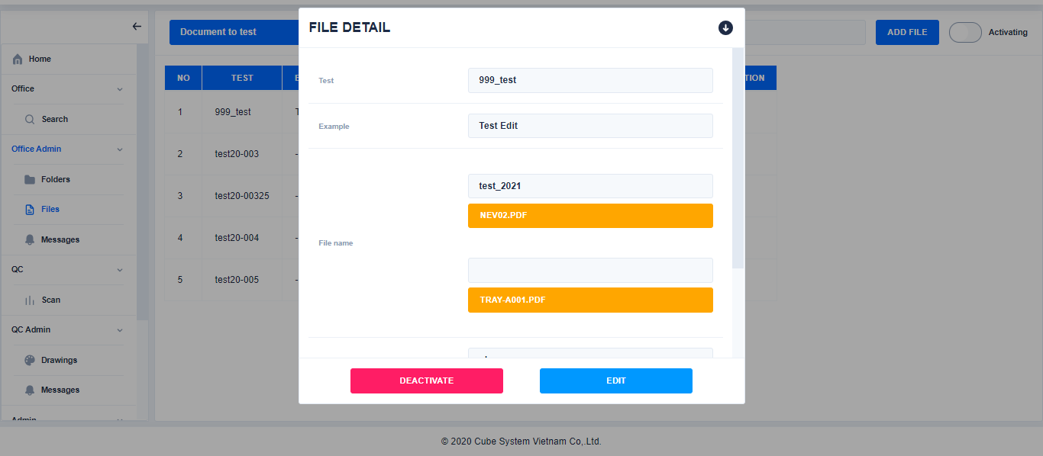 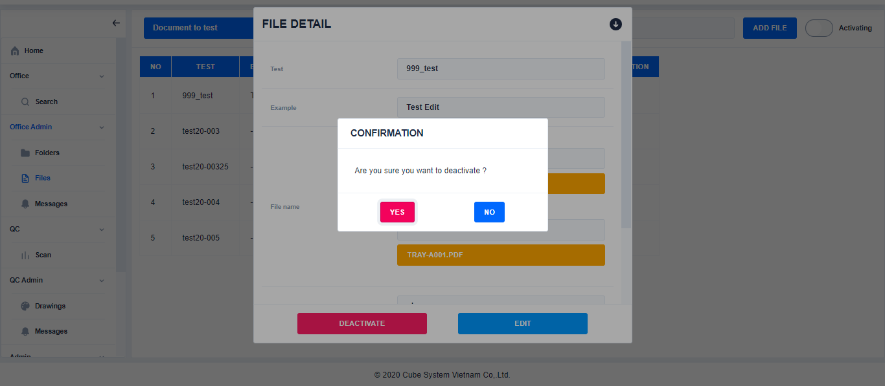 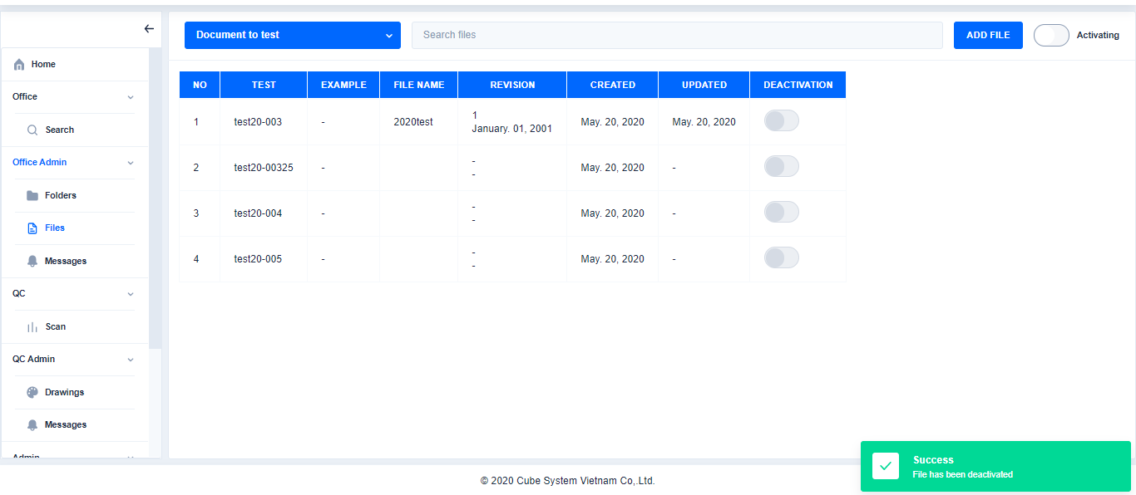

Click

Choose file

Click

※Active

Click

Click Files→Select to All →Select file→Click Activate→Click Yes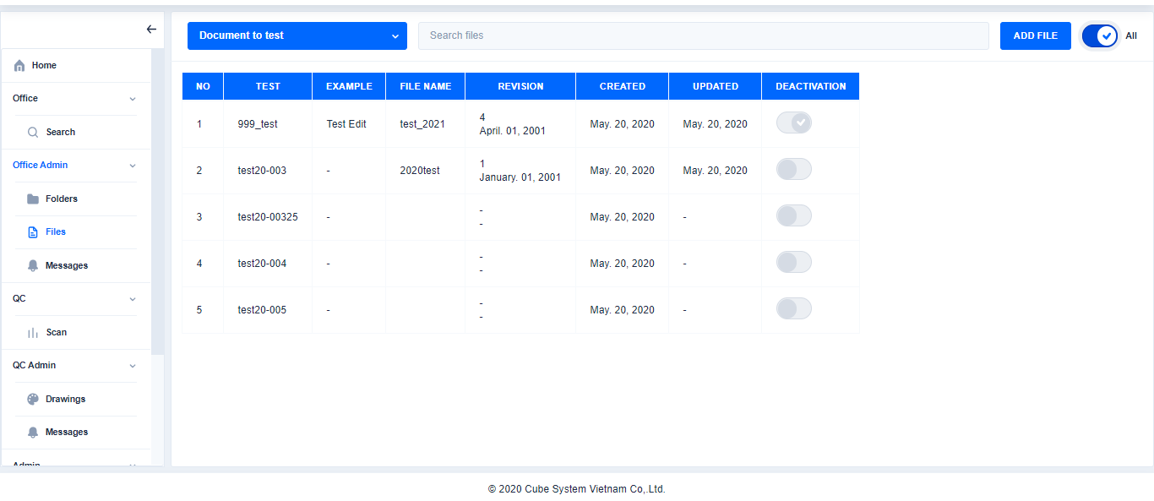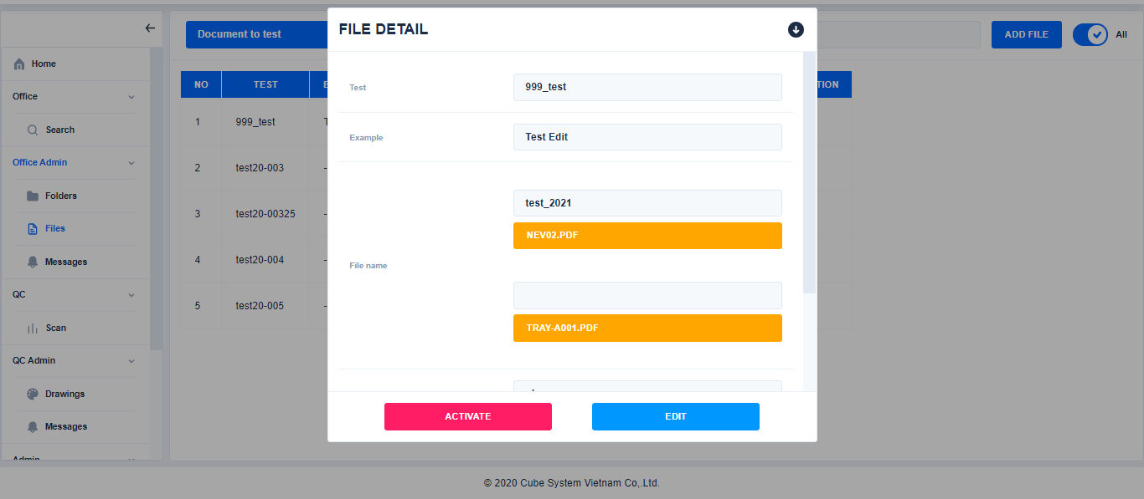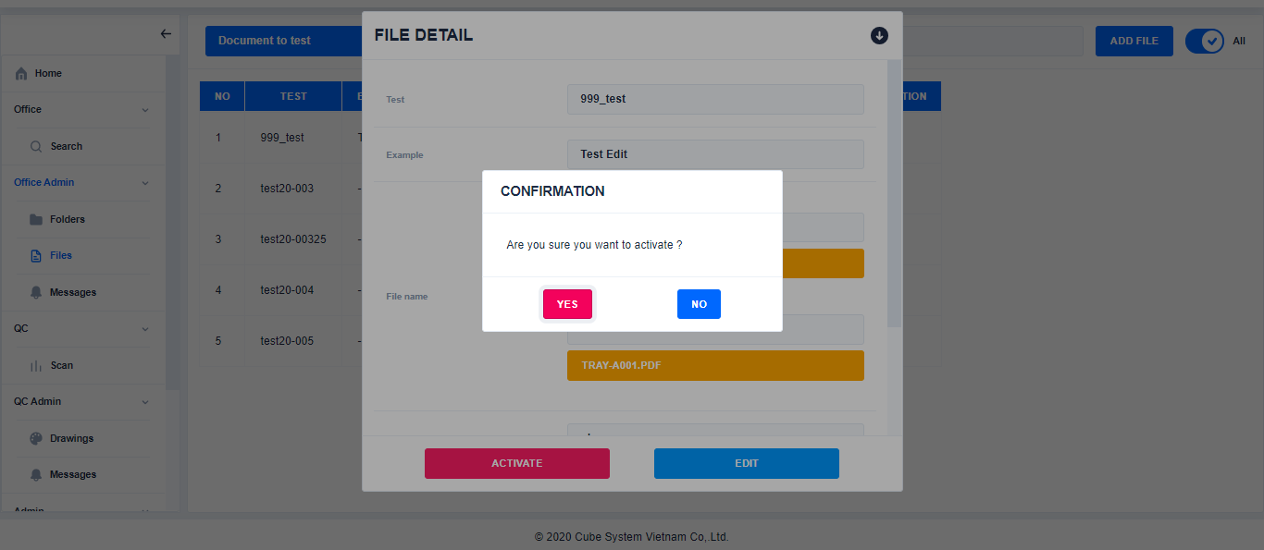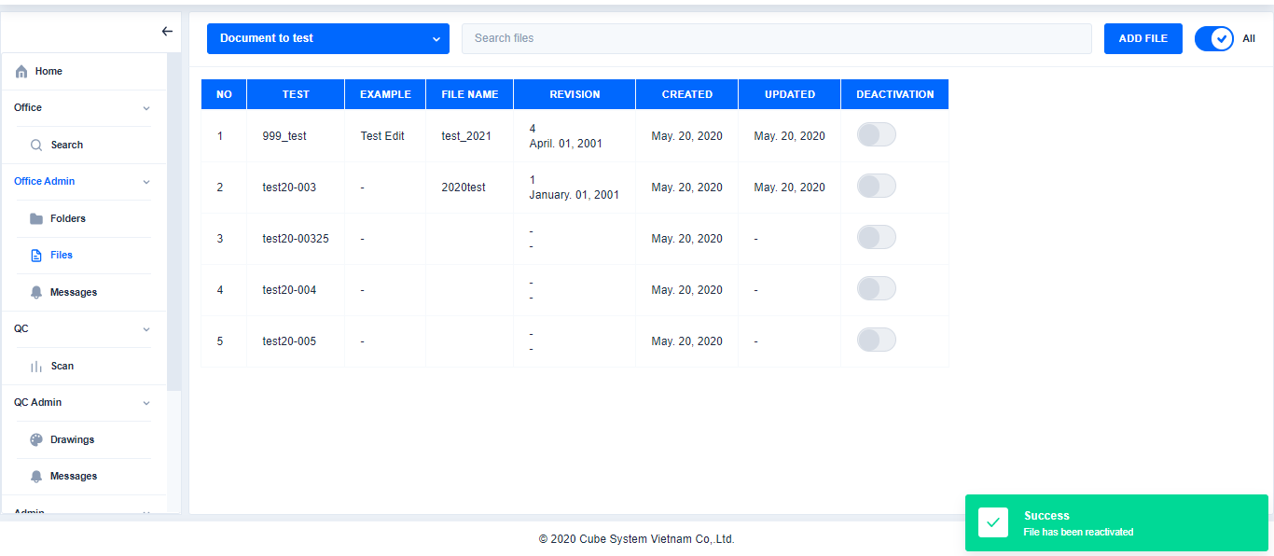

Select file

Select to mode All

Click

※Mode: show or hide Deactivated records

Click

Click

If status of this button is All: Display All the records

If status of this button is Activating: Only display the records that currently activating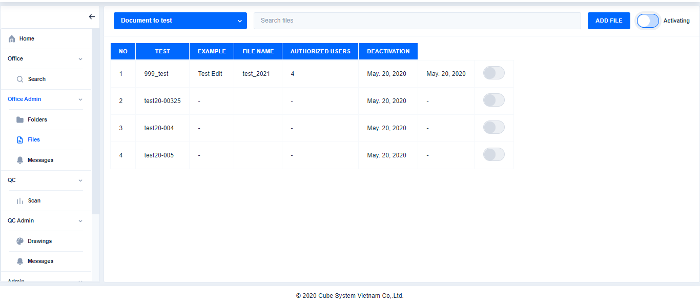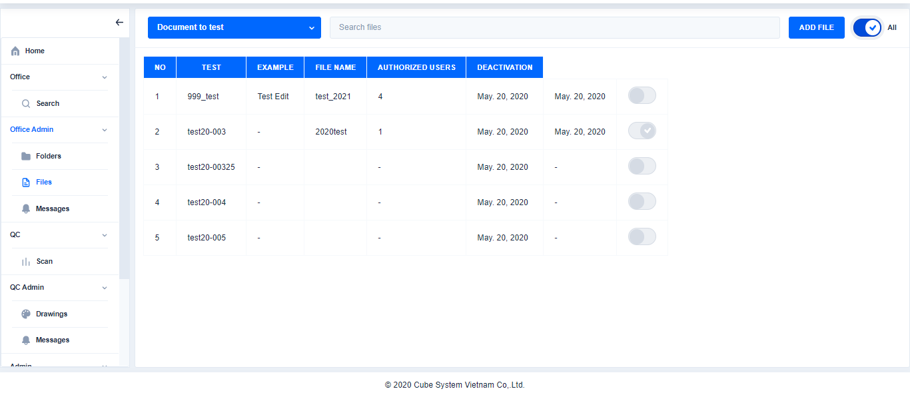

1. **Message****s**
2. Create new message for Office

Click Message→Enter the content→Click Save

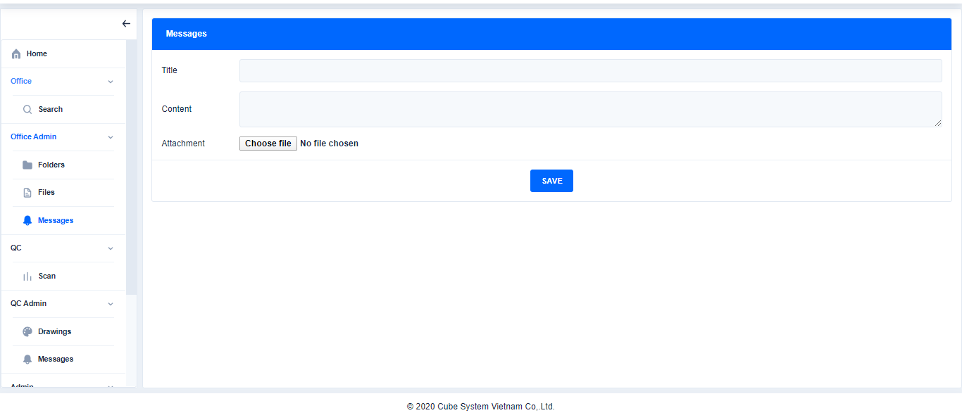

Enter the Title, Content, Attachment file

Click

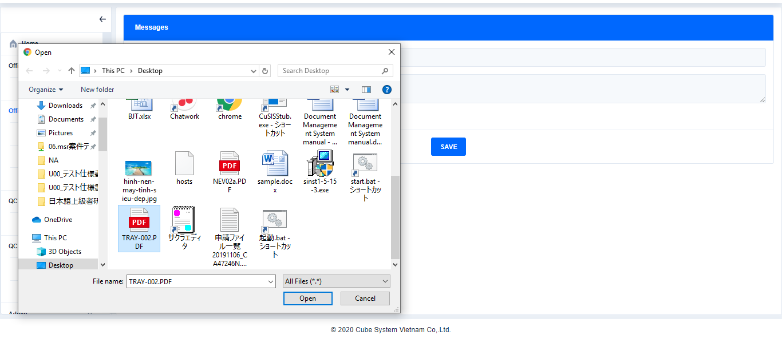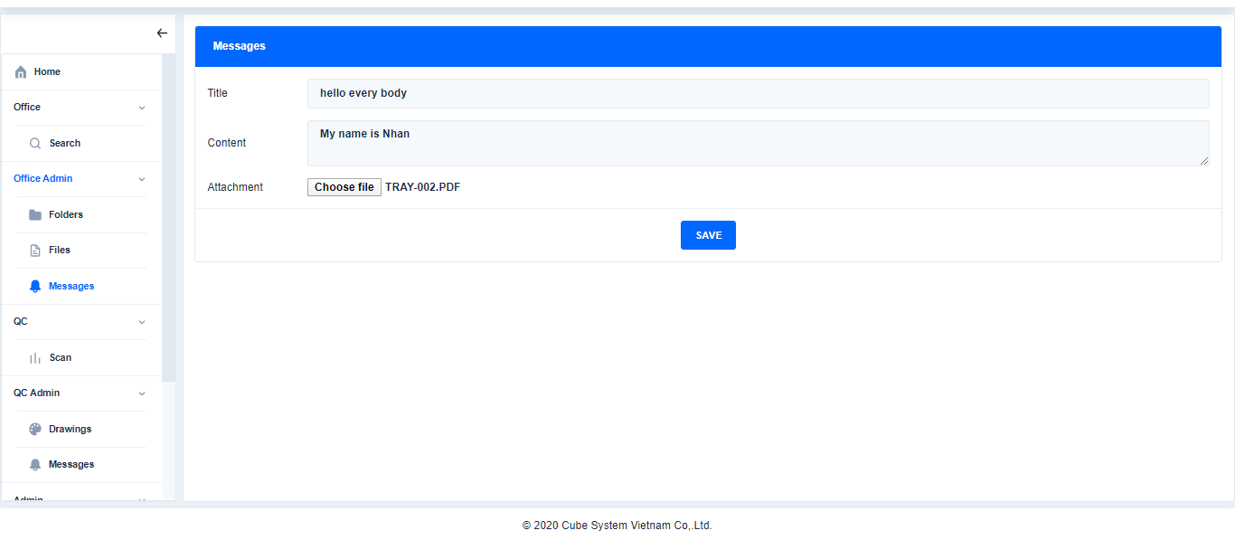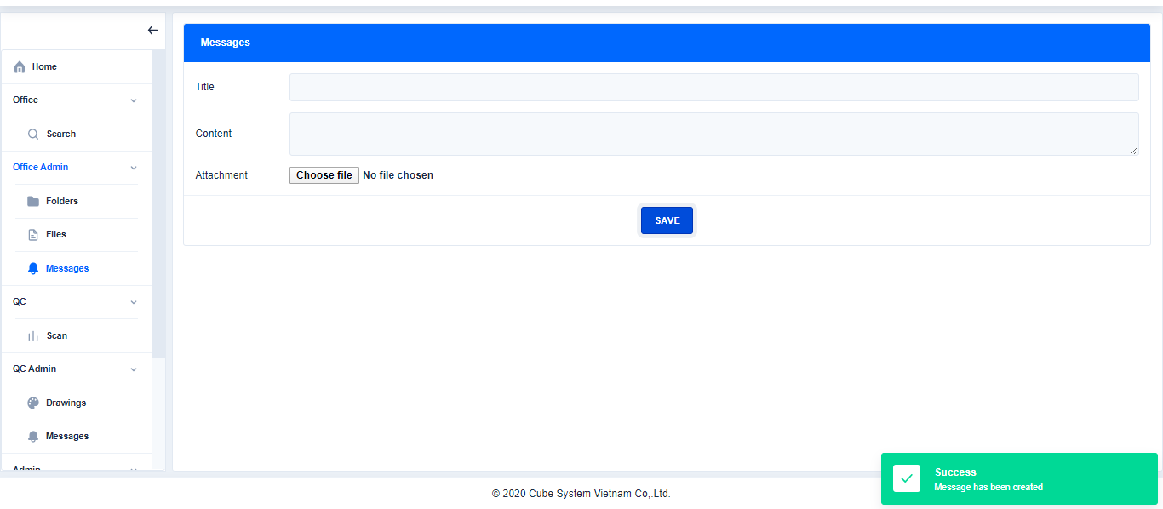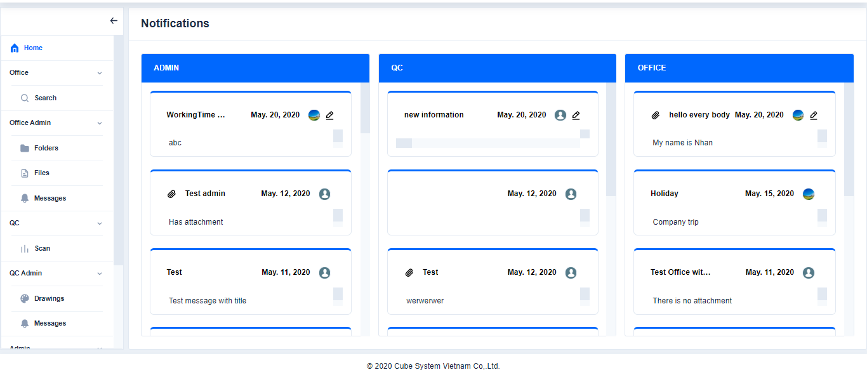

Click here to choose file or double click on file to add file

Click

Click

1. **QC**
2. **Scan**
3. Barcode Reader

Click Scan→Click Barcode→Enter or Scan the code

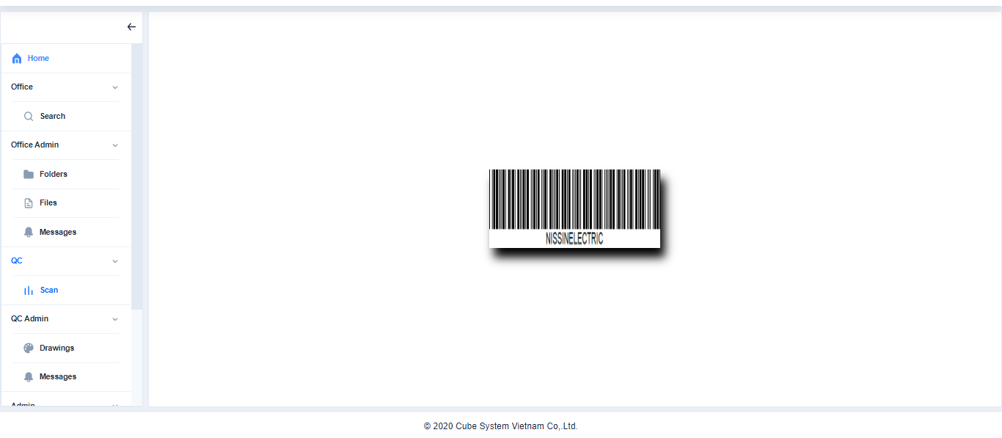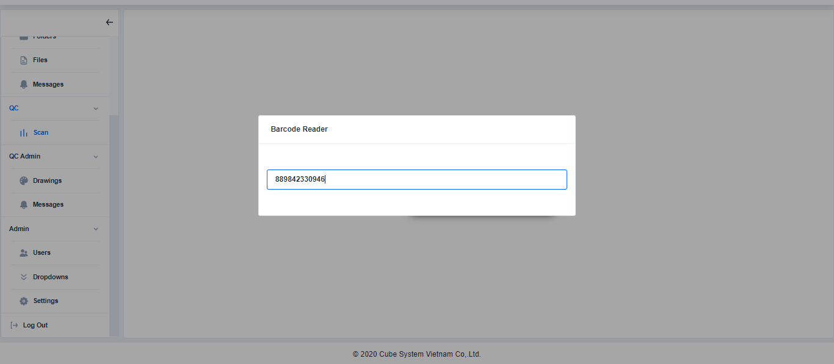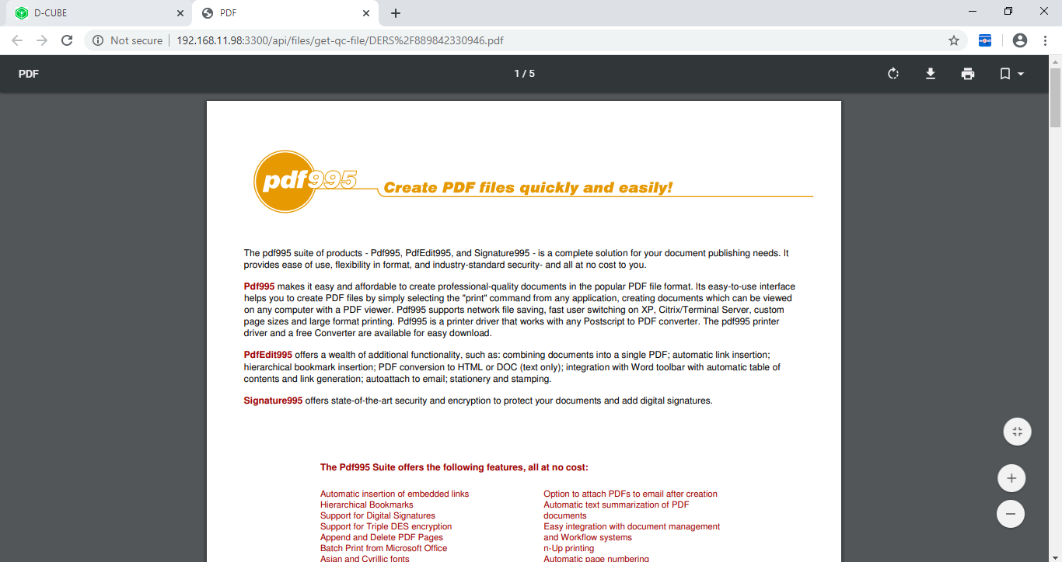

Click

1. **QC Admin**

Enter or Scan the code

1. **Drawings**
2. Search drawings in **Files Explorer**

Click Drawings→Seach drawing

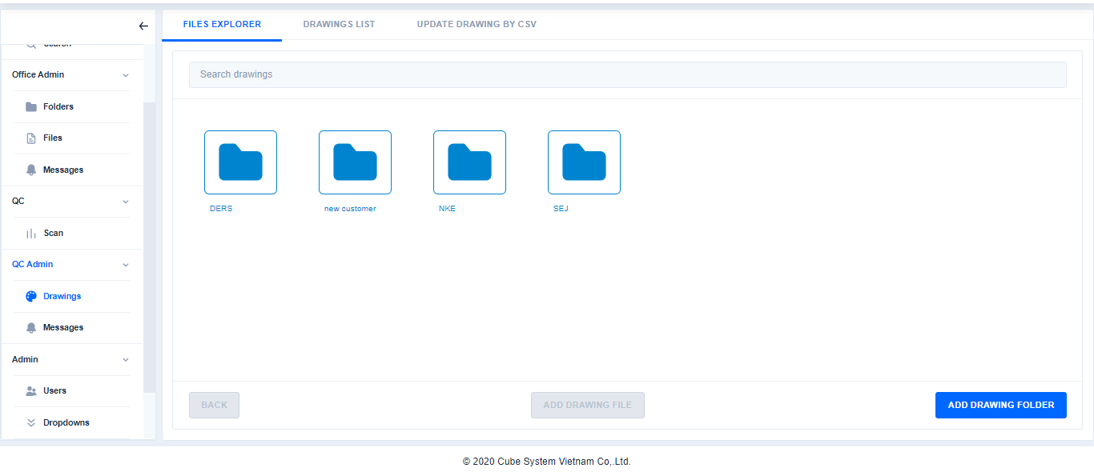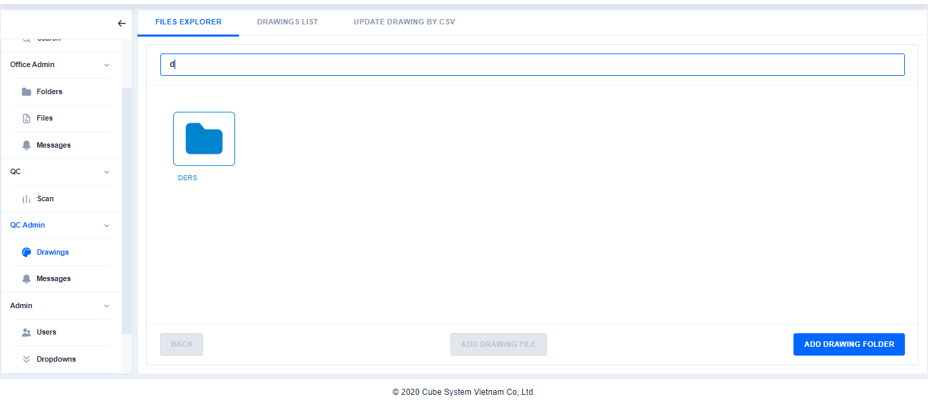

Search drawing

Click

1. Add drawings folderin **File Explorer**

Click Drawings→Click Add drawings folder

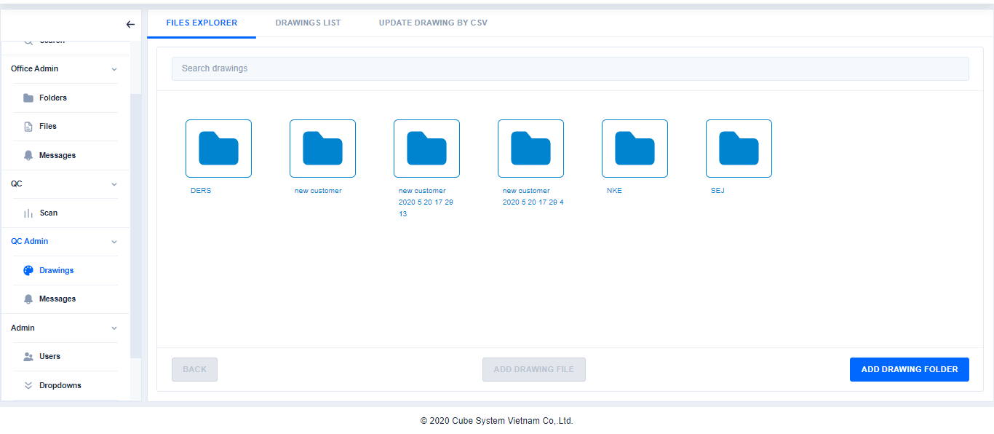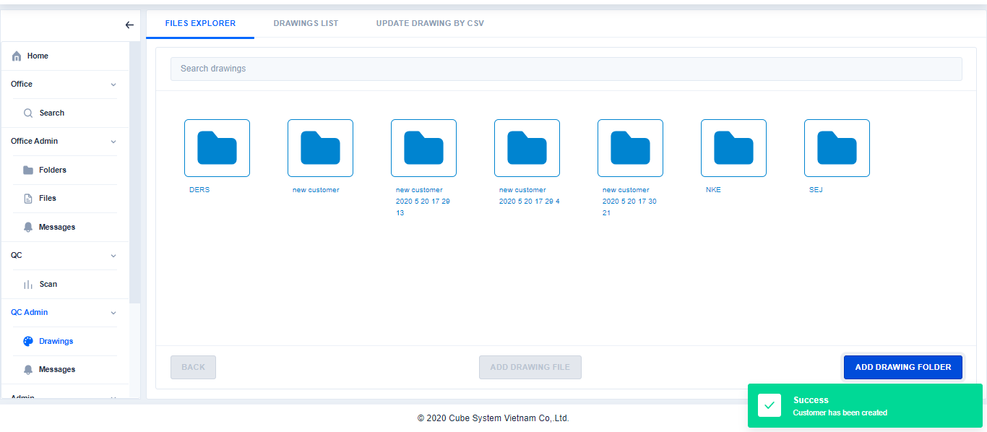

Click

Click

1. Add drawings file in **File Explorer**

Click Drawings→Choose Drawing folder→Click Add Drawing file

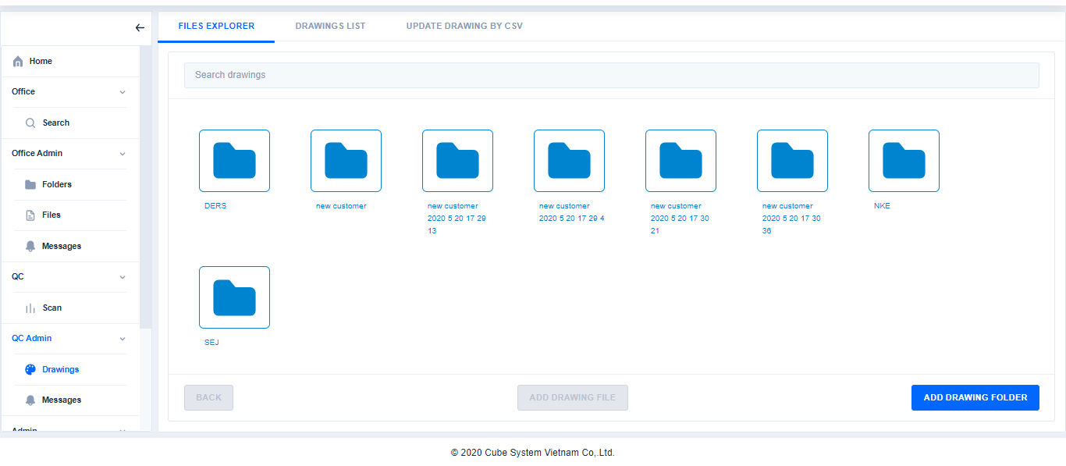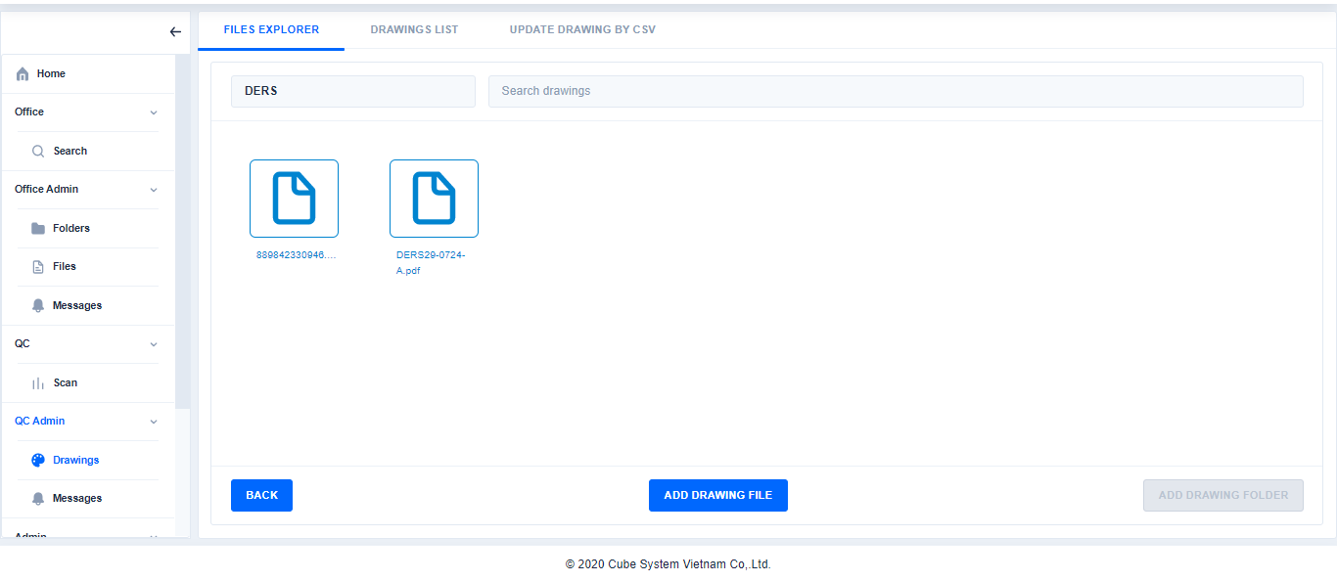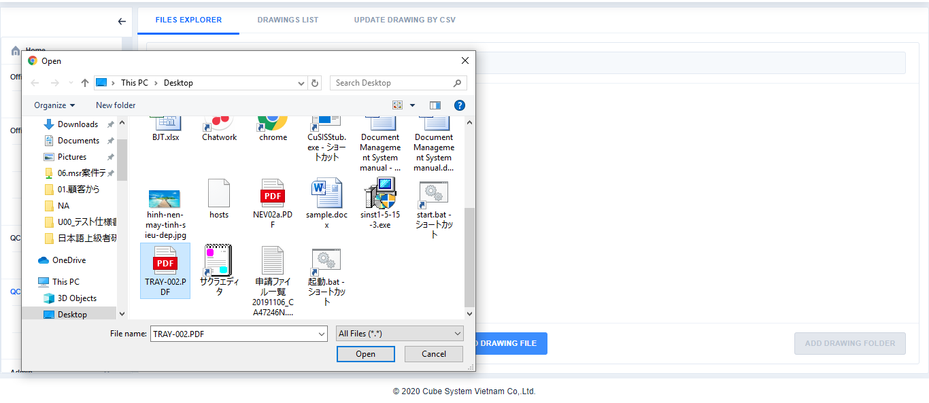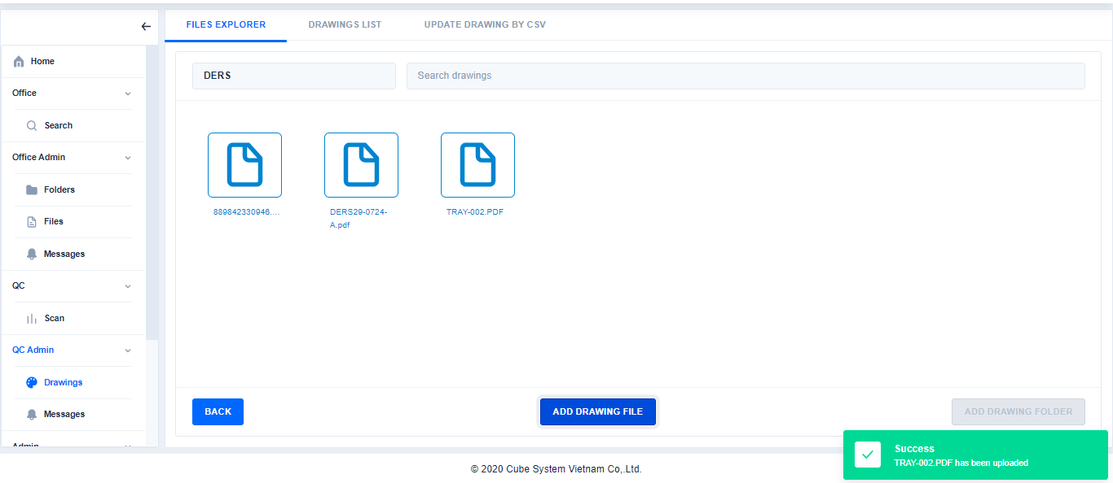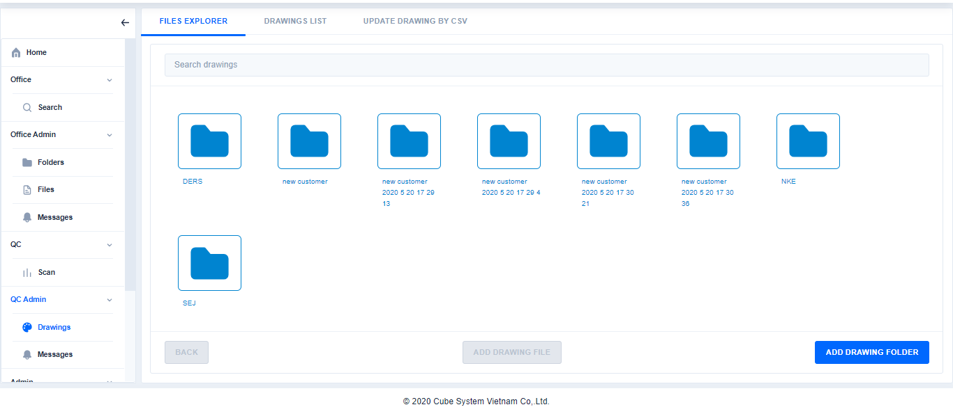

Click

Choose Drawing folder

Click

Select the file by double click or click Open

Click to return to the previous page

Click to Add New Customer Folder

1. Search drawings in **Drawings List**

Choose file: double click or clickopen

Choose file: double click or clickopen

Choose file: double click or clickopen

Click Drawings→Click Drawings List→Choose a drawing folder→Search Drawings

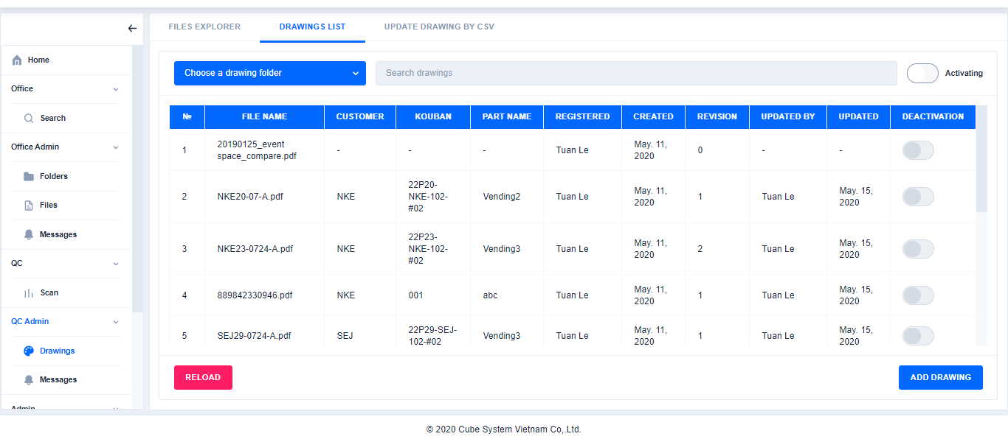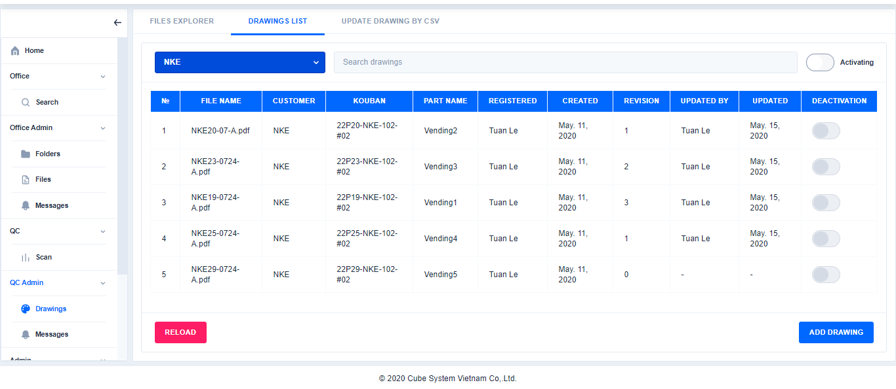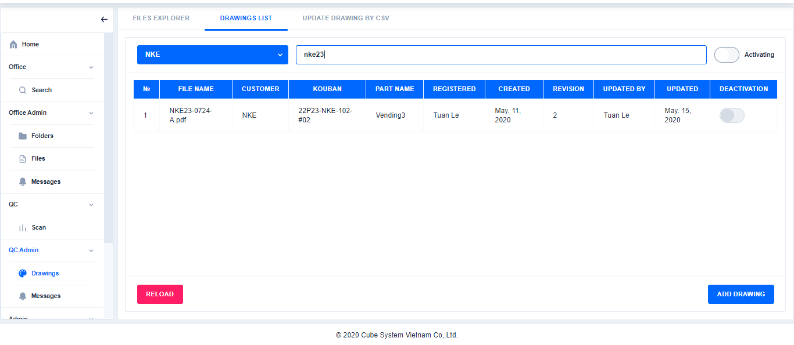

Click

Choose a drawing folder

Click

1. Add drawings in **Drawings List**

Click here to refresh page

Search Drawings

Click Drawings →Click Drawings List→Choose a drawing folder→Click Add Drawing→Enter the content and browse file→Click Create

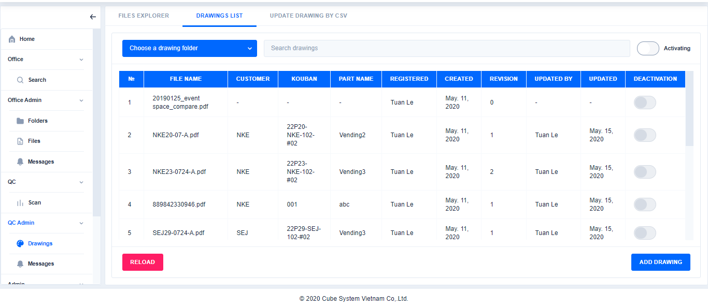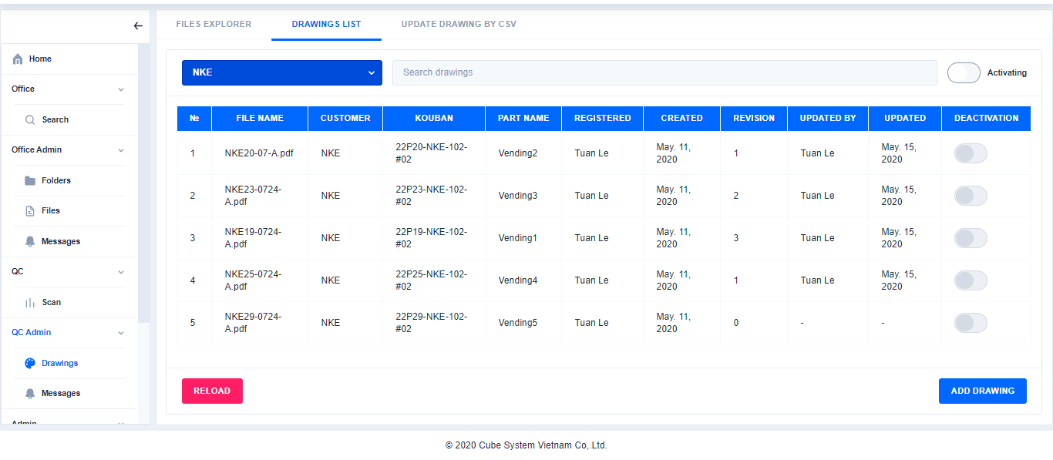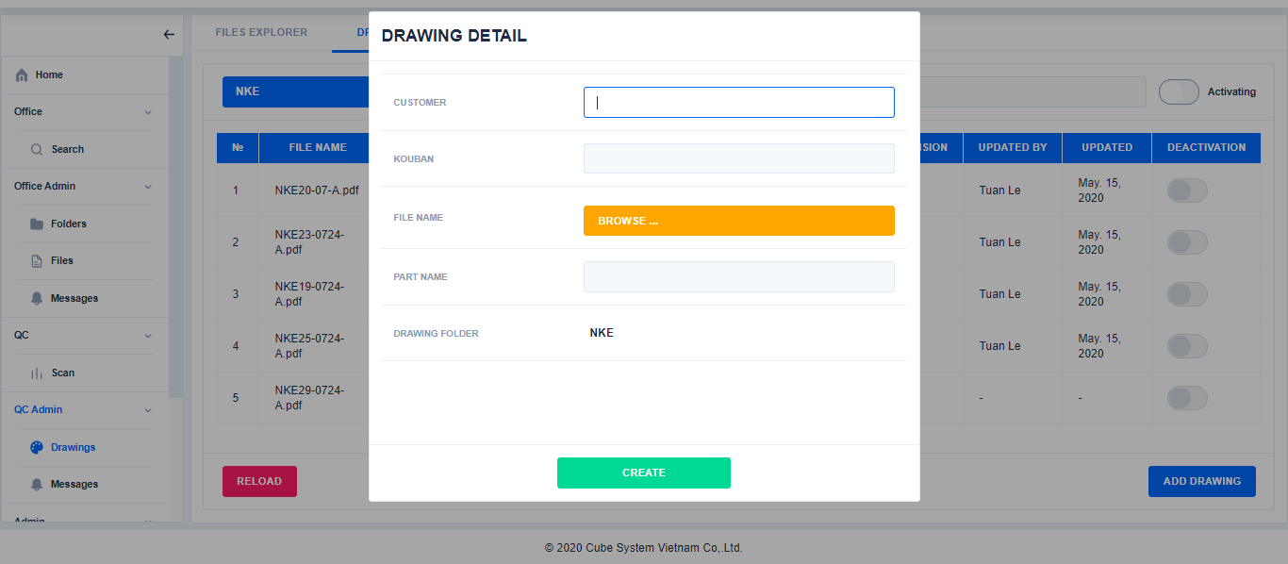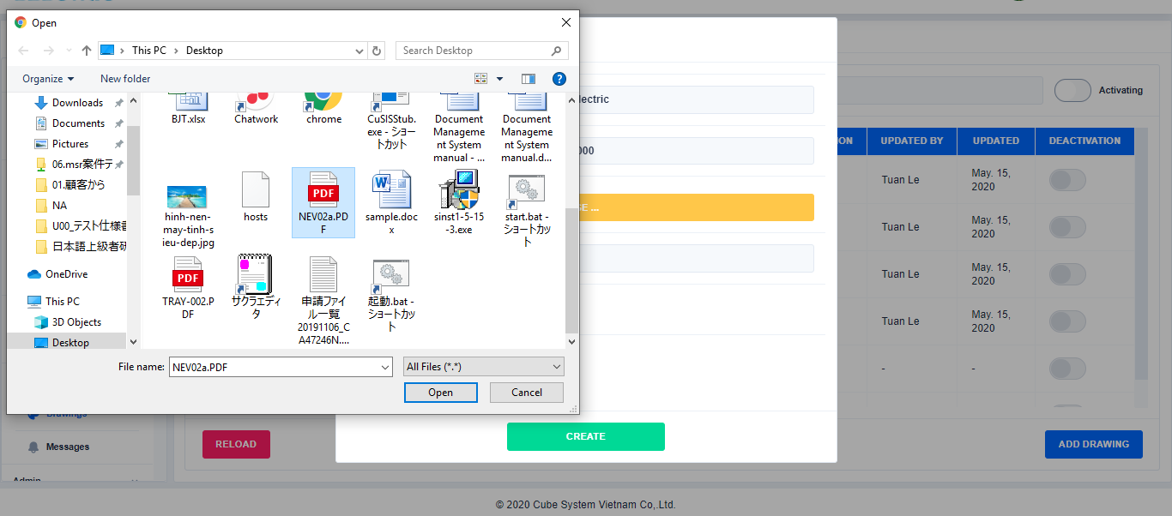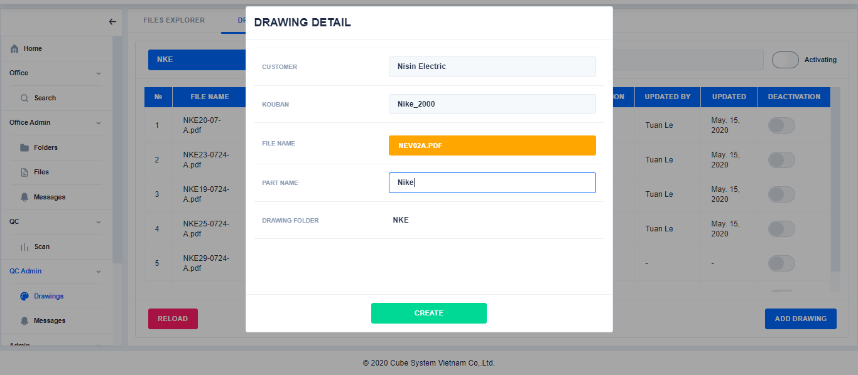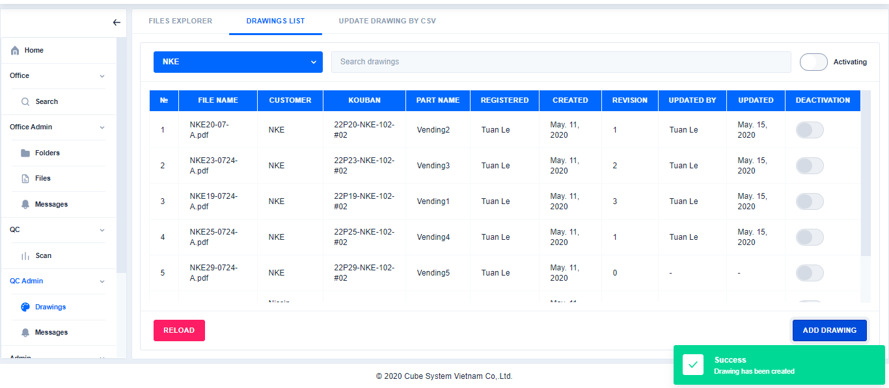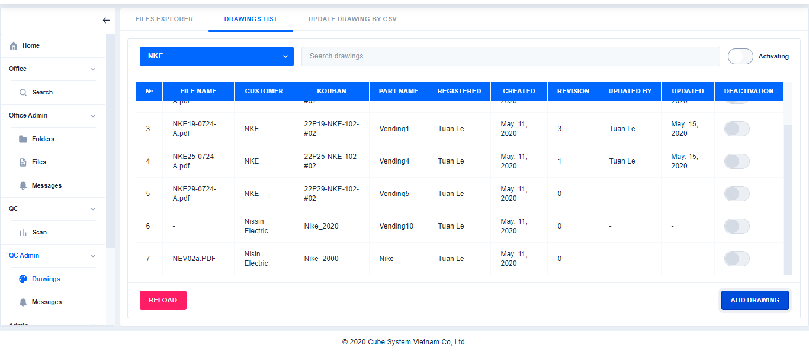

Click

Click

Click

Choose a drawing folder

Enter the content and browse file

Click here to choose file or double click on file to add file

Click

1. Edit drawings in **Drawings List**

Click Drawings→(Choose a drawing folder)→ Select file→Click Edit→Edit a content→Click Save

Choose a drawing folder(If necessary)

Select to file

Click

※Active or deactive files can be edited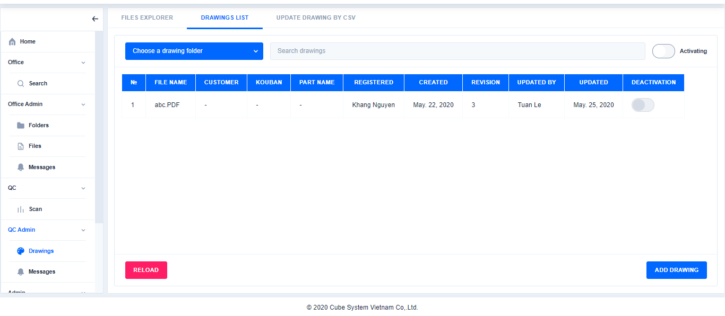 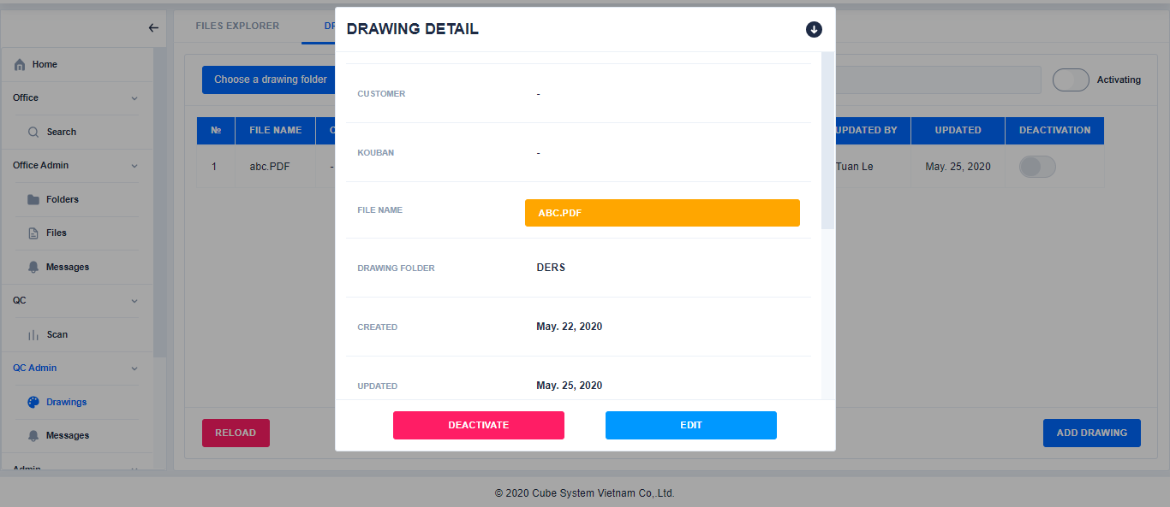 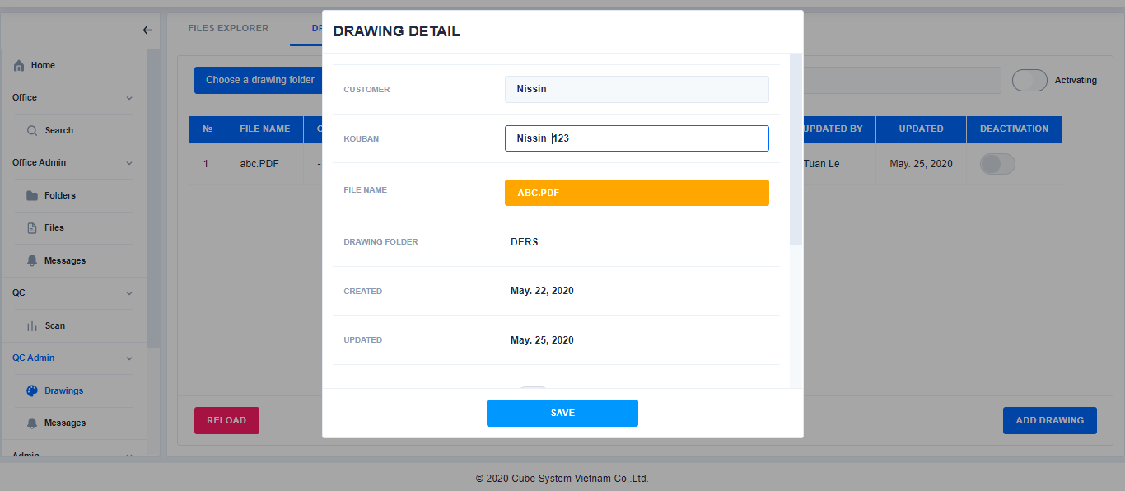 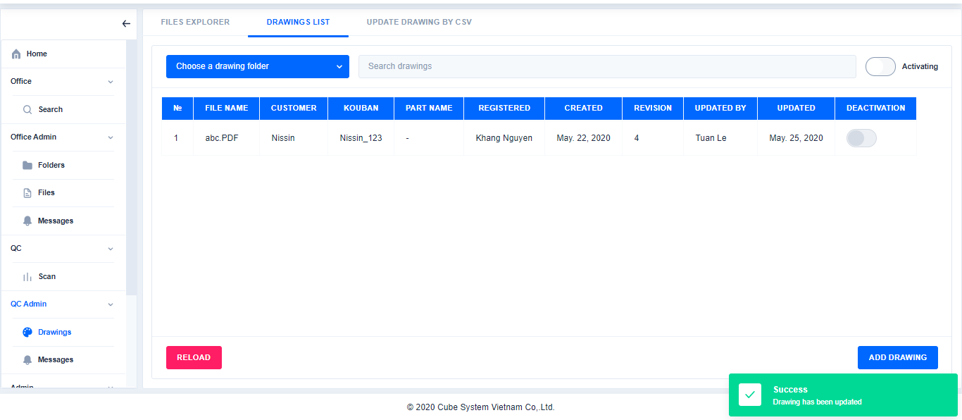

Click

1. Deactivate drawings in **Drawings List**

Click to refresh page

Click

Edit a content

Click Drawings→(Choose a drawing folder)→ Select to file→Click Deactivate→Click Yes

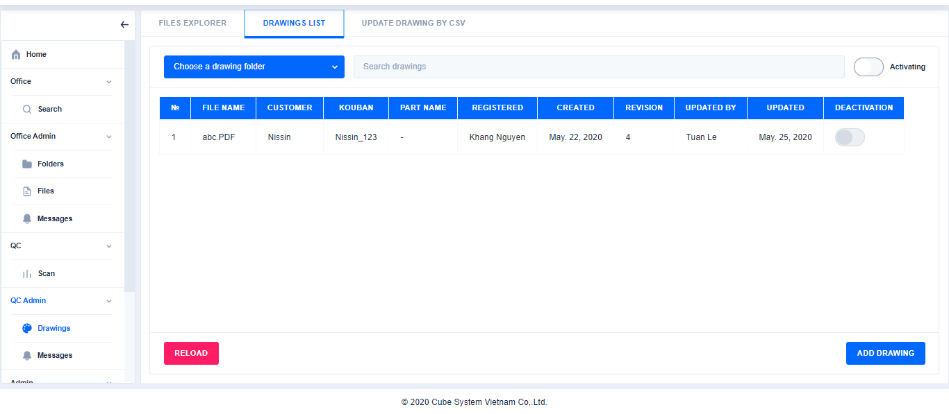 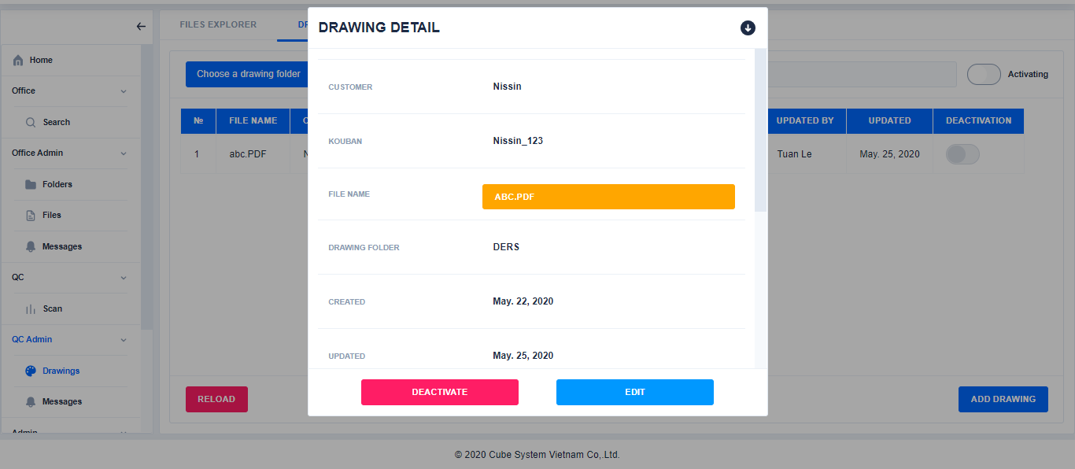 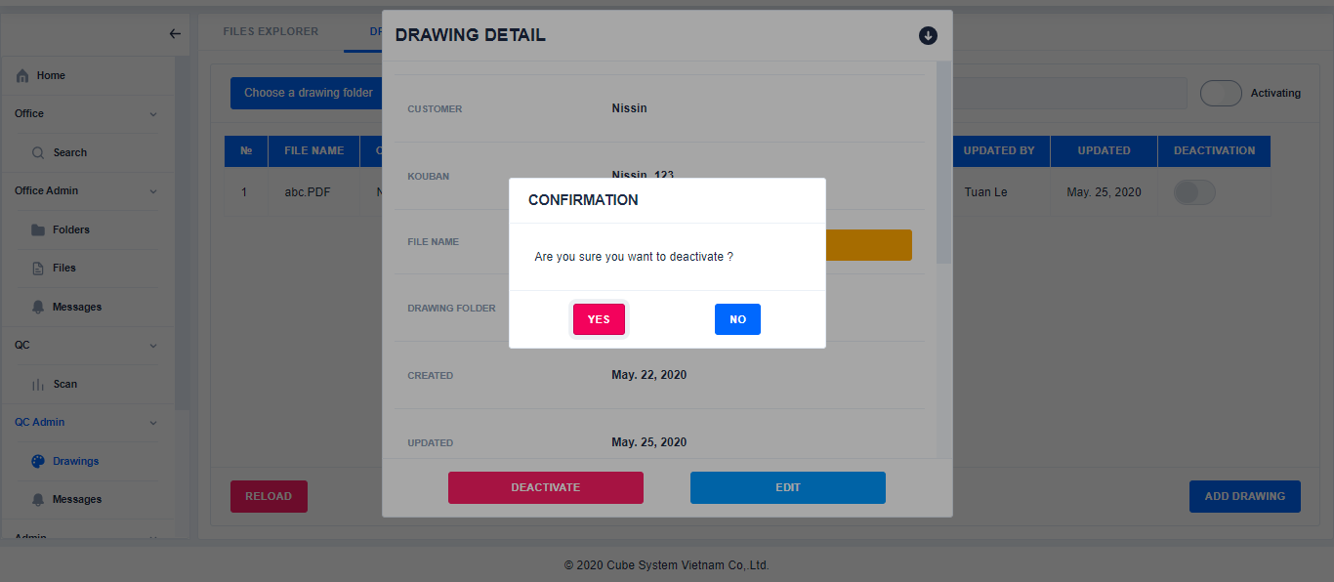 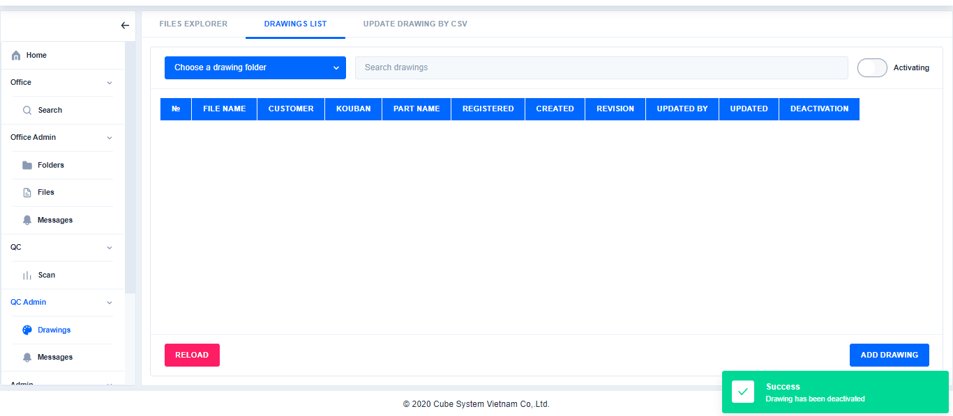

Click

Click

Select to file

Choose a drawing folder(If necessary)

Click

Click

1. Activate drawings in **Drawings List**

Click Drawings→Choose a drawing folder( If necessary)→Switch status to All→Select to file→Click Activate→Click Yes

※When click the deactivate or activate button, the file in physical disk will be deleted, only properties's info remains

Switch status to All

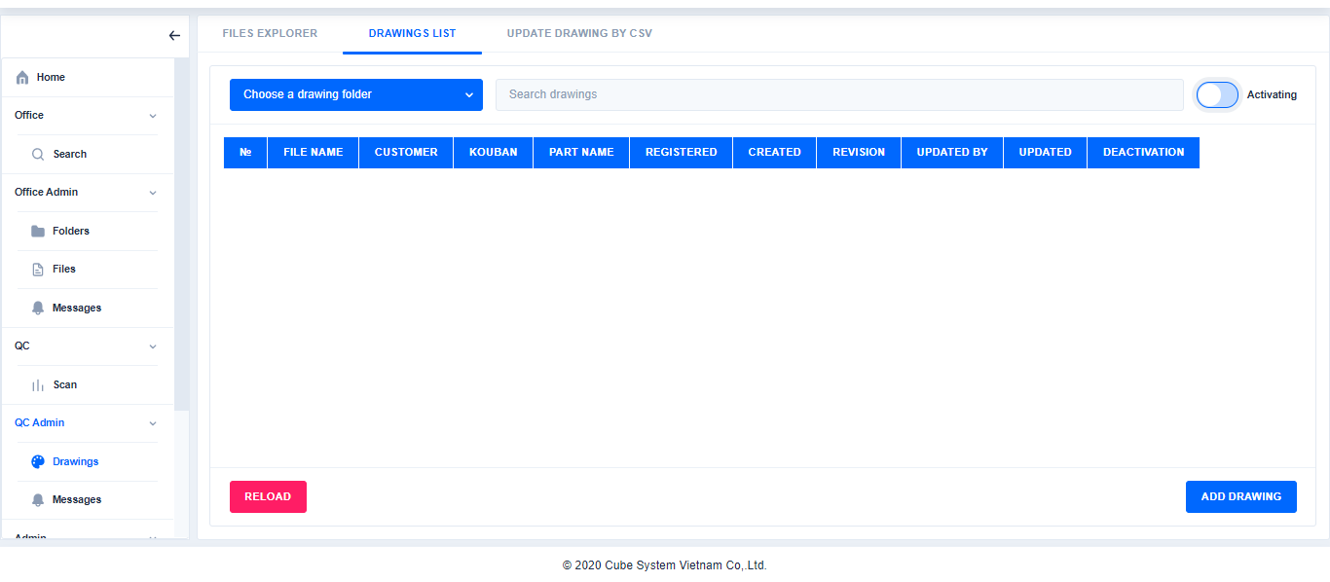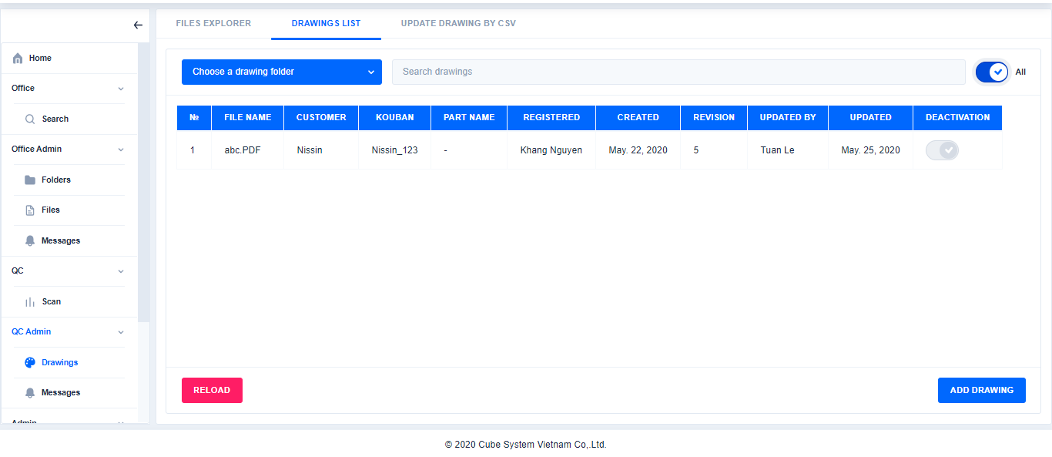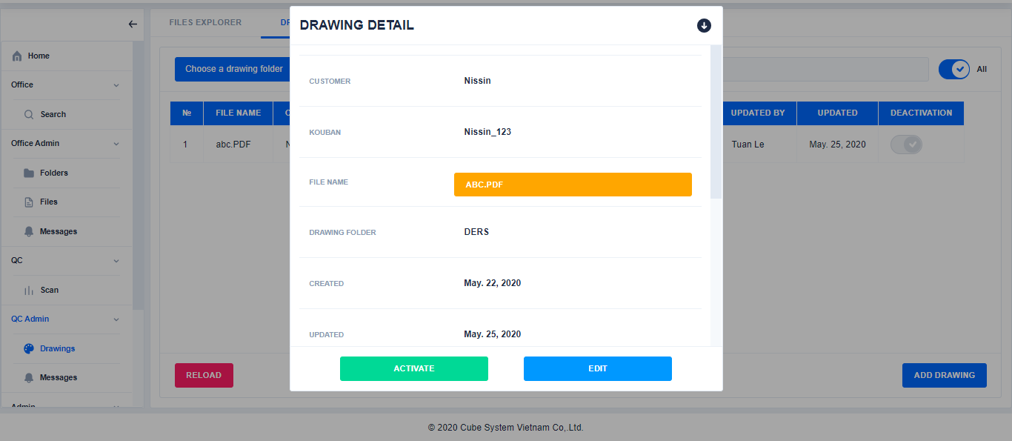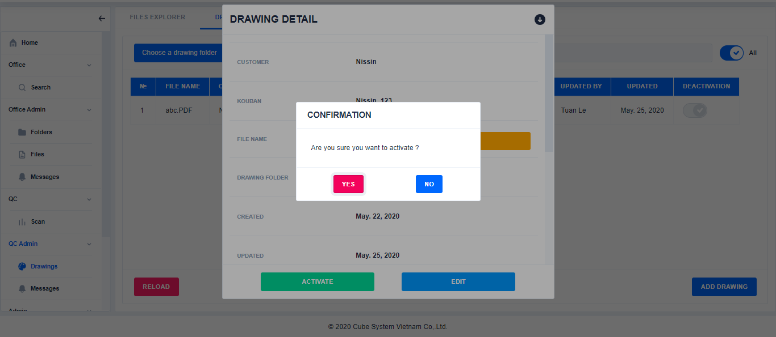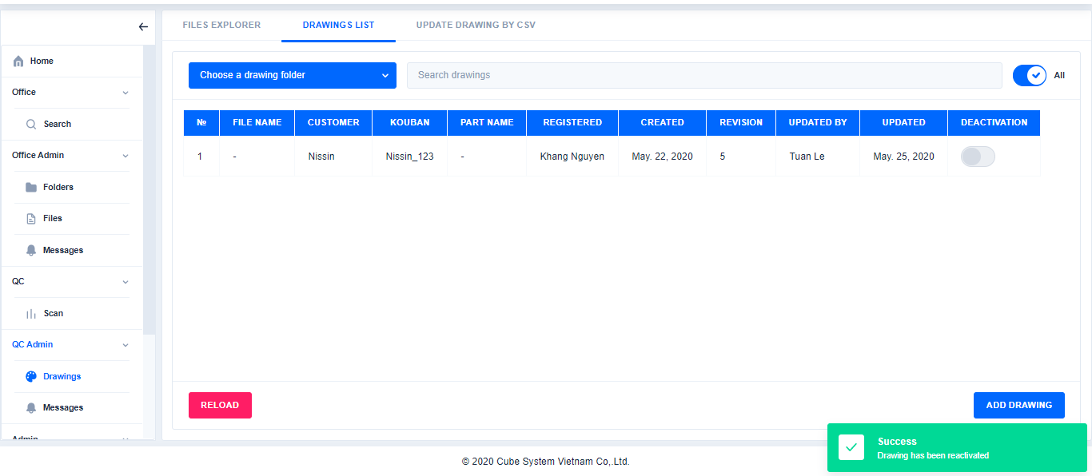

Click

Select to file

Choose a drawing folder(If necessary)

Click

1. Show history of drawing

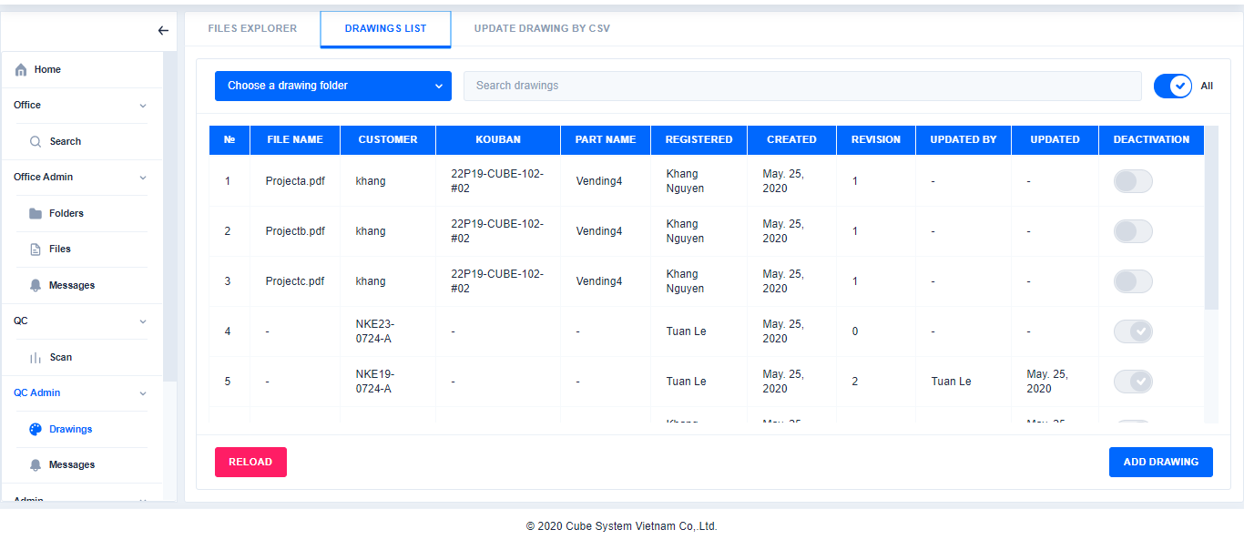

Select file

Click

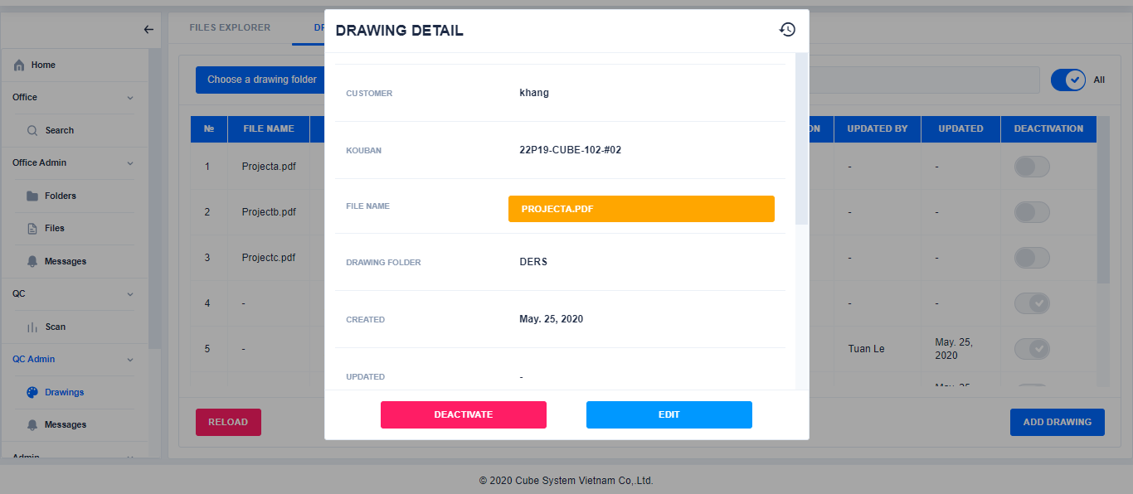

Click

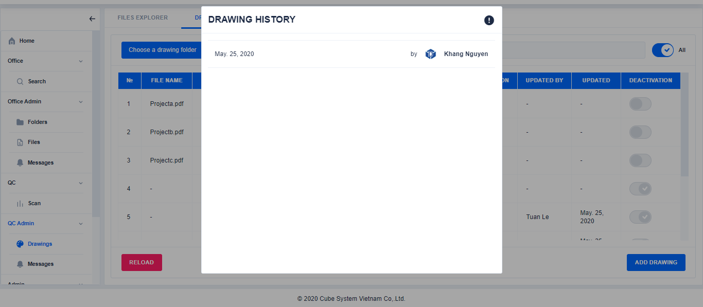

**Error! Not a valid bookmark self-reference.**※In order to Update using csv file, files must have already been existed in the physical disk.

The First column in csv file is File name, which will be used to update properties of the file that has the exact same File name. Below is an example of a CSV file

1. Update drawings in **Update drawing by CSV**

※Do step j→Search file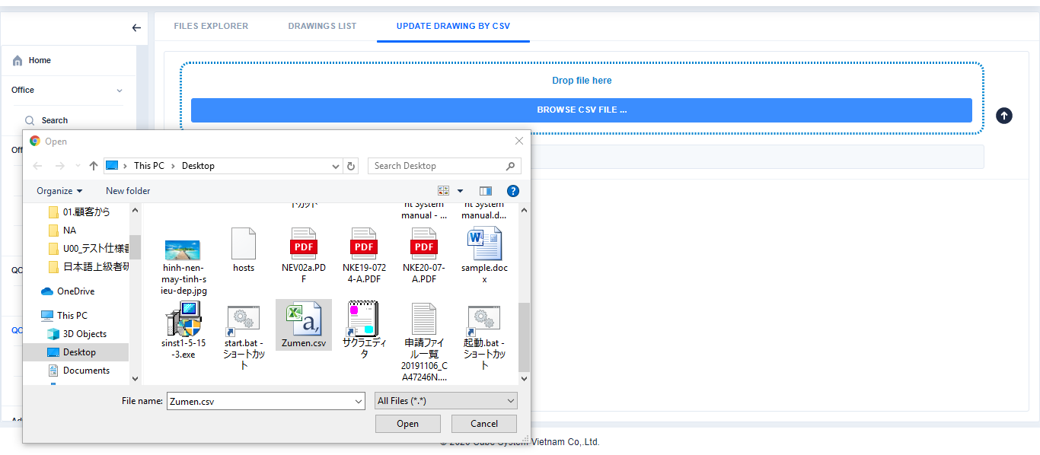

Drop file or browse CSV file

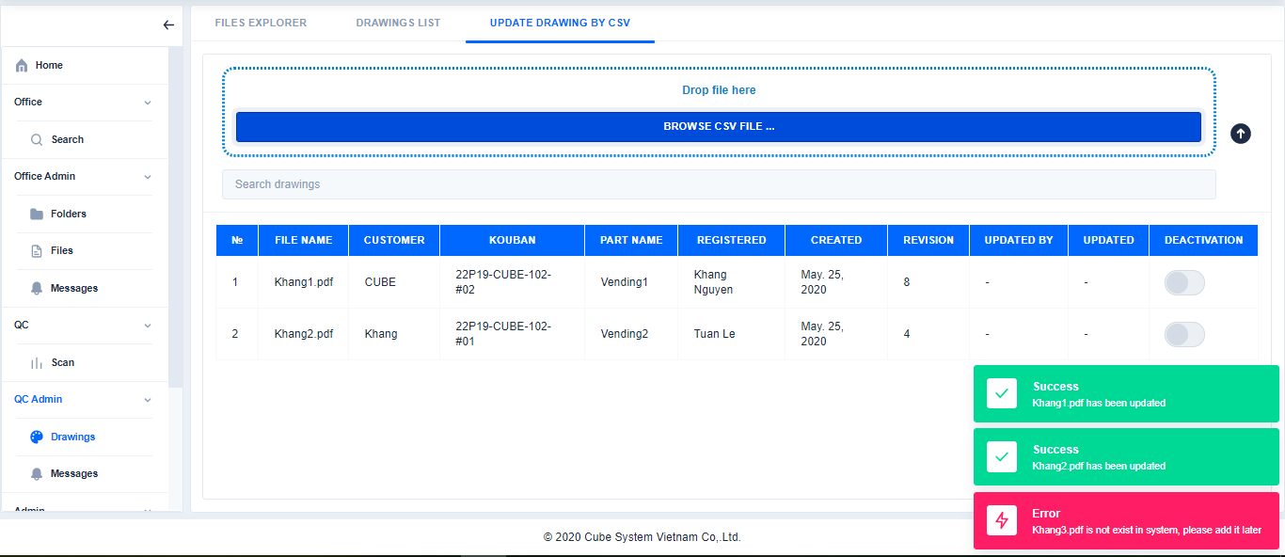

Search file

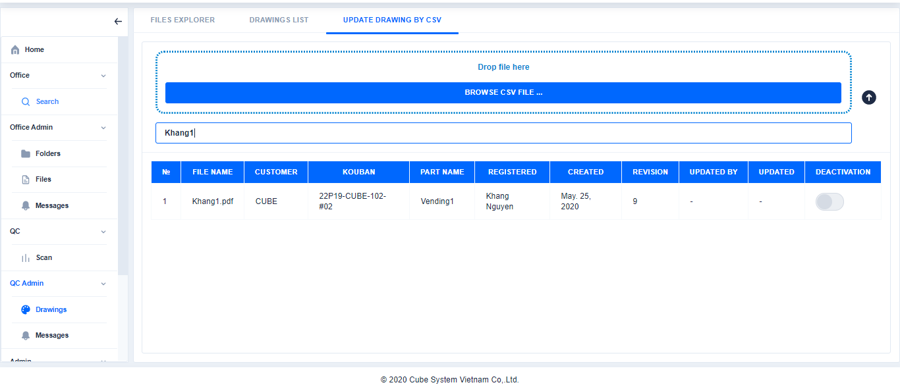

1. Search drawings in **Update drawing by CSV**

※Do step j→Search file

Drop file or browse CSV file



Search file



1. Edit drawingsin **Update drawing by CSV**

※Do Step j to display file in Update Drawing by CSV→Select file→Click Edit→Edit the content→Click Save

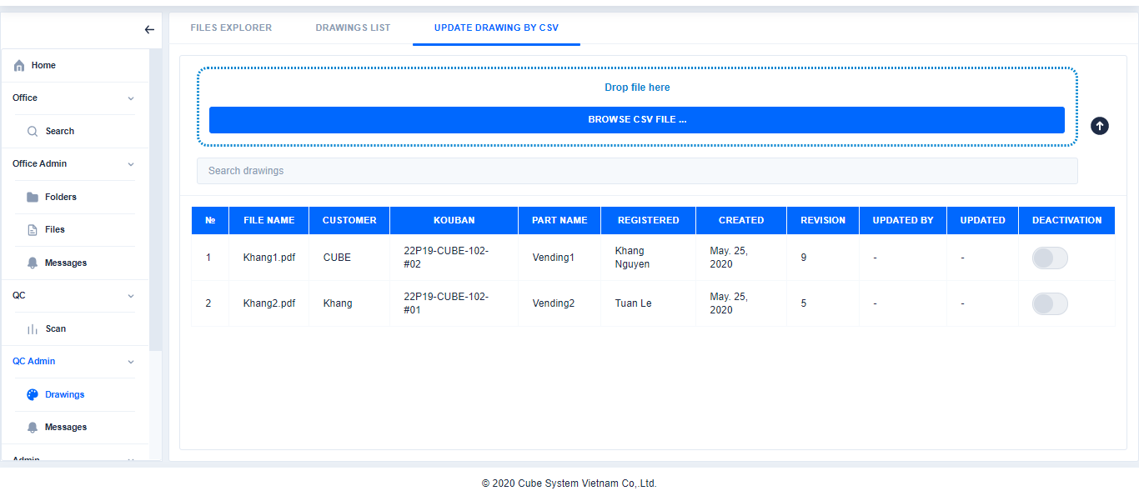 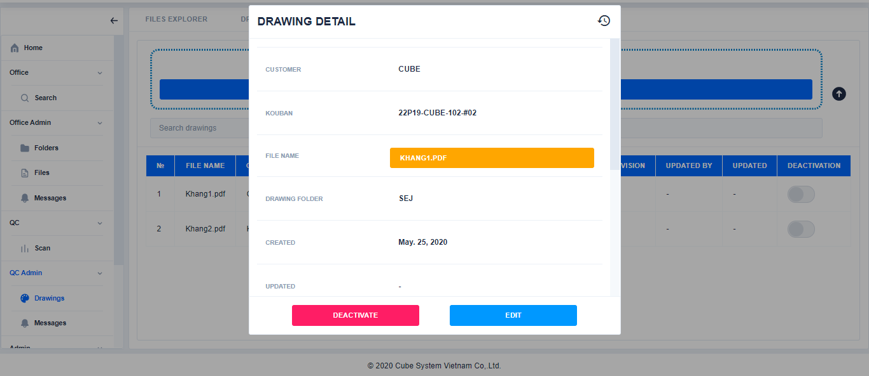 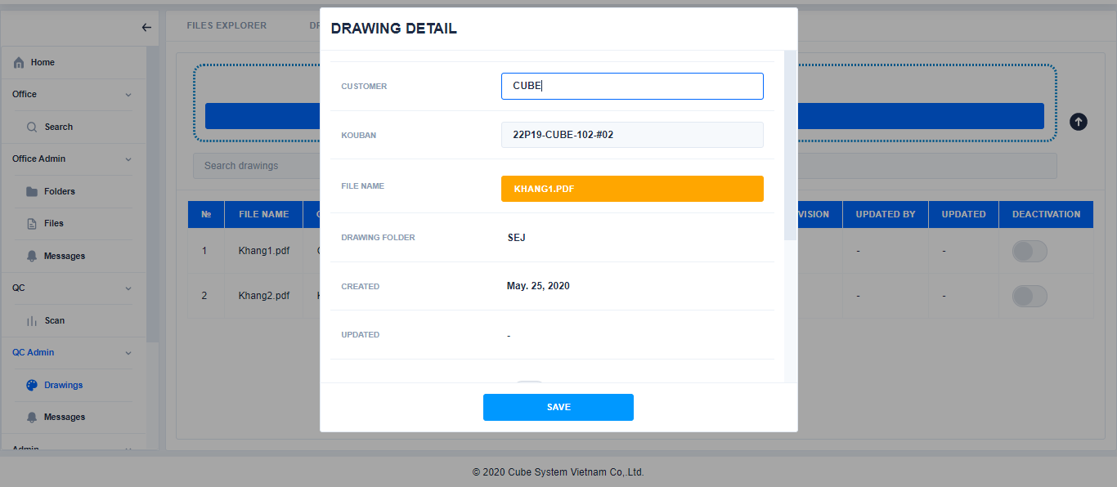 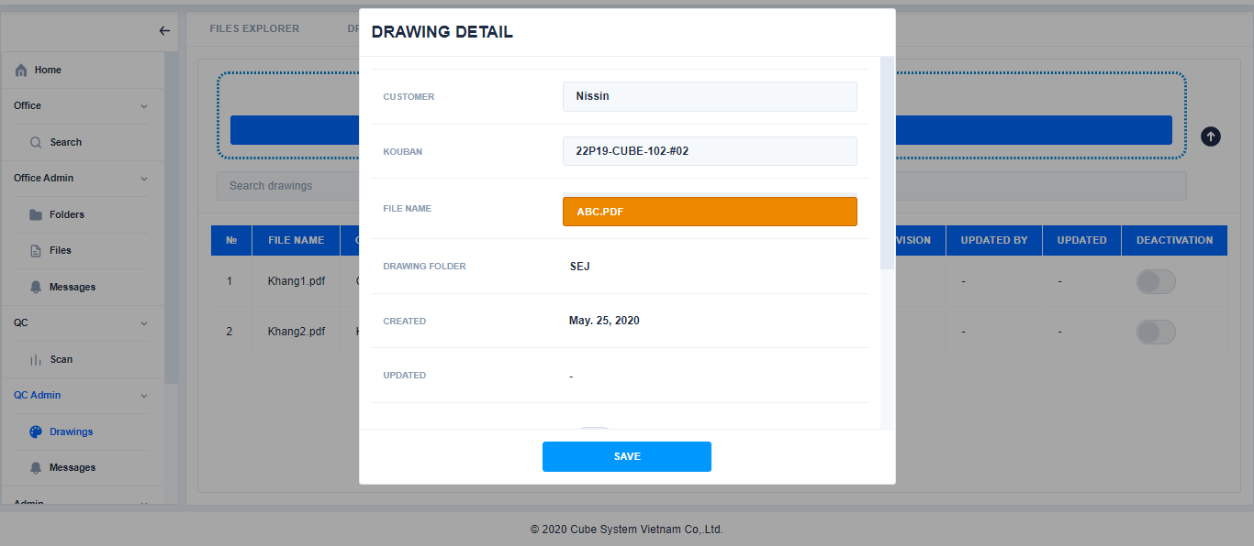 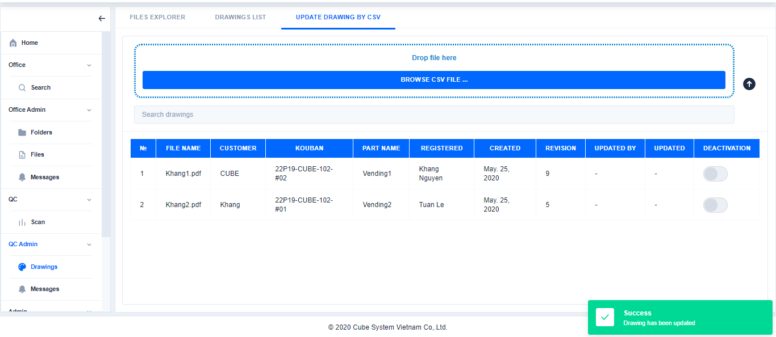 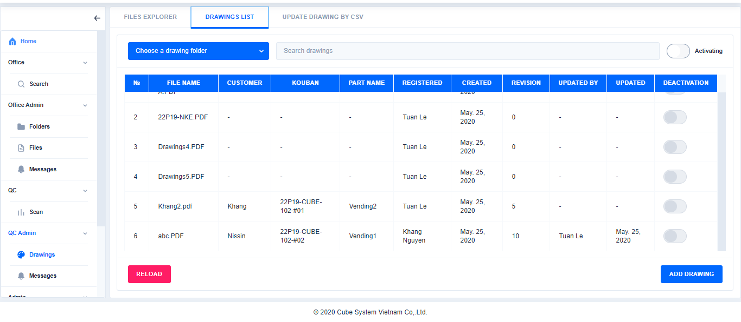

Click

Click

Edit the content

Edit the content

1. Deactive drawings in **Update drawing by CSV**

If necessary , click here to refresh page

Click

※Do Step j to display file in Update Drawing by CSV→Select file→Click Deactive→Click Yes

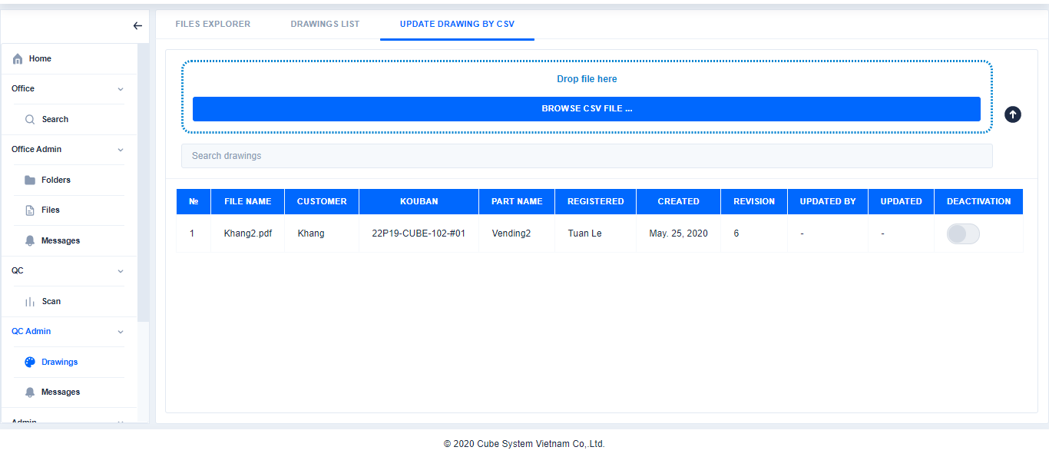 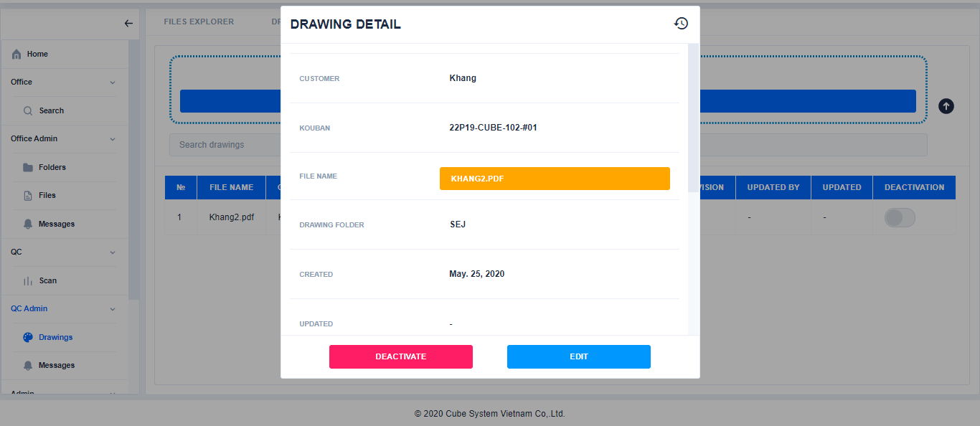 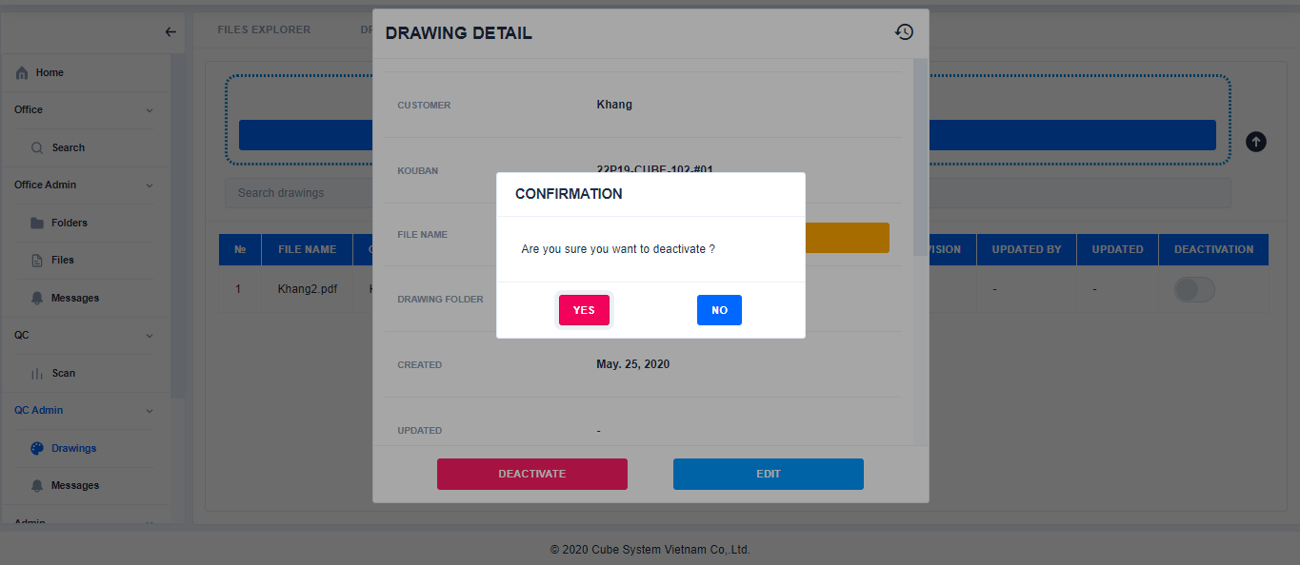 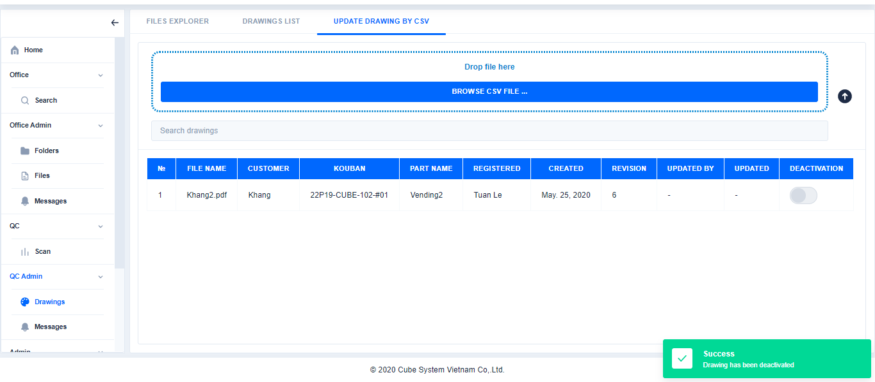 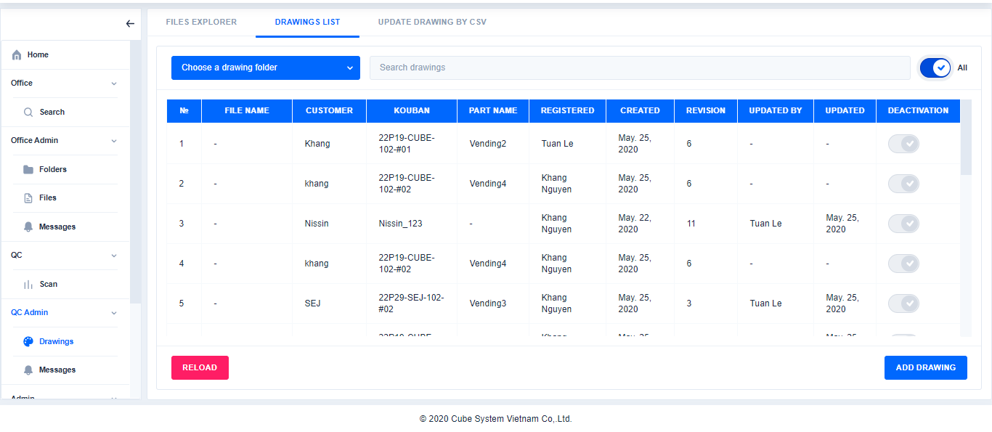

Click

Select file

Click

1. **Messages**

If necessary , click here to refresh page

1. Create new message for QC

Click Message→Enter tile and content→Choose file→Click Save

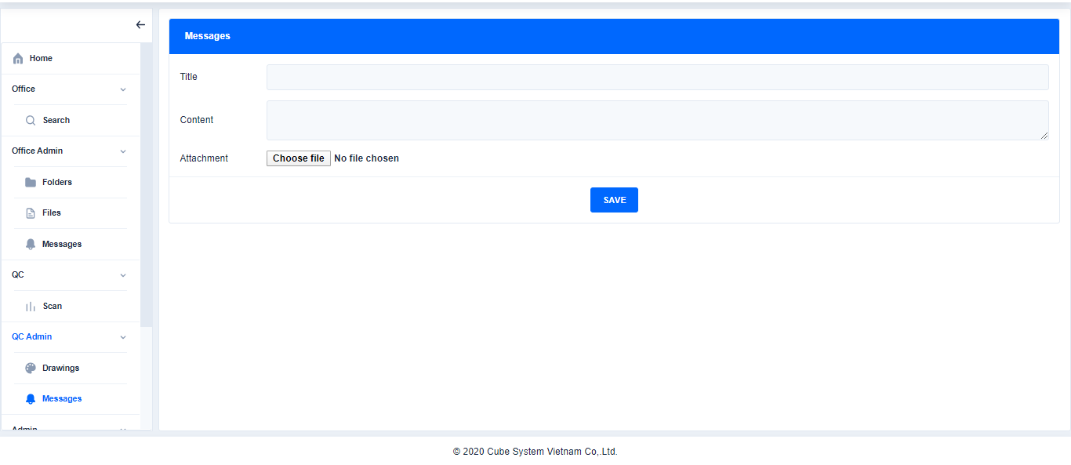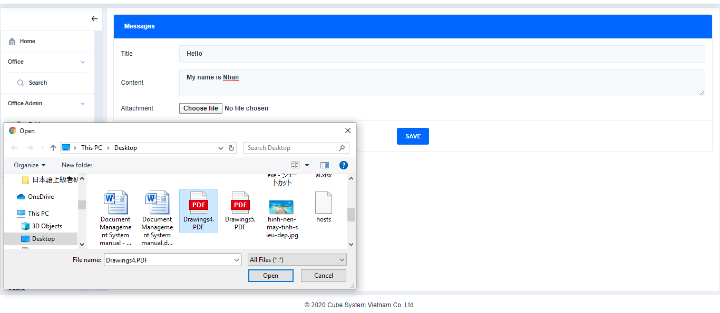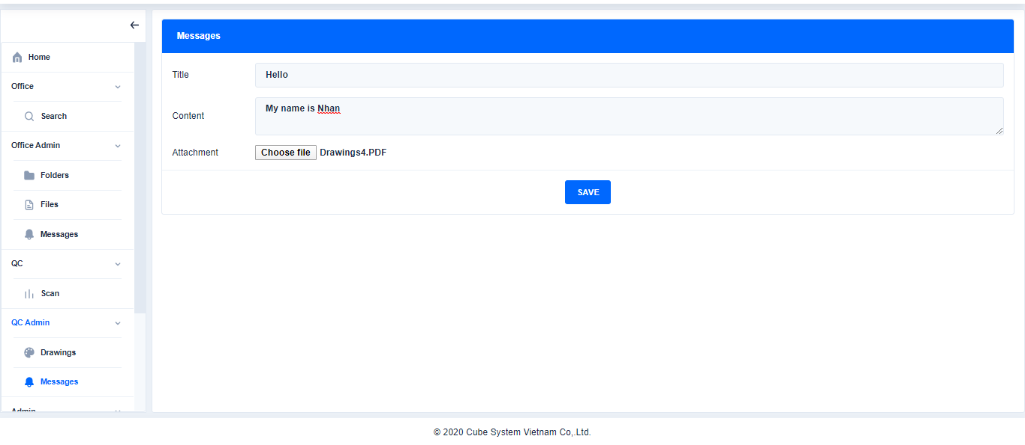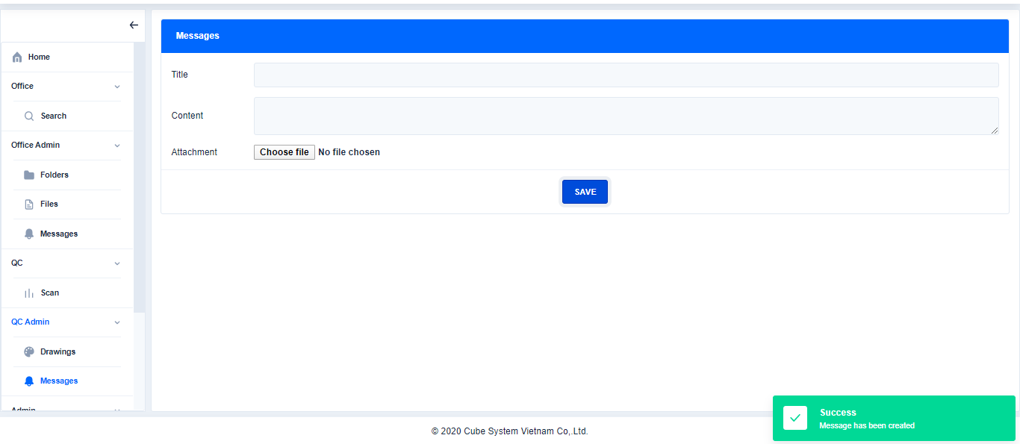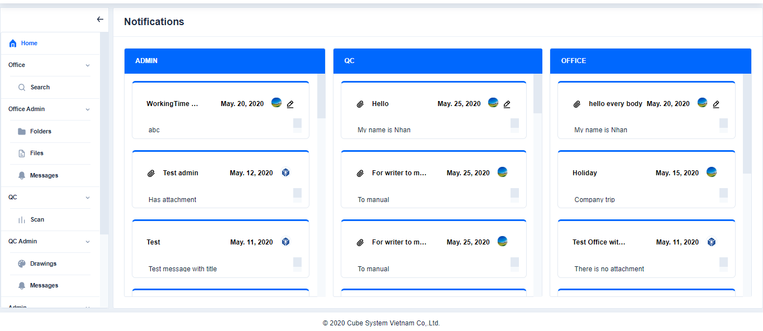

Click

Click

Choose file

Enter title and content

Click

1. **Admin**
2. **User**
3. Mode show or hide Deactivated records

Click or 

※If status of this button is All: Display All the records

If status of this button is Activating: Only display the records that currently activating

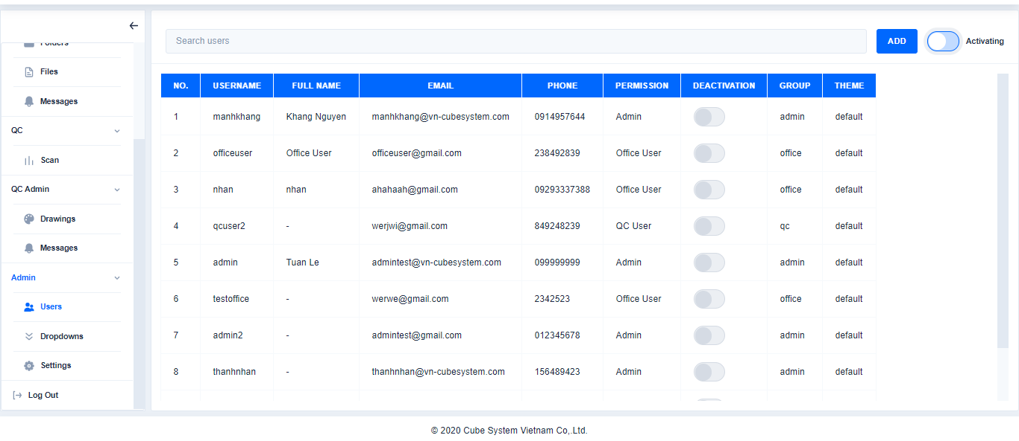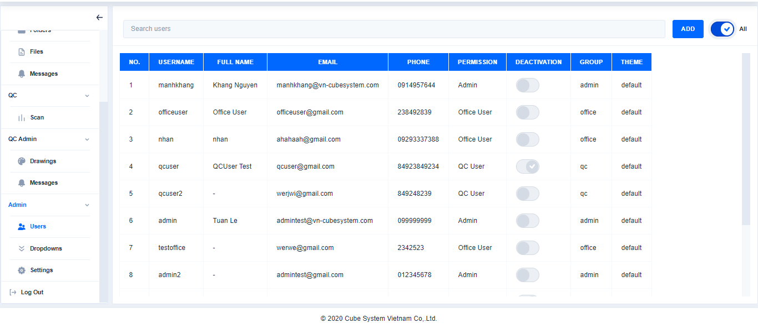

1. Search user

Click

Click **Users**→Search users

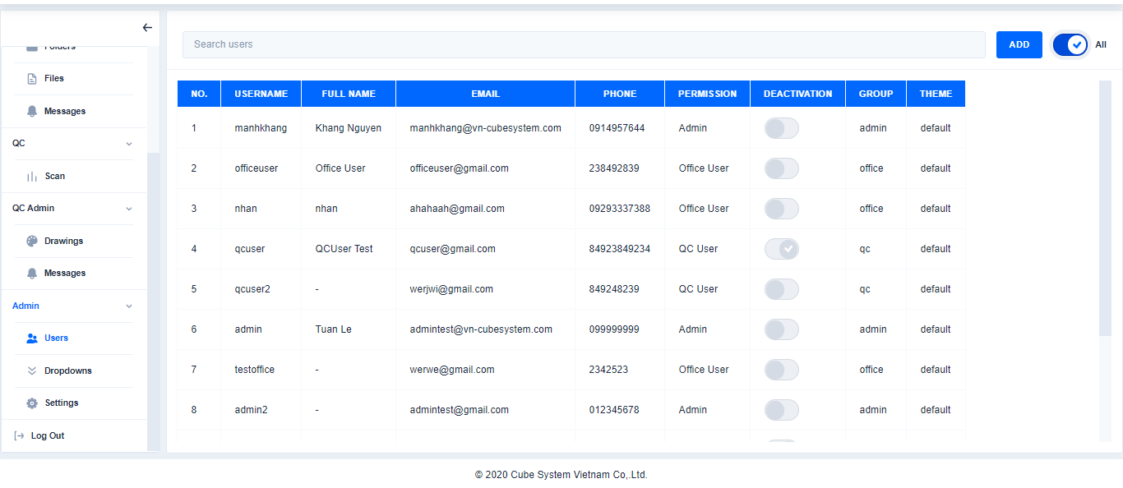

Enter the Username to Search file

Click

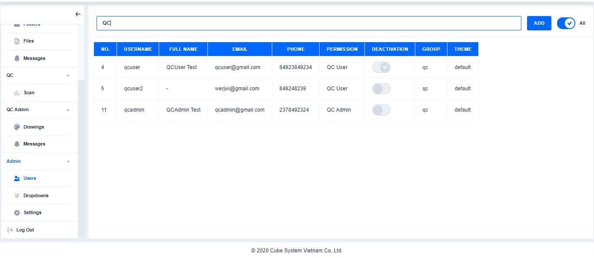

1. Add user

Click **Users**→Click **Add**→Enter the content→Click **Create**

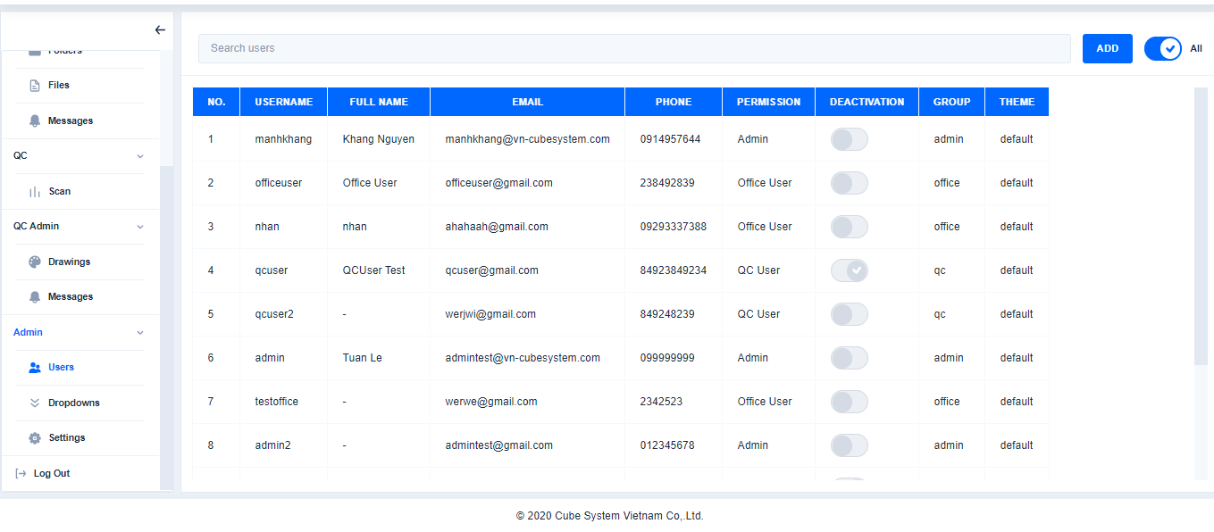

Click

Click

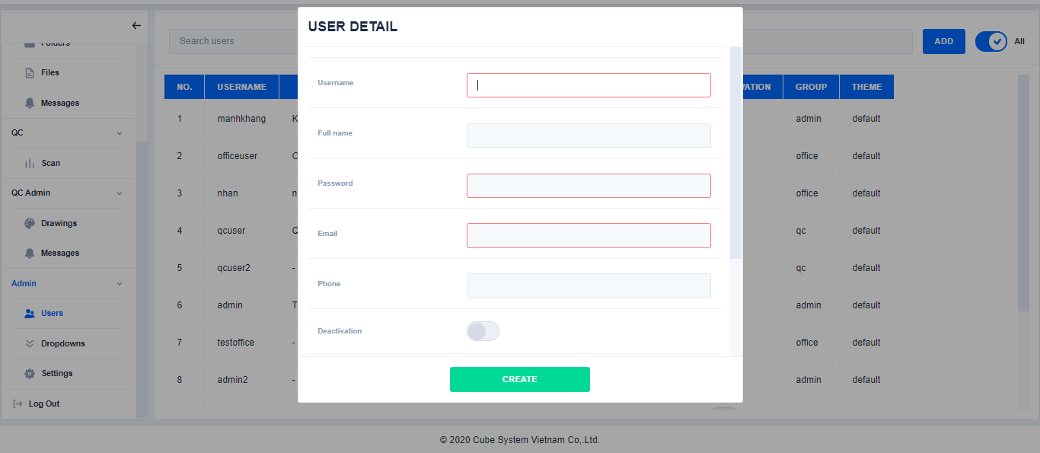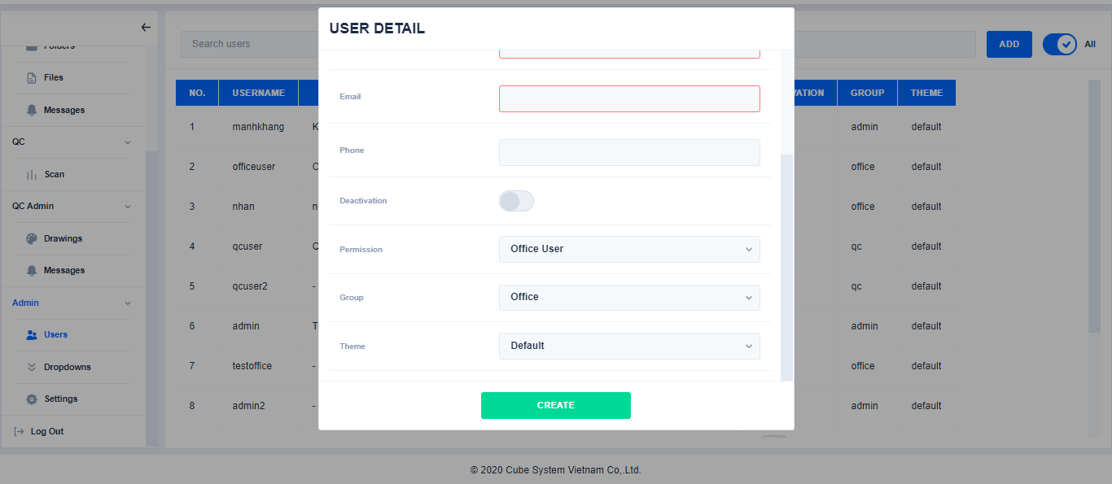

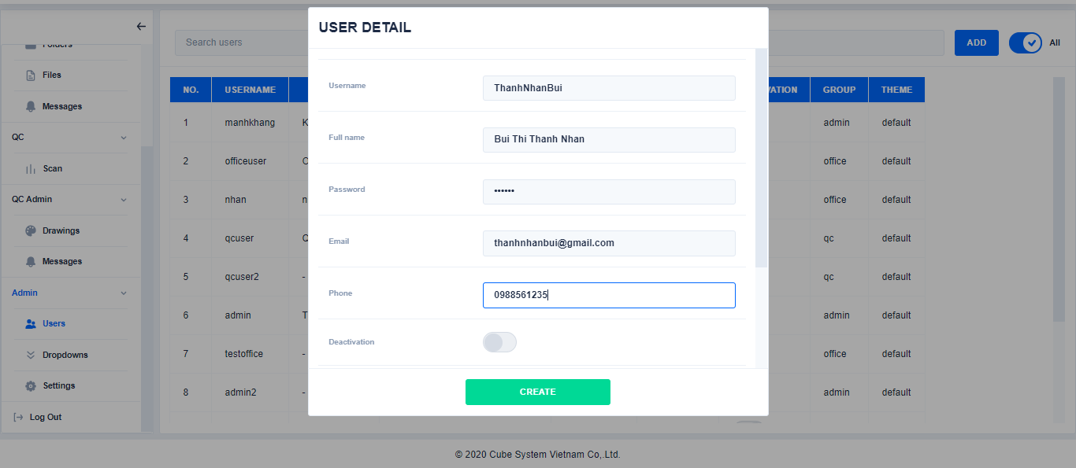

Enter the content

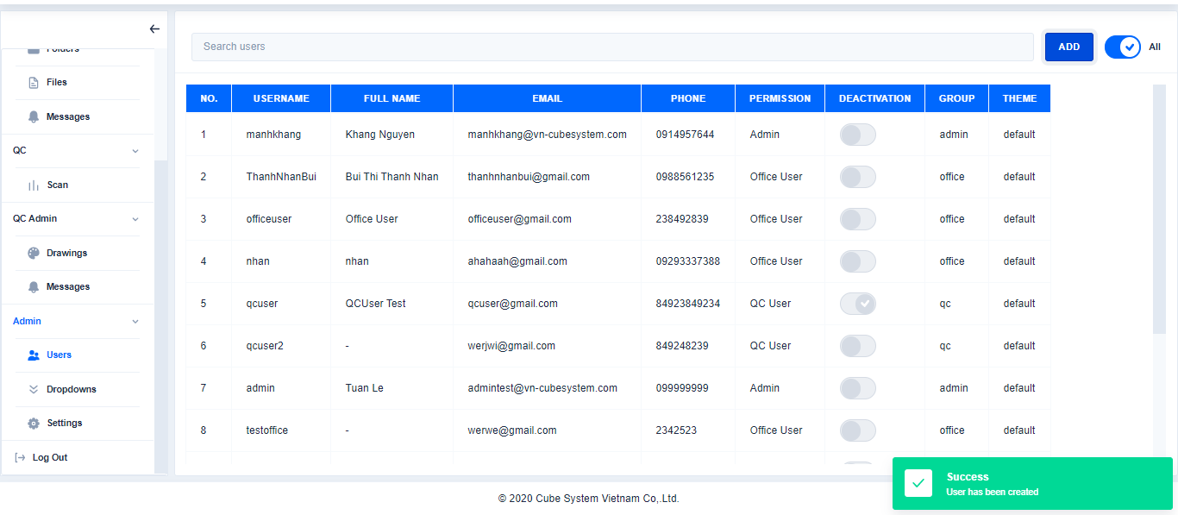

Click

1. Edit user

Click User→Select the user to edit→Click **Edit→Click Save**

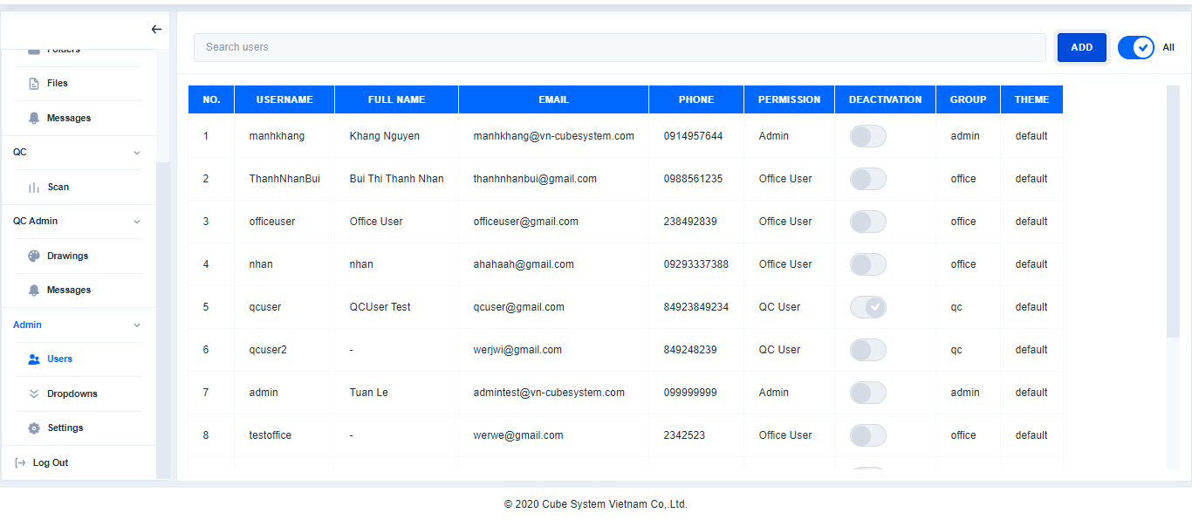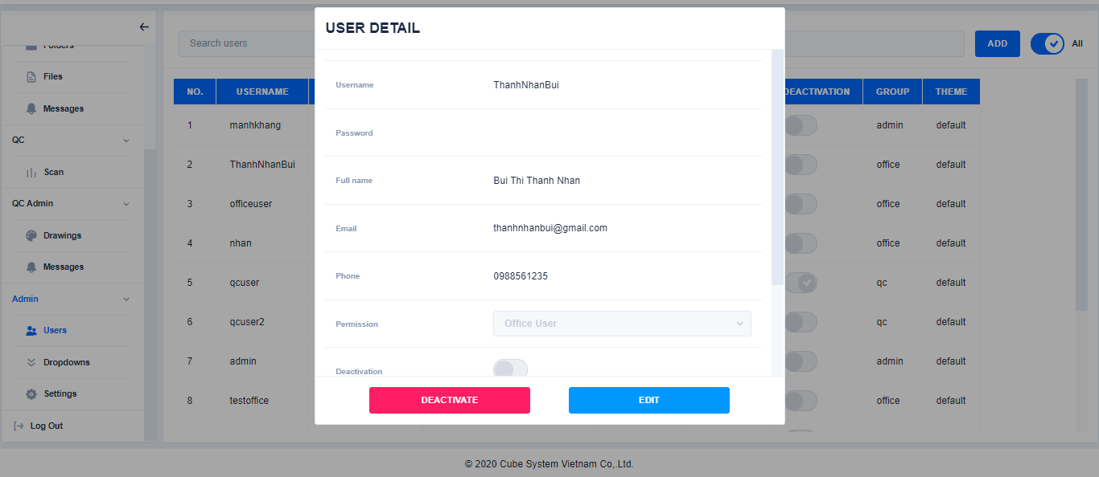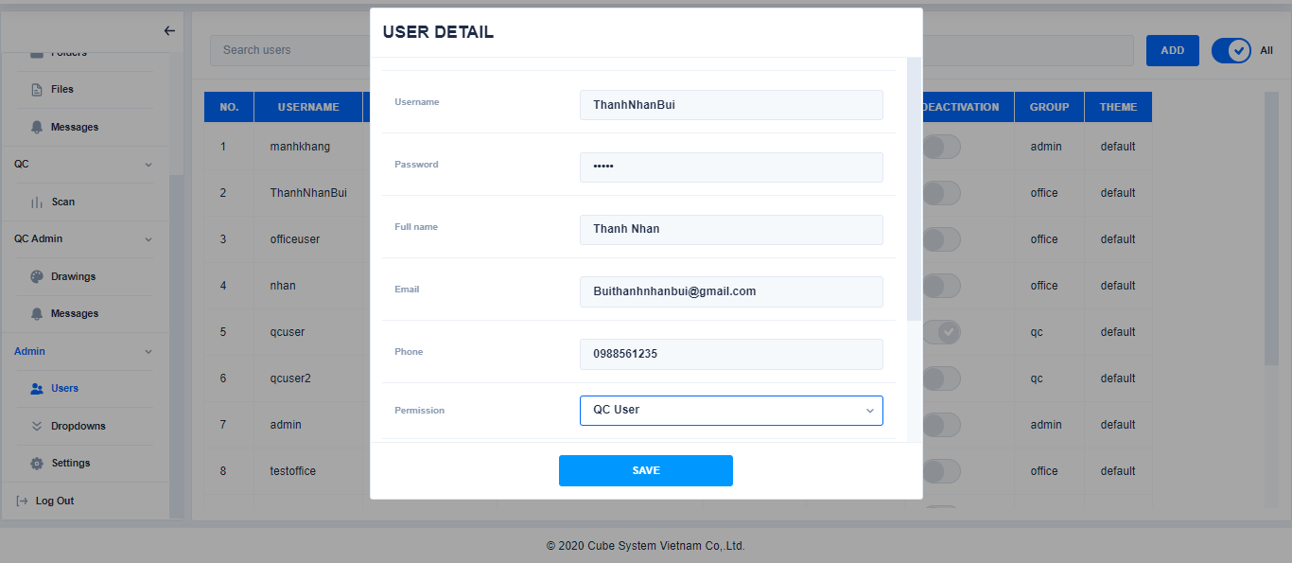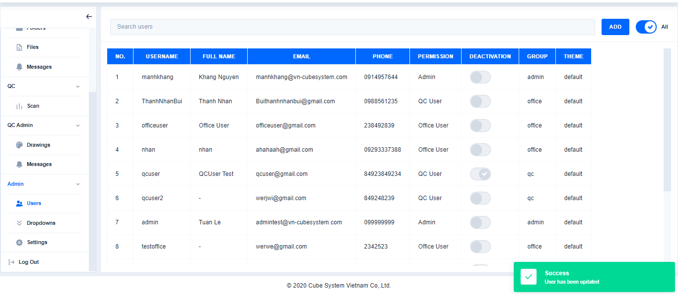

Click

Select user to edit

Edit content

Click

1. Deactivate User

Edit content

Click

Click User→Select User→Click Deactivate→Click Yes

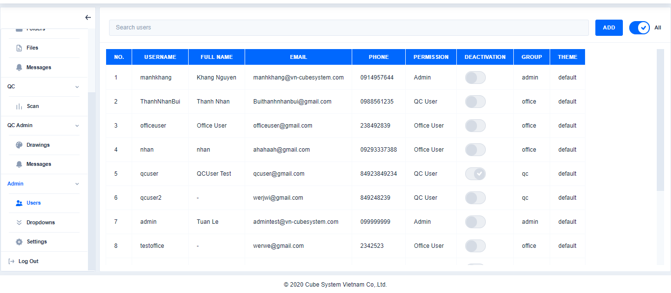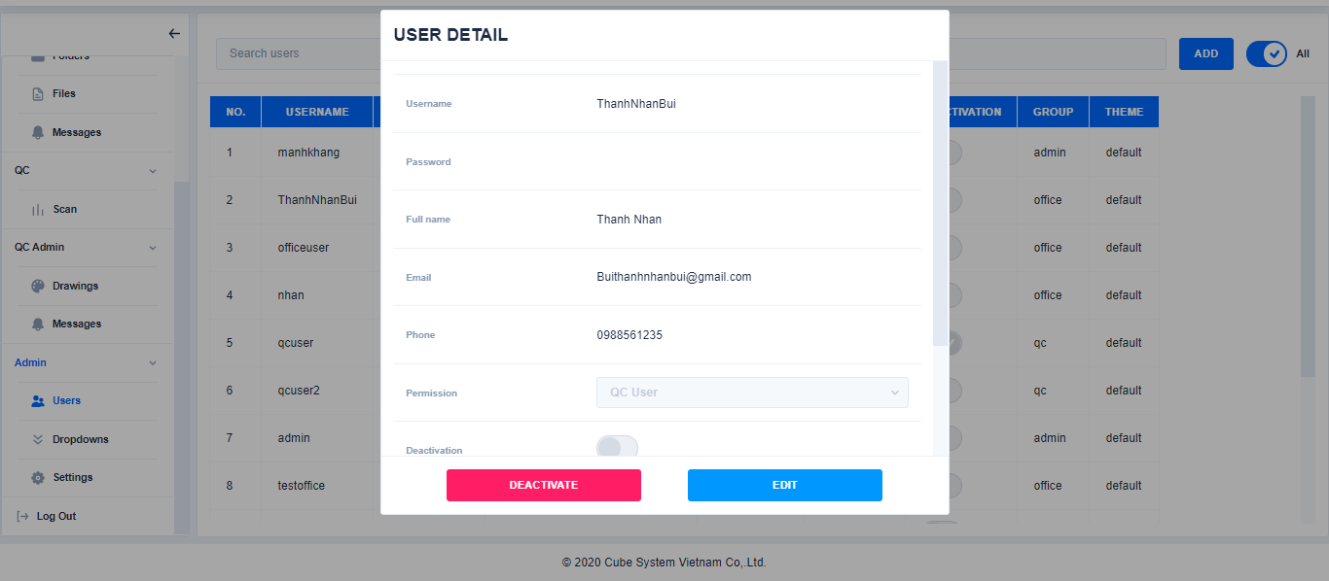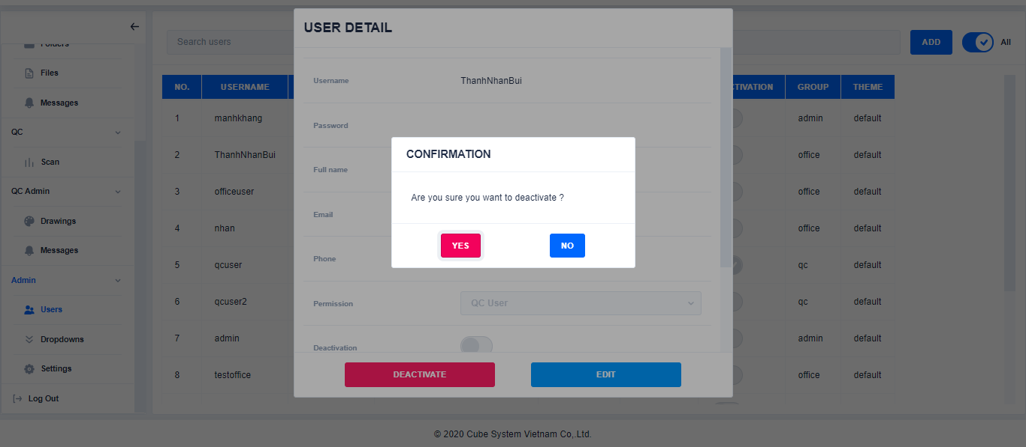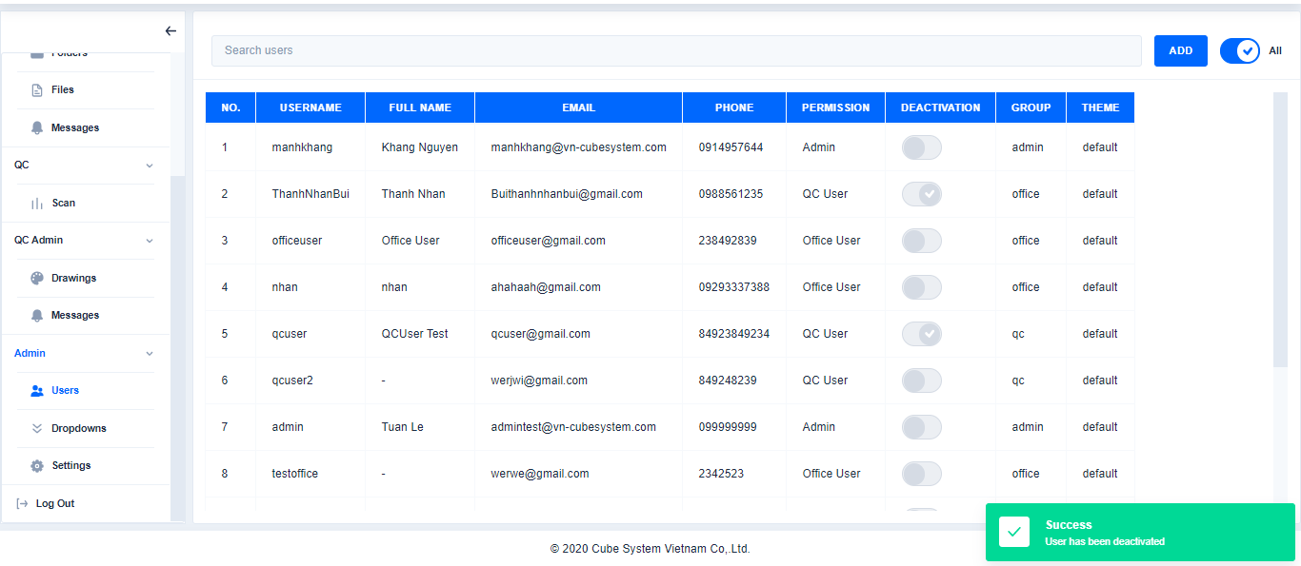

Click

Click

Click

Select User

1. Activate User

Click User→Slelect mode All to show all user(Mode Activating only show the user activating)→Select User→Click Activate→Click Yes

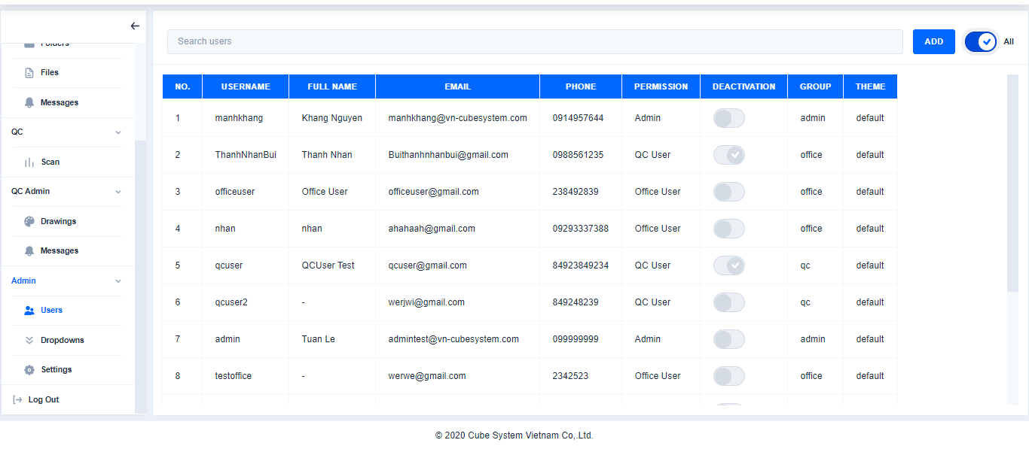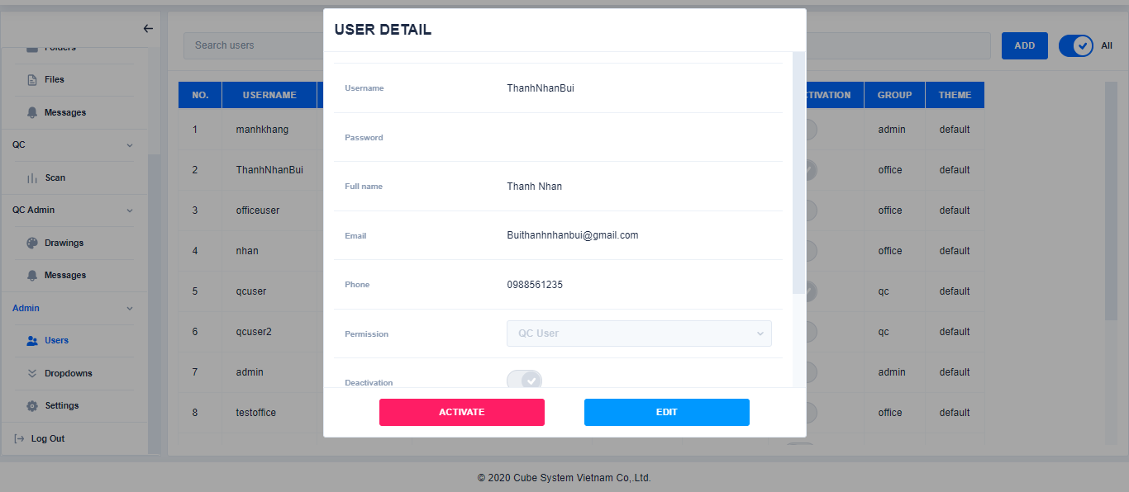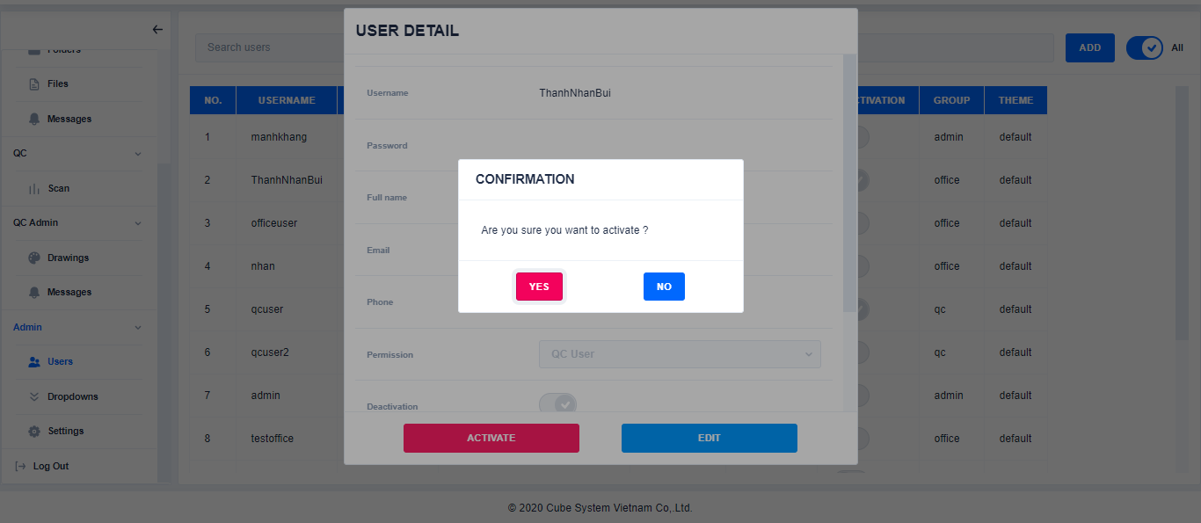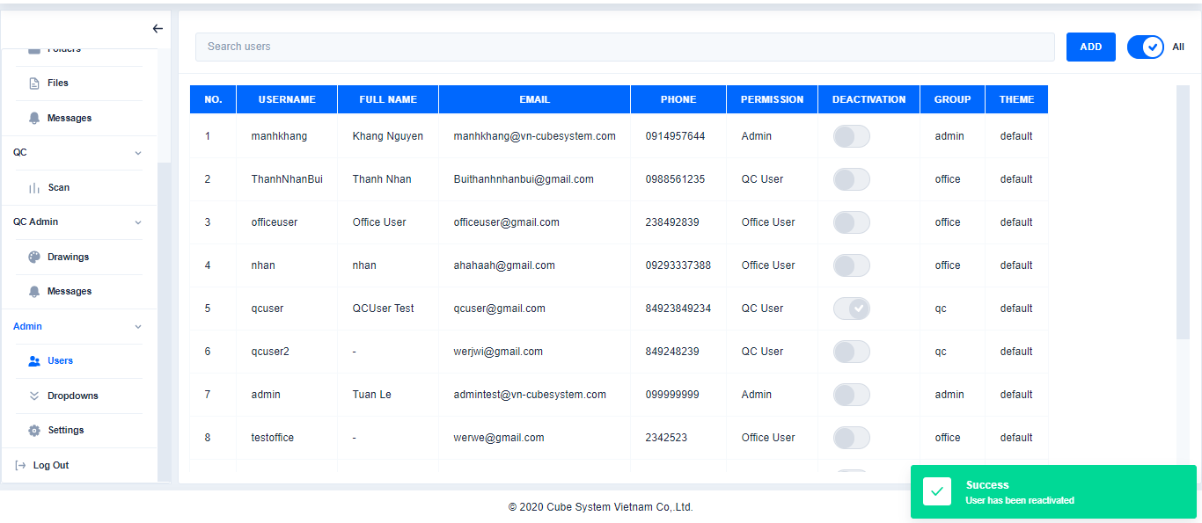

Select All

Click

Select User

Click

1. **Dropdowns**

Click

1. Add Dropdown

Click Dropdown→Choose a folder→Click Add dropdown→Enter content→Click Create

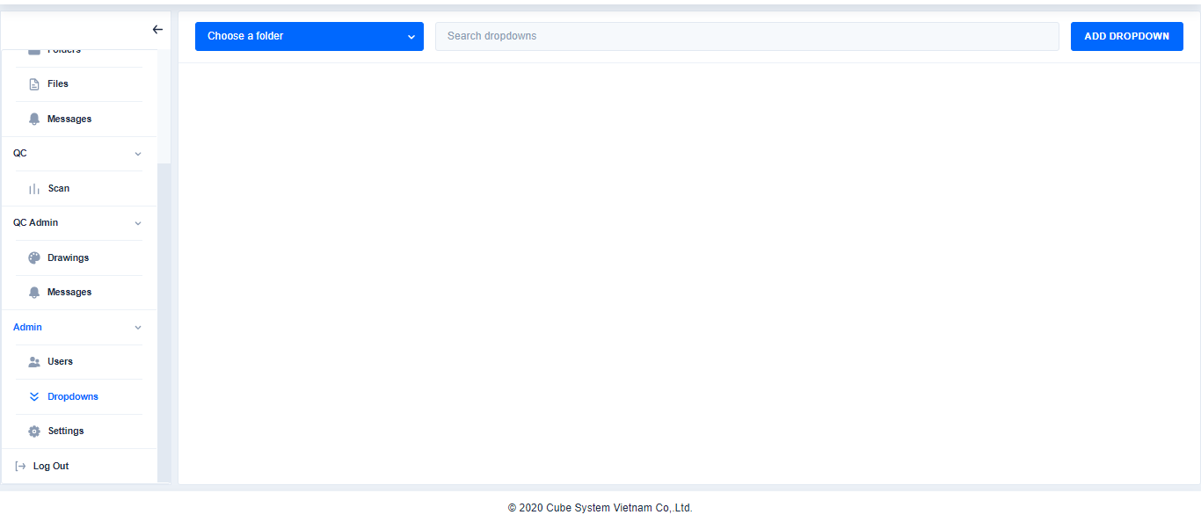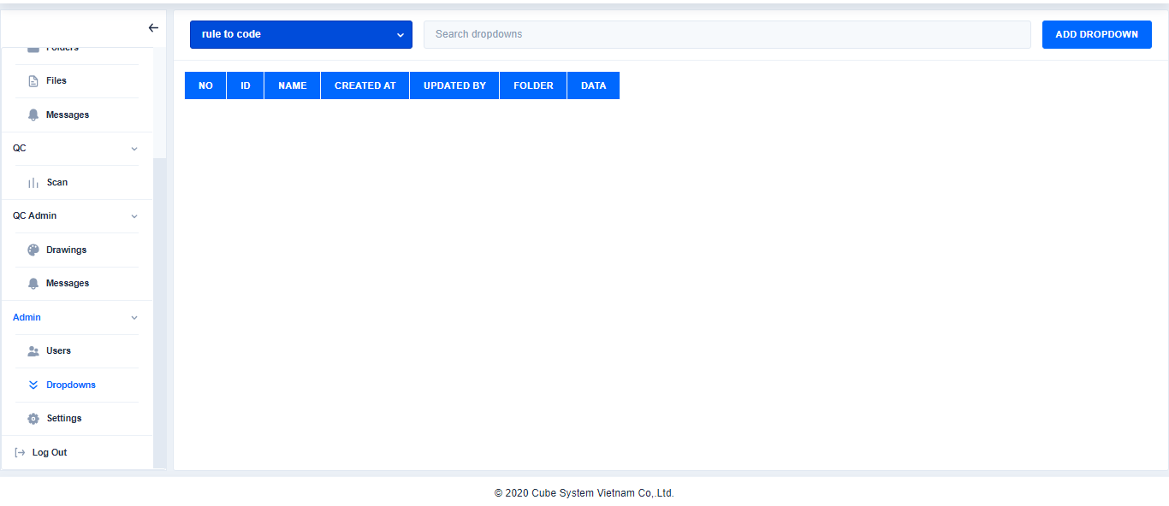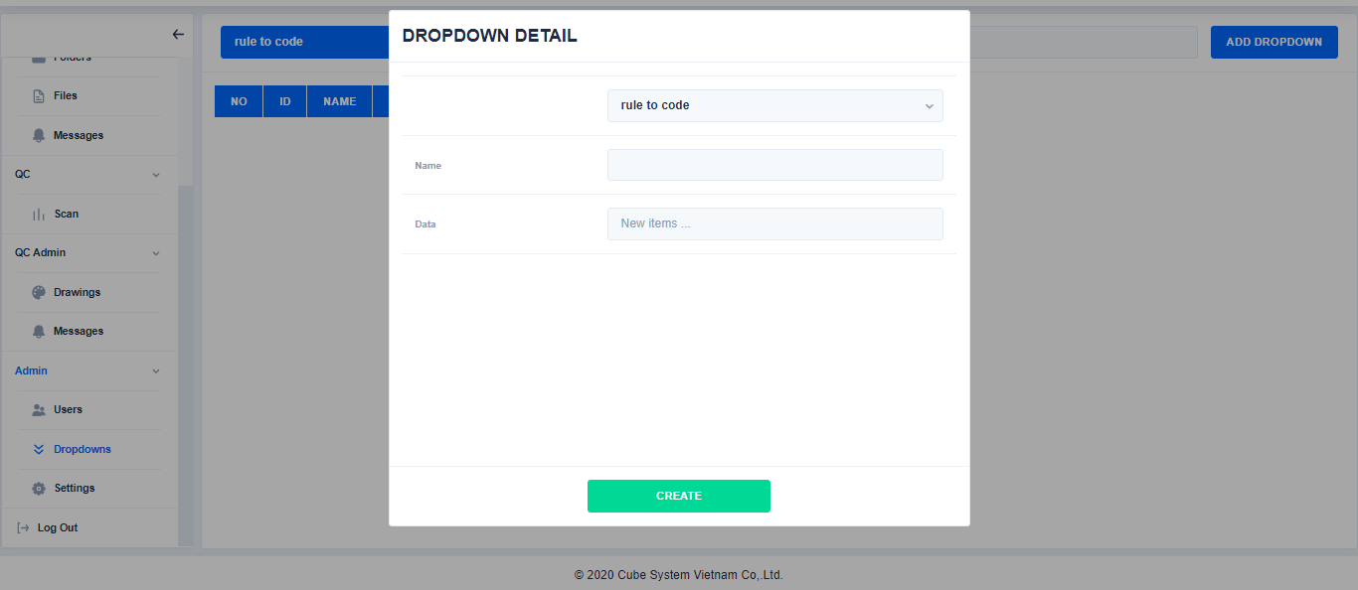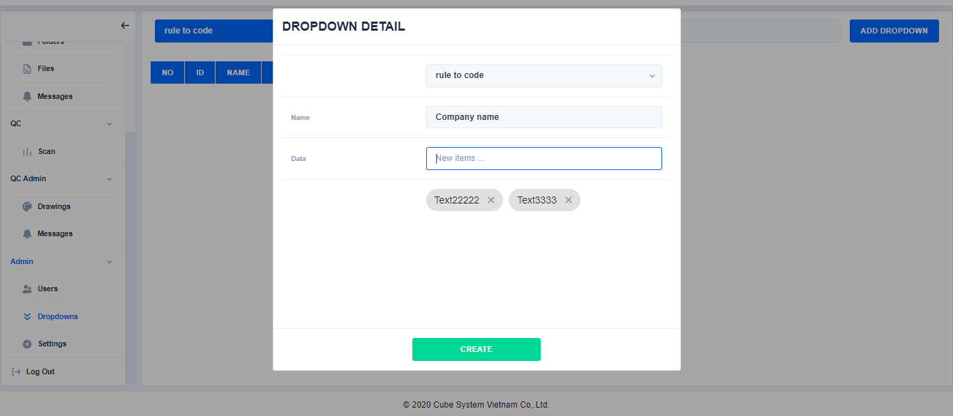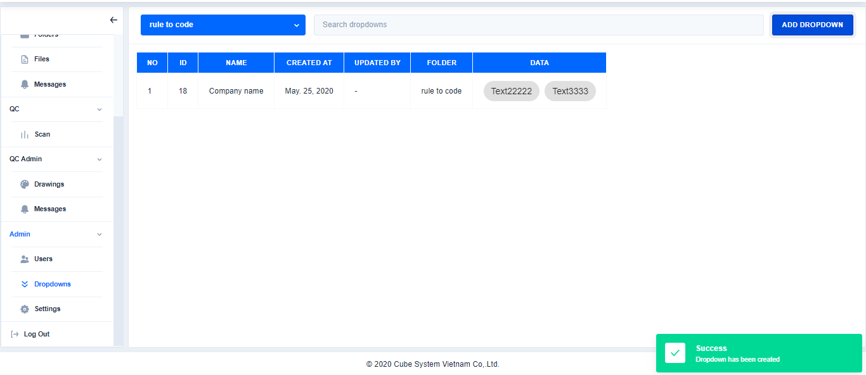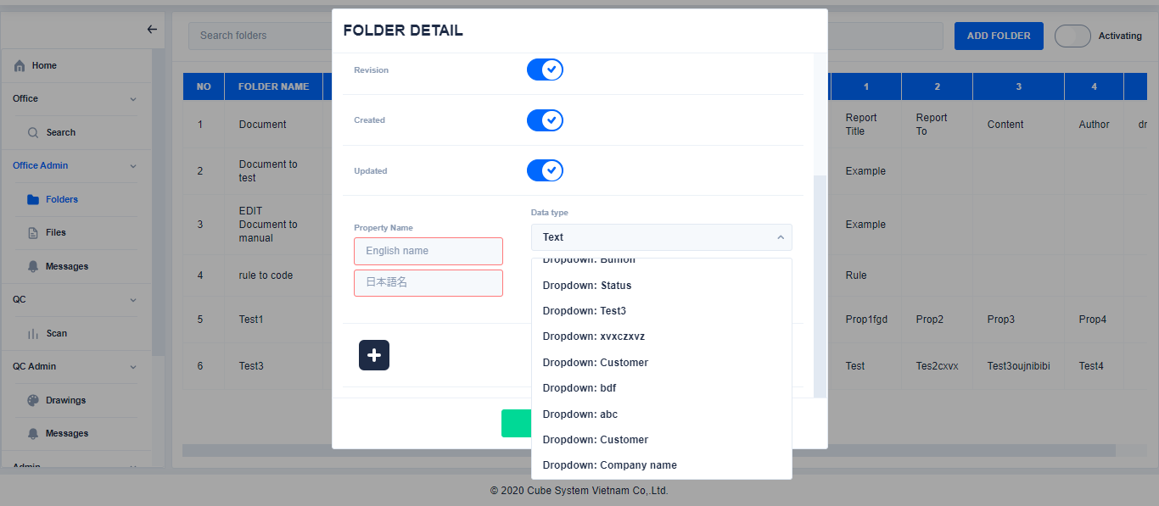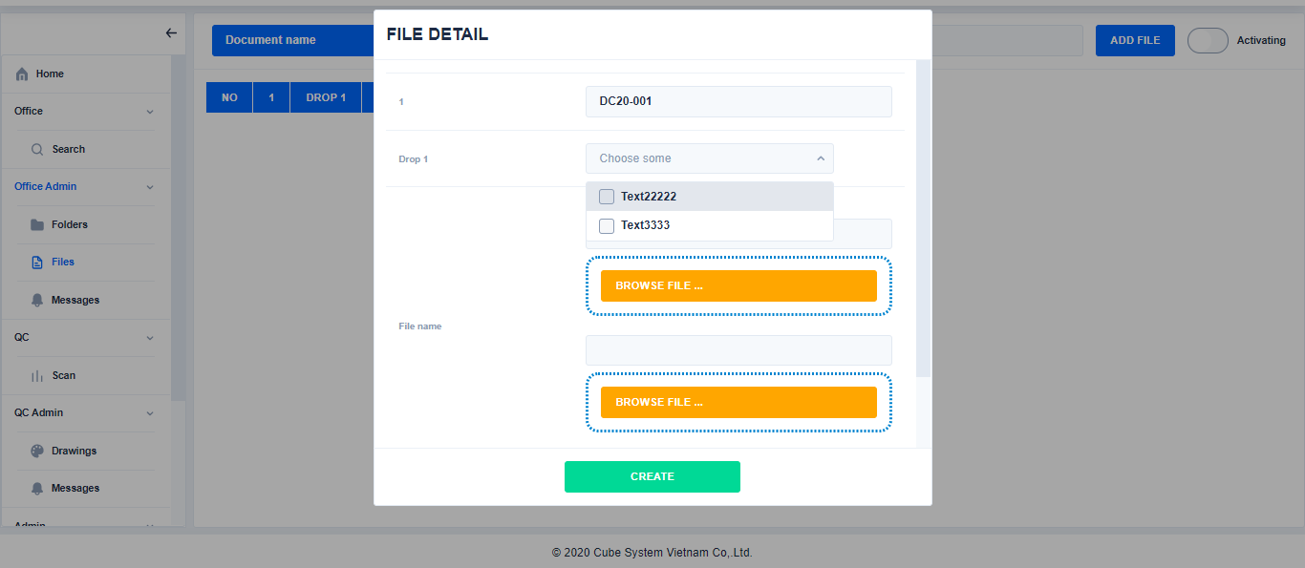

Chooe a folder

Click

Click

Ennter content

※Can select multiple data at the same time

Click

1. Search dropdrown

Click dropdown→Choose a folder→Search Dropdown

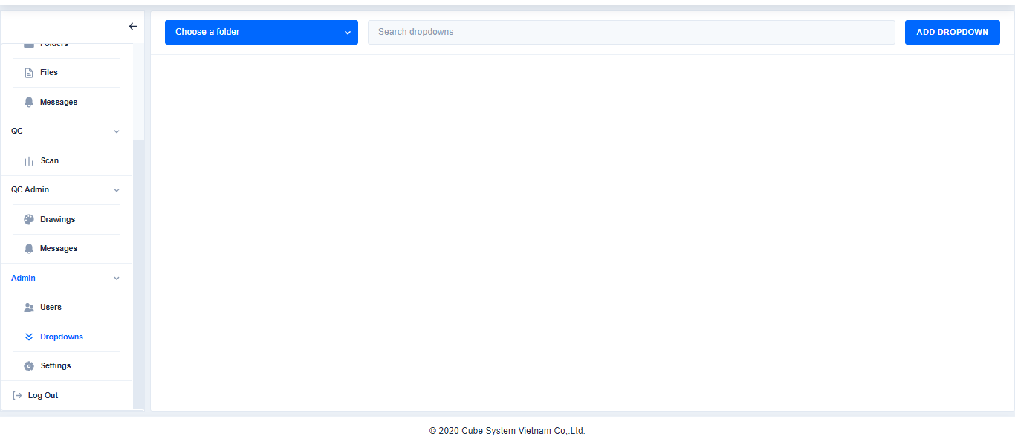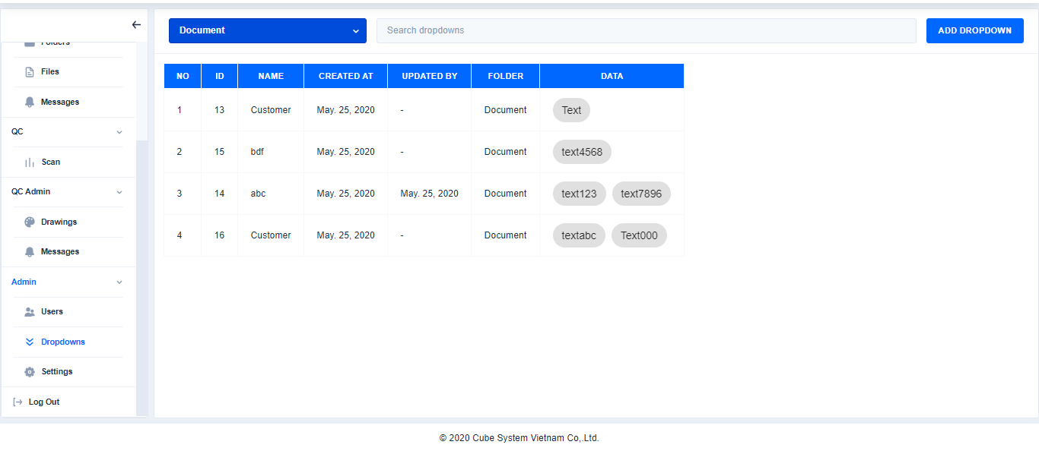

Search dropdown

Choose a folder

Click

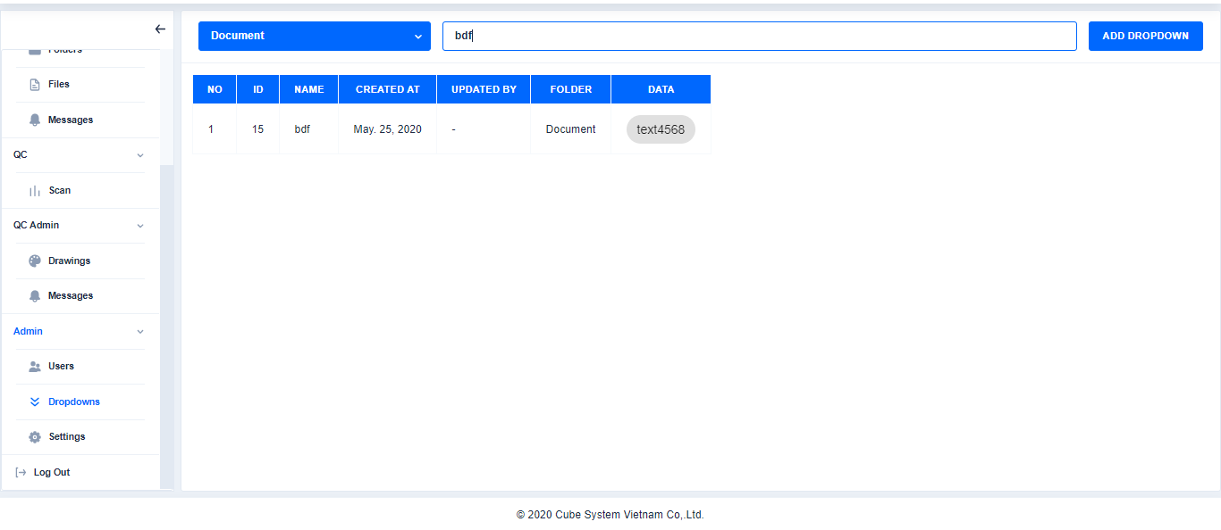

1. Edit dropdown

Click dropdown→Choose a folder→Select file→Click Edit→Edit content→Click Save

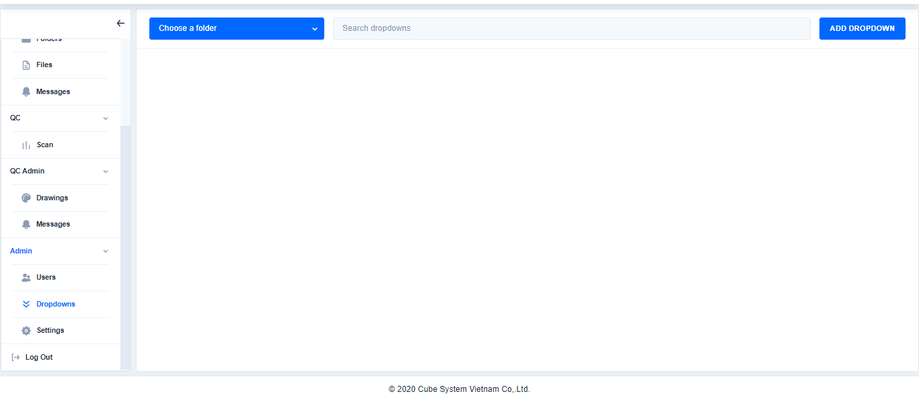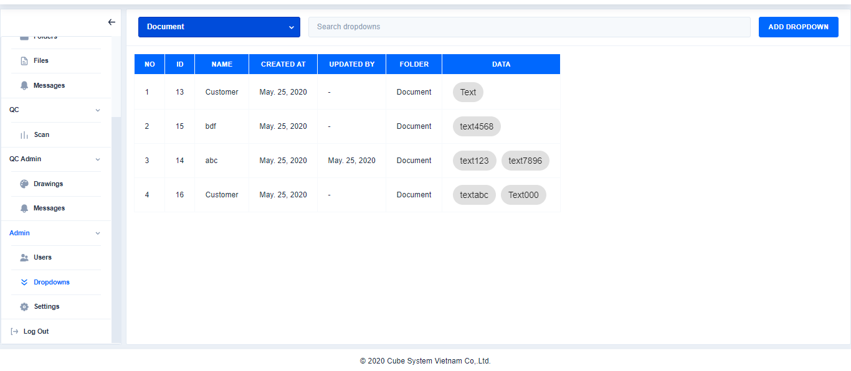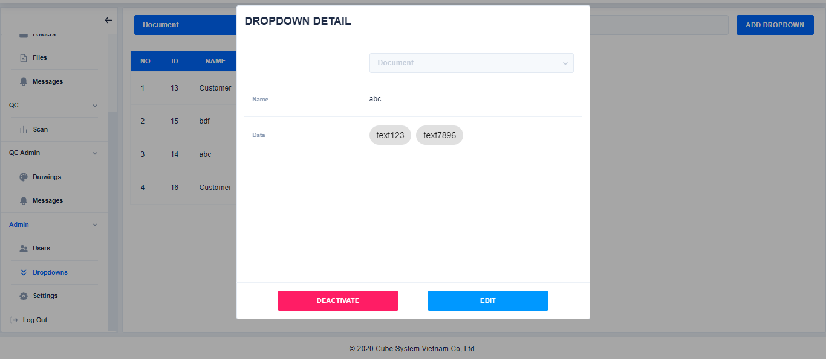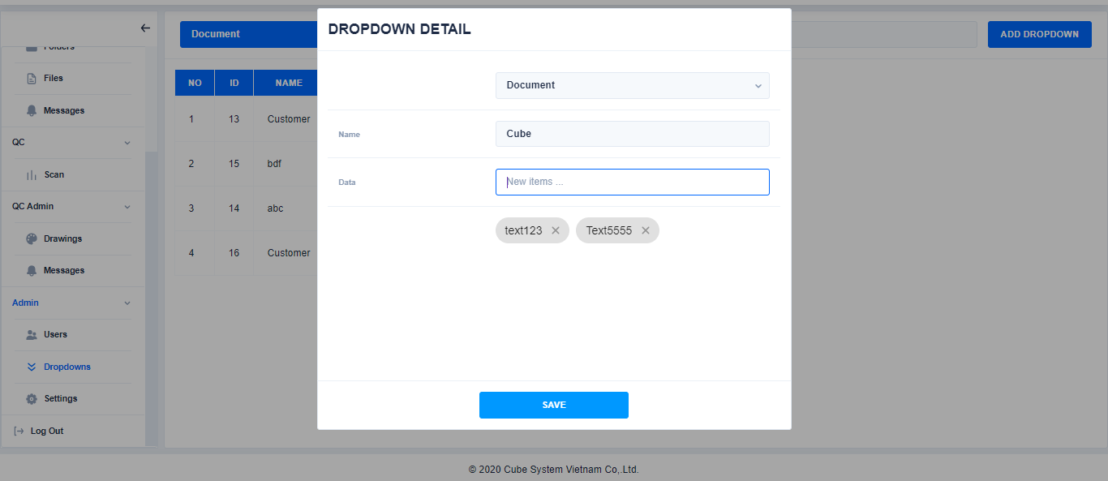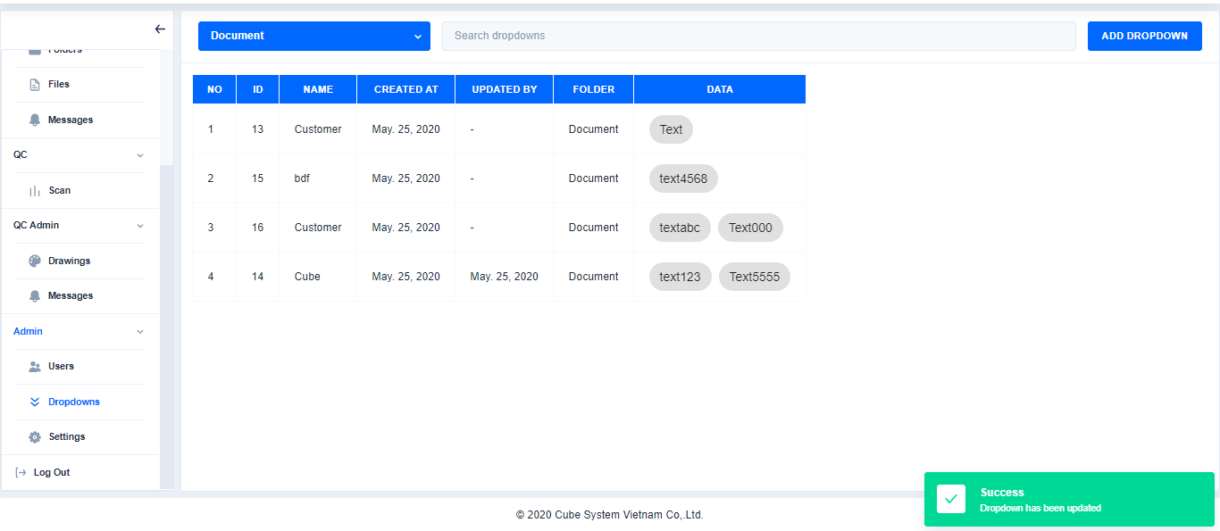

Click

Select file

Choose a folder

Click

1. Deactive dropdown

Click

Edit content

Click Dropdown→Choose a folder→Select file→Click Deactivate

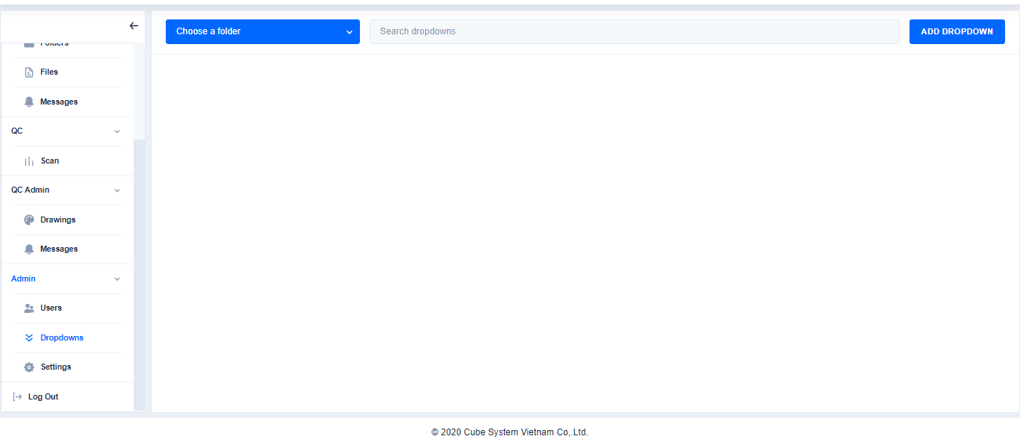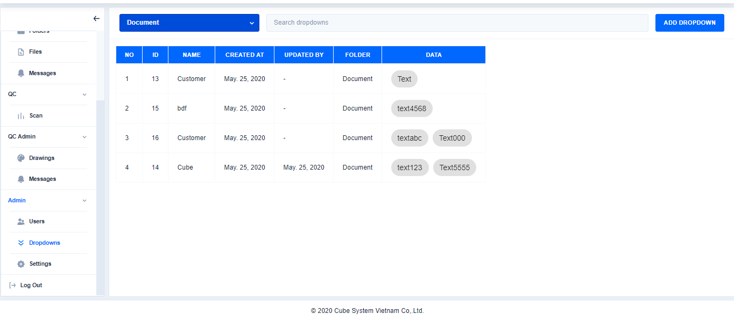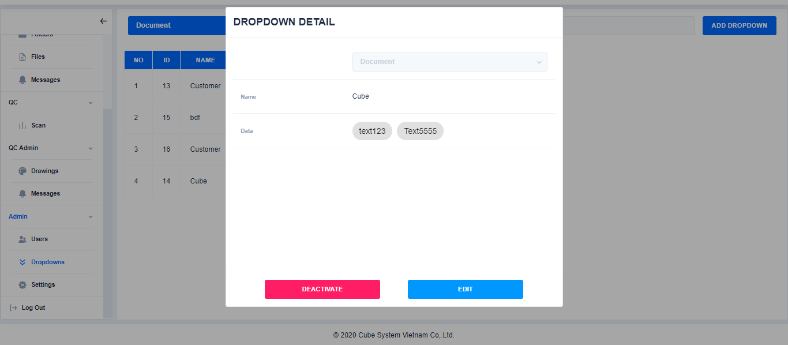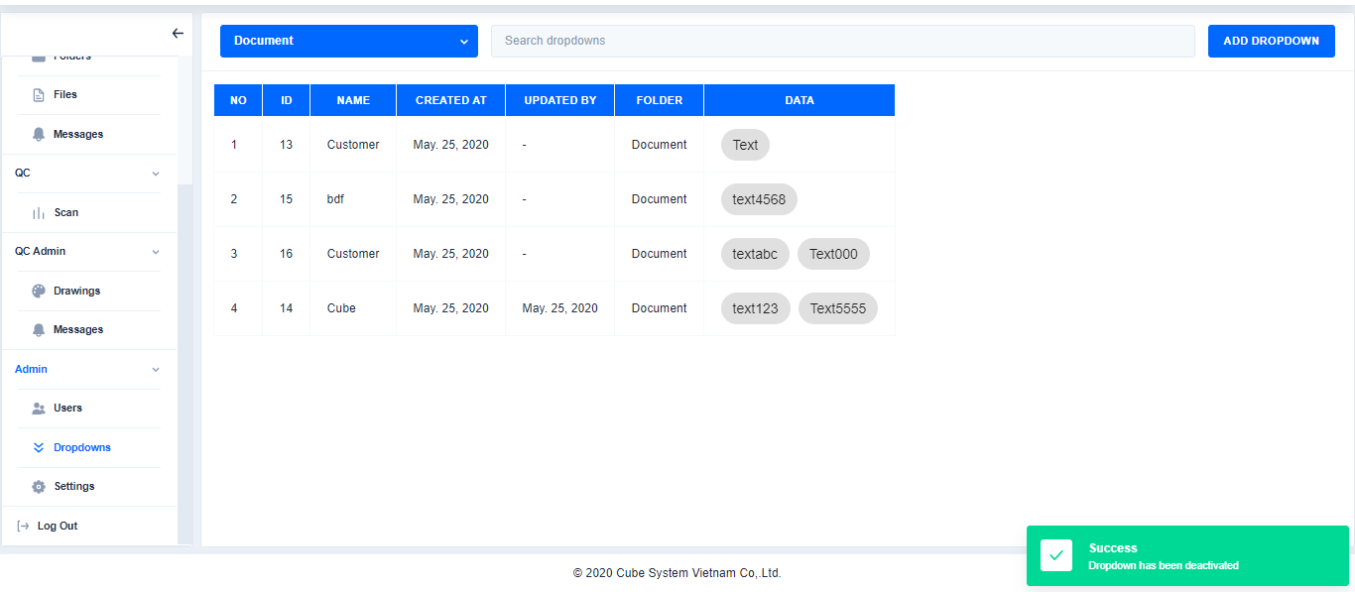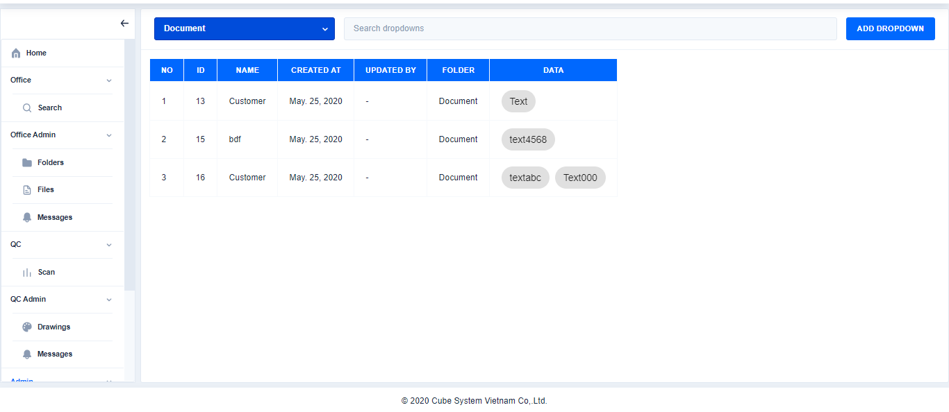

Choose a folder

Click

Select file

Click

1. **Setting**
2. Create a new message

Click **Settings**→Enter the content→Click **Save**

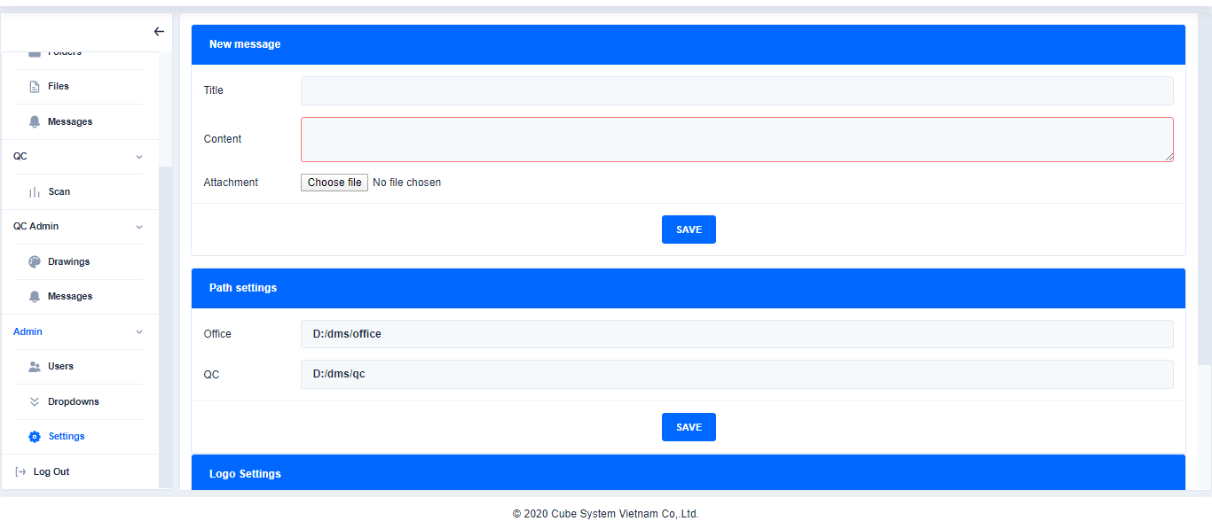

Click

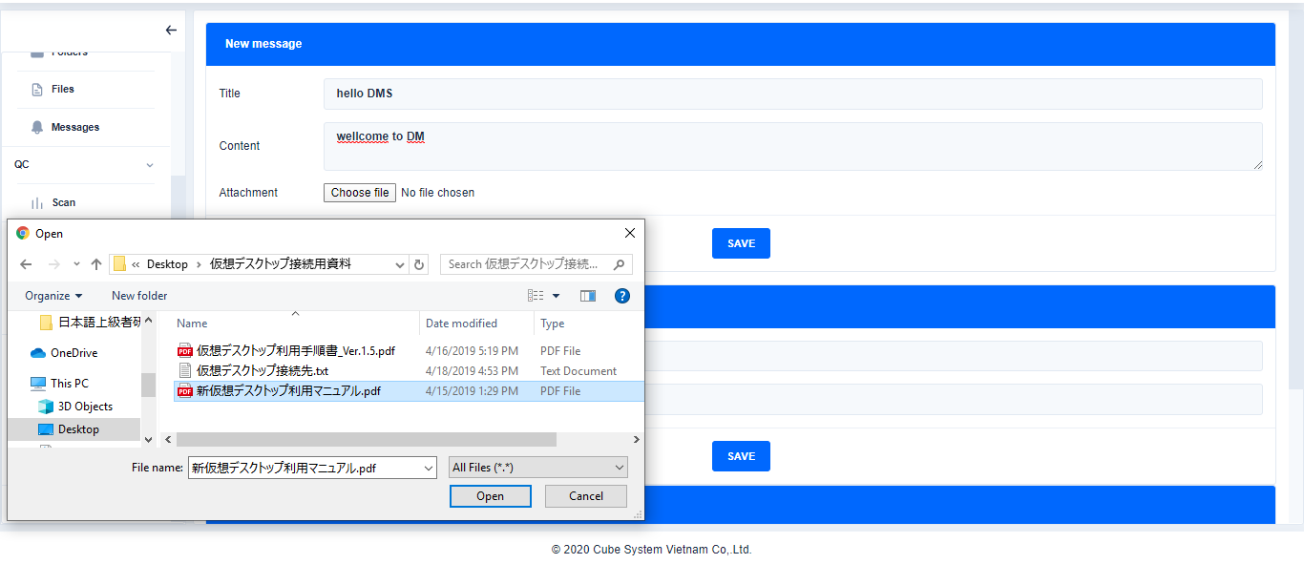

Enter content and Choose file

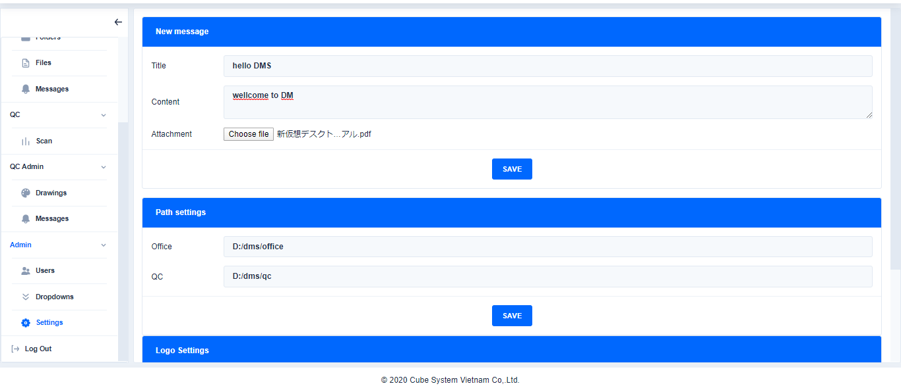

Click

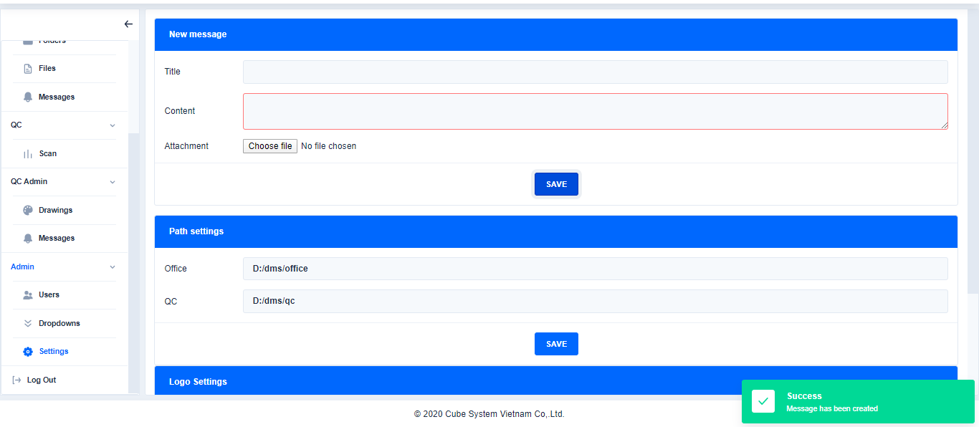

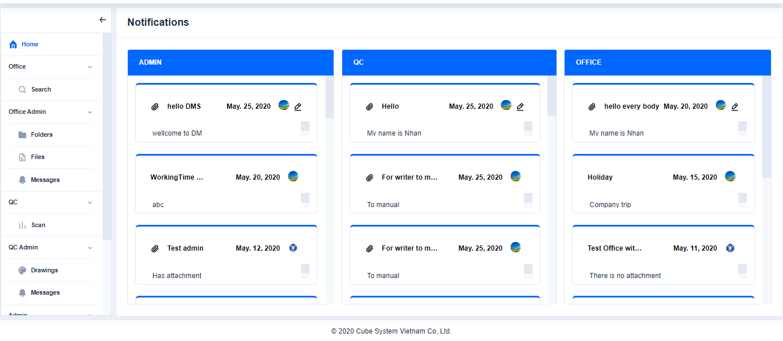

1. Path settings

* To enter the root URL of the Office and QC. The Folder and File created will be saved here

Click Settings→Enter the root URL of the Office and QC→Click Save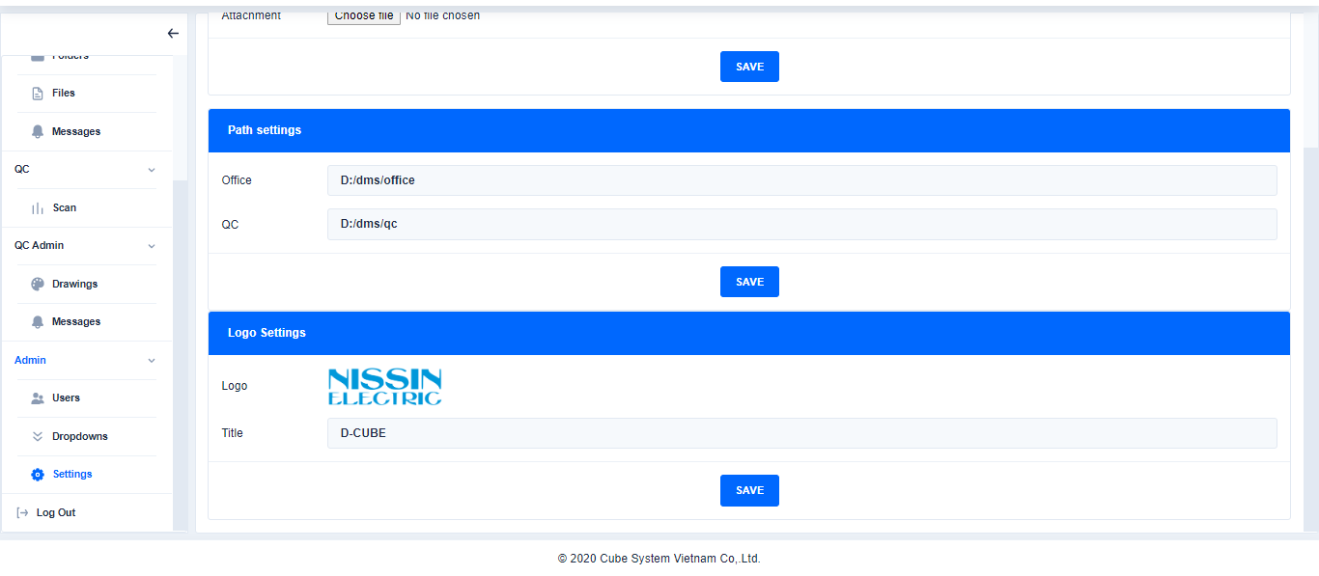 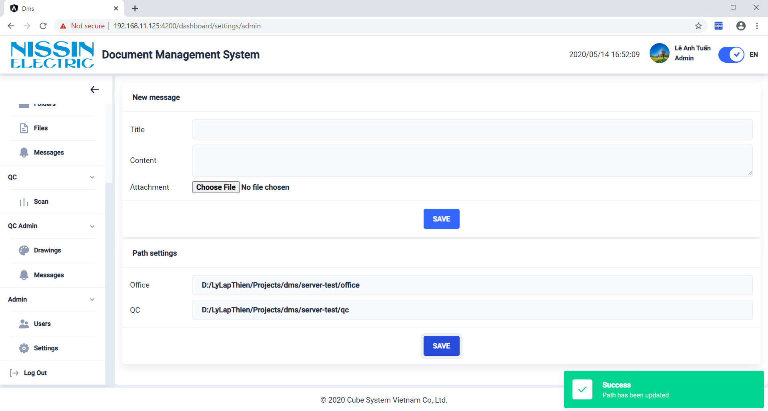

1. Logo Settings

Click Settings→Change Logo and title→Click Save

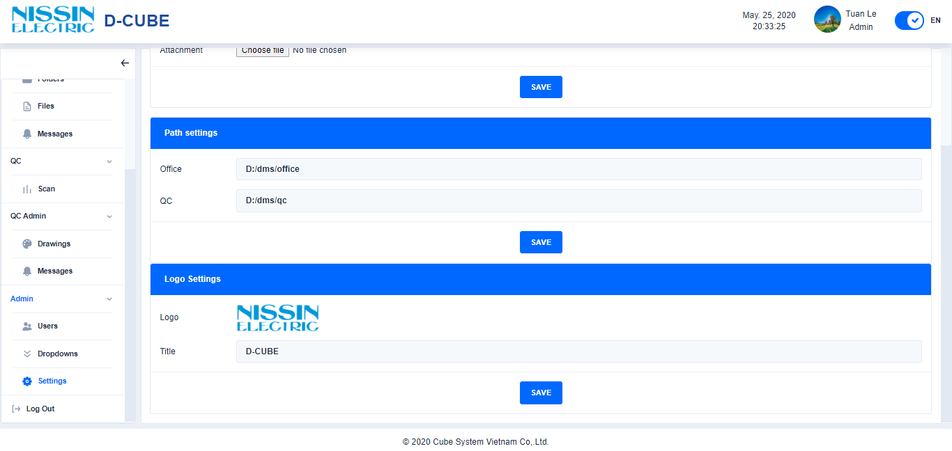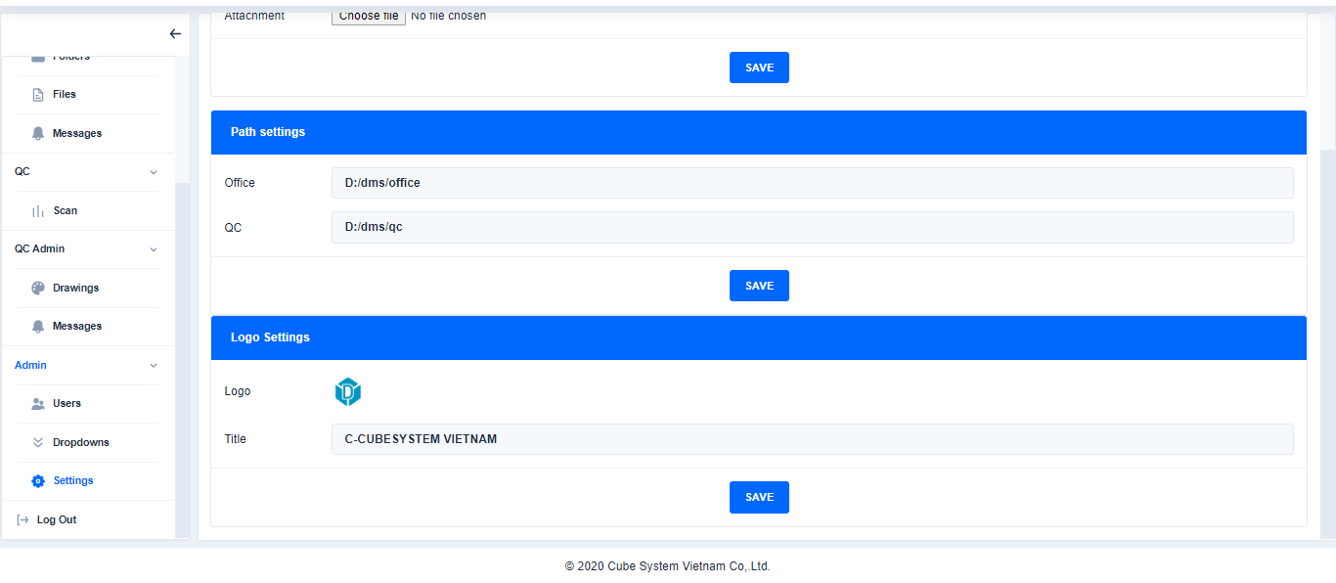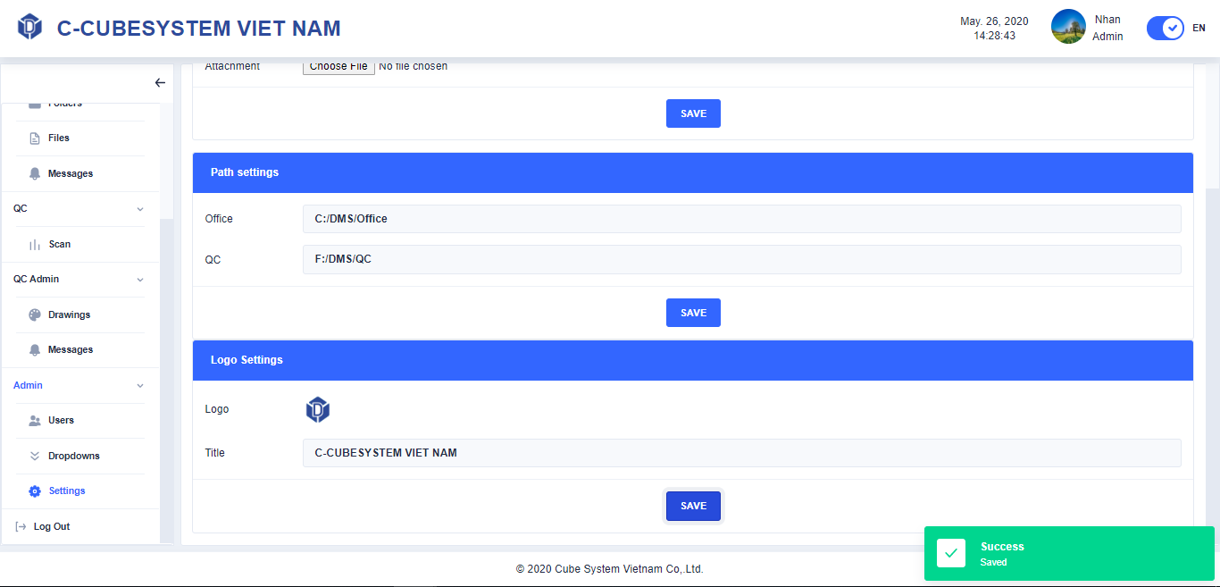

Change Logo and title

Change Logo and title

Click